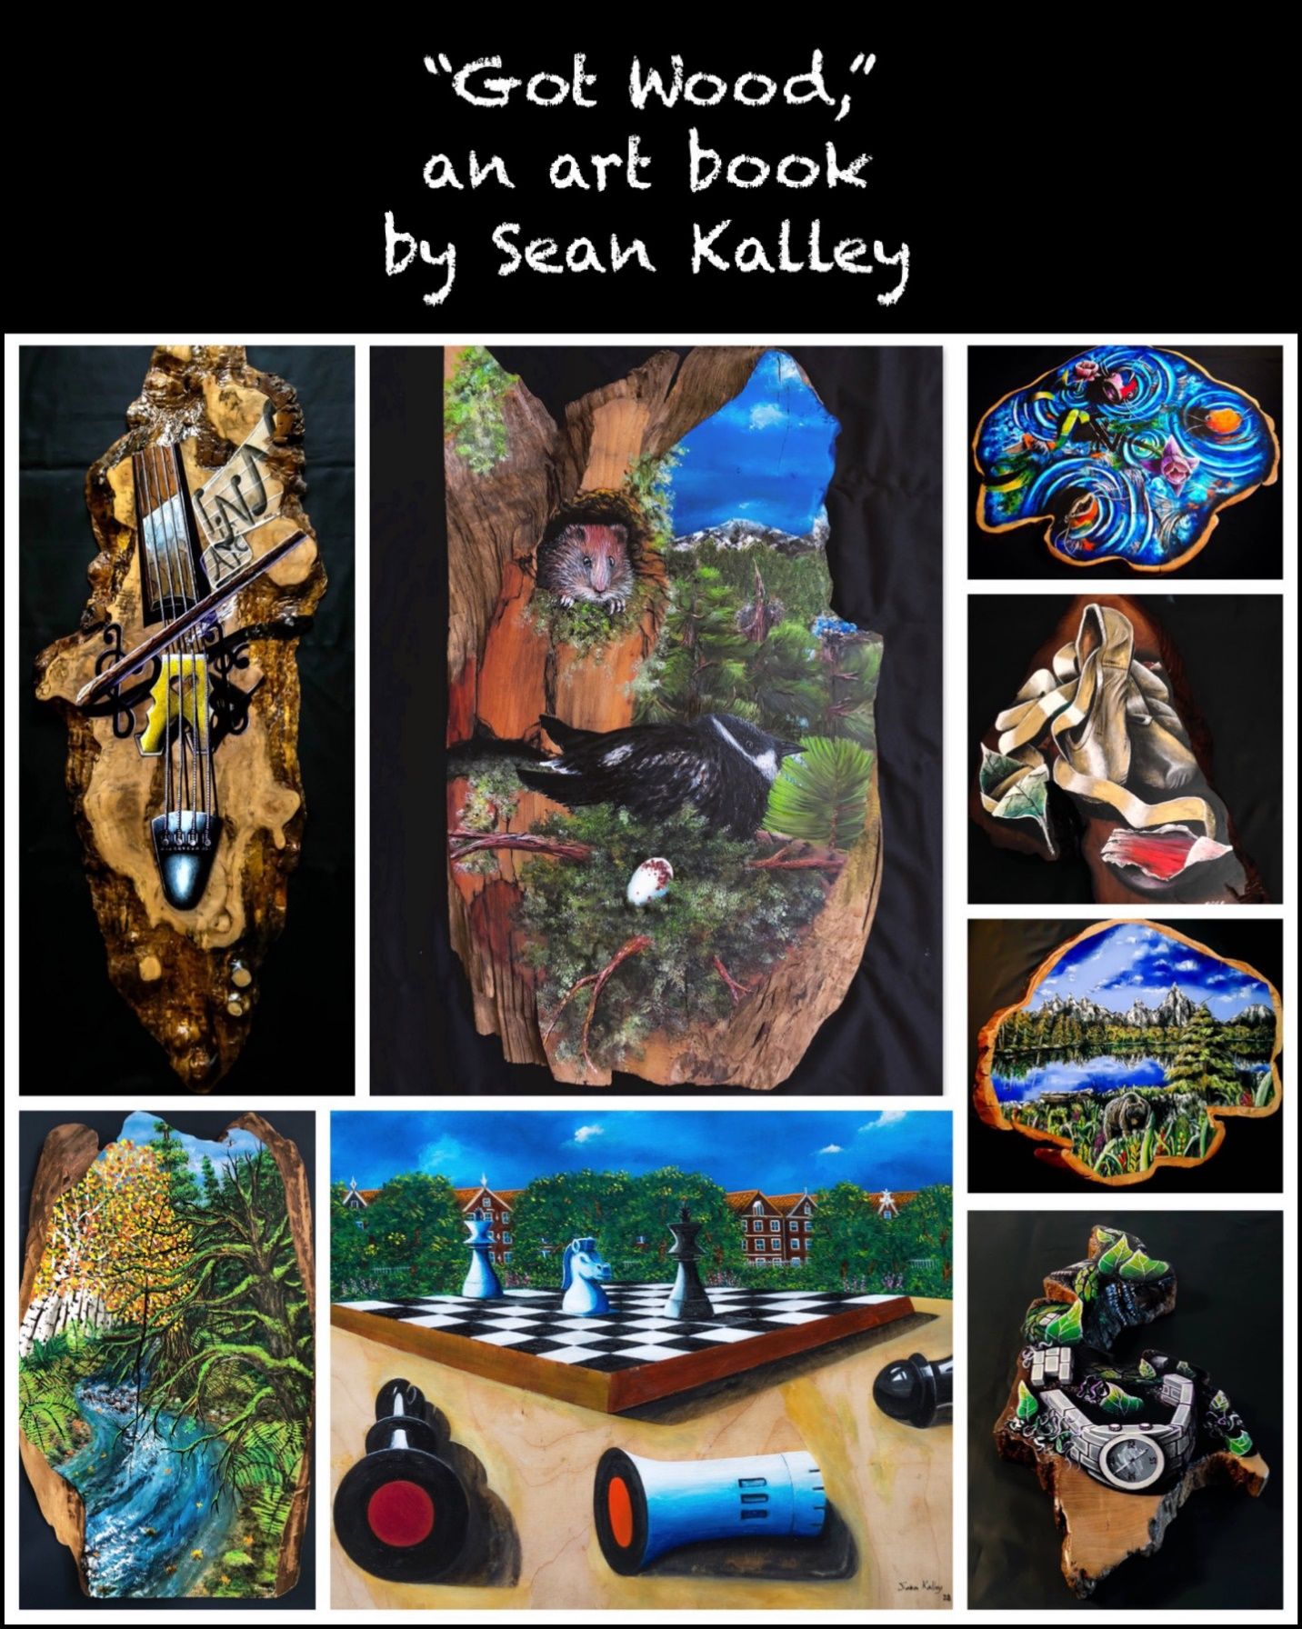

Got Wood?

A creative art book
By
Sean Kalley

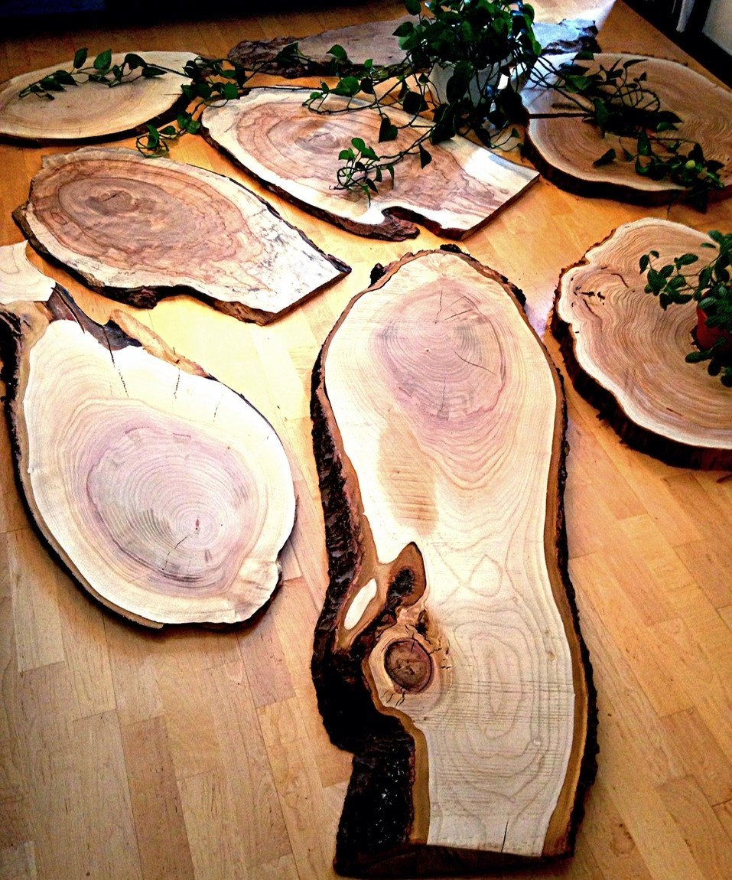
Introduction
Art popped into my life at the age of 35 after needing an outlet to release anxiety, confusion and loss due to an injury with several failed surgeries. During this time being physical and athletic had defined a major part of life since childhood, and it was suddenly taken away. As “Guru from Gang Starr rhymed we all must face the moment of truth.” Instead of falling to the ground and giving up, I decided to rebuild into something new creatively and authentically. The energy and focus found through different aspects of life became a refined patience, and It flowed from my veins right from the start. The constant daily effort trying almost every method of creating art while teaching myself in the process continued to build confidence. “What would it become,” crossed my mind all the time. On many occasions I wanted to quit, let it go, or just make creating a hobby. Yet, after 12 years I am still here and working at a higher vibration than ever.
An important piece of the puzzle was completing the artwork in a professional manner from the very beginning. With that said, I had to be creative in how this was completed since professional framing is expensive. Not to mention there needed to be a unique original quality as we well. So how does this happen? This process started with finding old frames or objects to repurpose them as frames. I would clean them up the best with the resources provided along with trying to do this with a shoulder replacement while needing another. This lasted for about the first 6 years, and lead into the next phase of original framing.
In 2010 life lead to Oregon, and a land of trees really big trees. There are reclaim lumber shops, arborists, and plenty of spots to find plank wood at a decent price. Portland also had spots where I could go work on building these frames for low monthly fees and all the ride share programs allowed me to get the wood to where it needed to be. The ability to piece all of this together at a reasonable business expense helped keeping prices for my creations at a cost affordable for a wide range of potential buyers. This was another level of creativity finishing out the lumber while building frames from all types of beautiful wood. I enjoyed this time of building frames, there was just something not unique enough about it.
One day a friend of mine asked if I knew about a place called, “Salvage Works.” Not sure how I didn’t yet, and the next week we planned a trip there. It was like a wood wonderland of almost every type of wood you could think of for affordable prices. Reclaimed 12” floor planks to fallen trees milled and cured ready to use in all different shapes and sizes. Then in the corner I found a 2, 4 ft tall 36” cross-sections of a fallen Big Leaf Maple. This was it, and it started a journey that lead to finding a meth addict to cut the cross section into rounds with a chain saw, to finding a mill shop later to do the work, to finding cross sections anywhere and everywhere I could. It took a lot of work, money, multiple shops to help in the process, and letting go of over 30 of them for free in the pursuit of an authentic creative life. There isn’t one aspect I would change about this adventure, and now look at the creations with earned effort and pride as the result of over 70 originals. I hope the book is pleasing to the eyes, and it inspires you to find a creative, authentic passion within.

“Got Wood, the start of it all…”
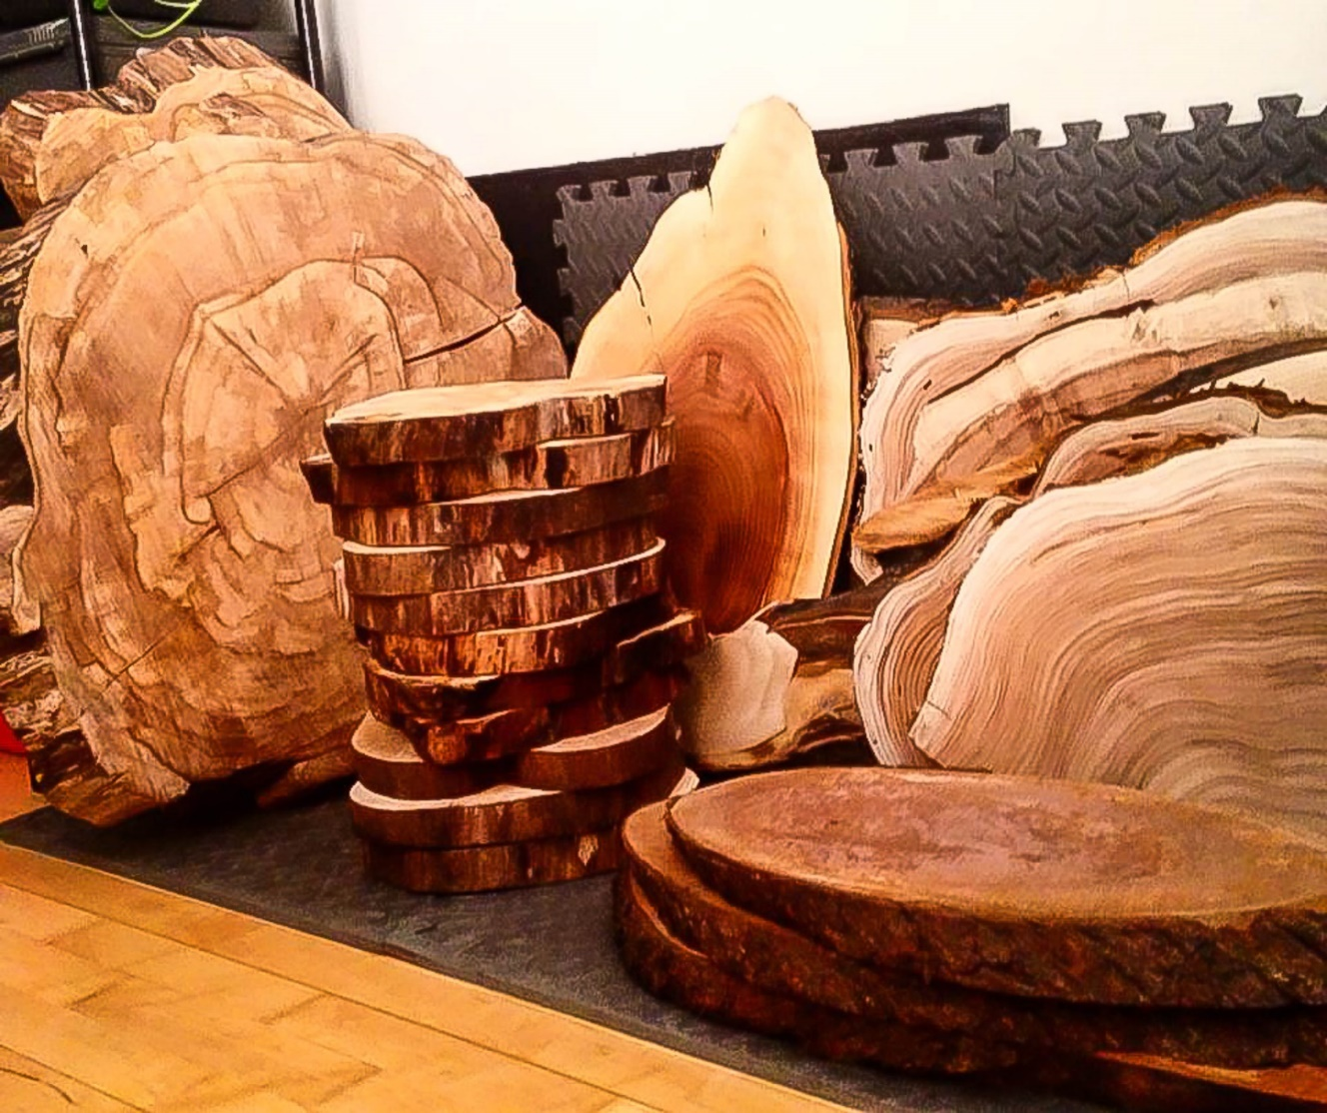

“Open Your Mind”
PNW cedar
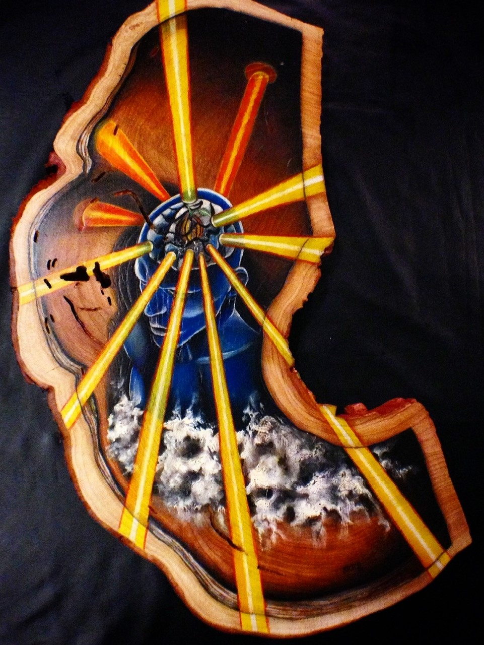
“Live for the summer”
PNW cedar
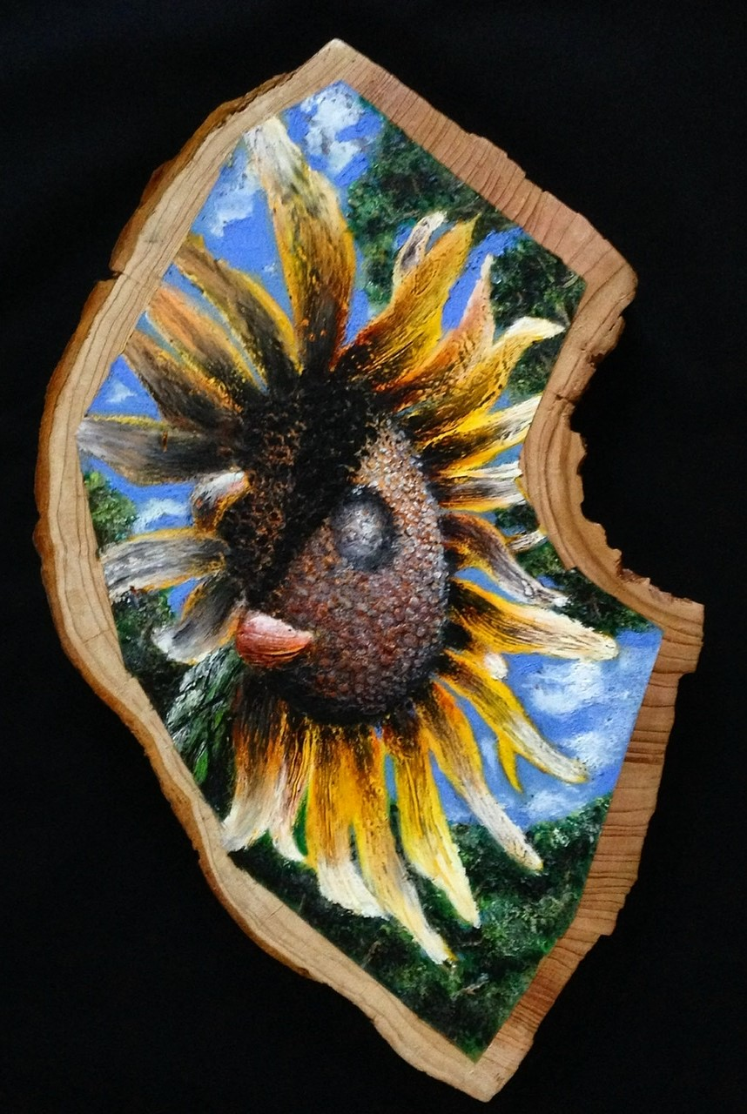
“Into the Light”
Black walnut
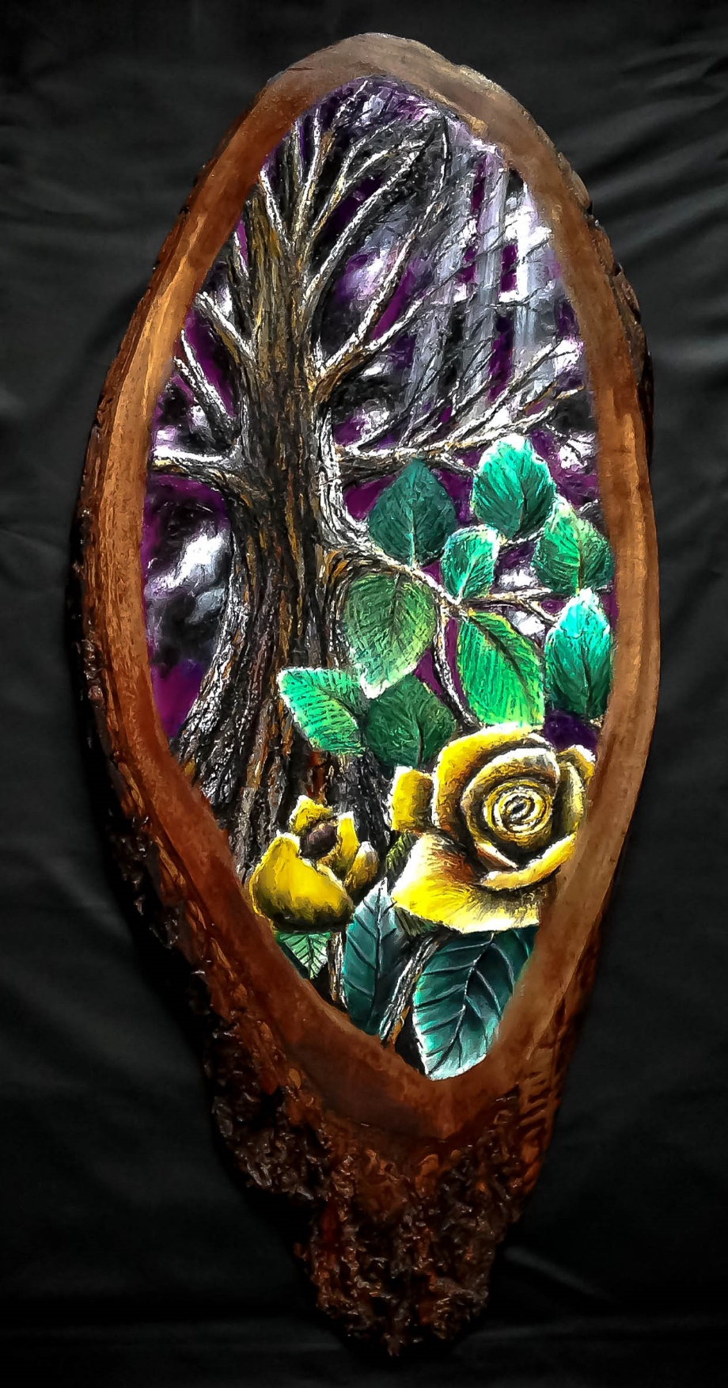
“The Hudson Dream”
PNW cedar
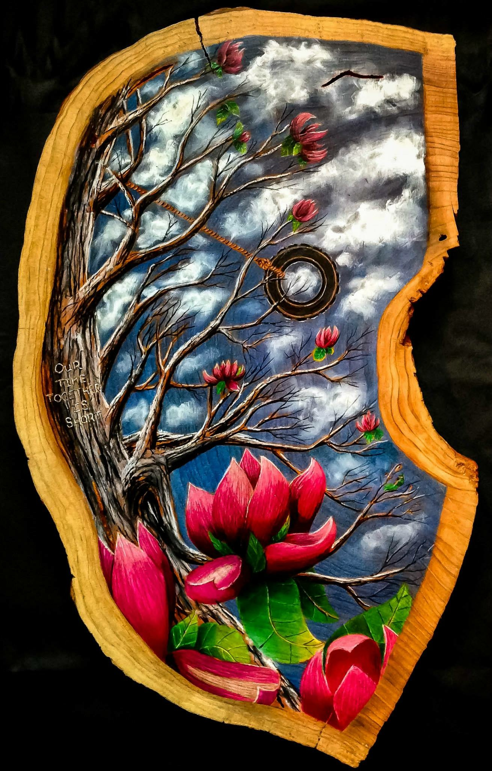

“The Burning Bush”
Black walnut
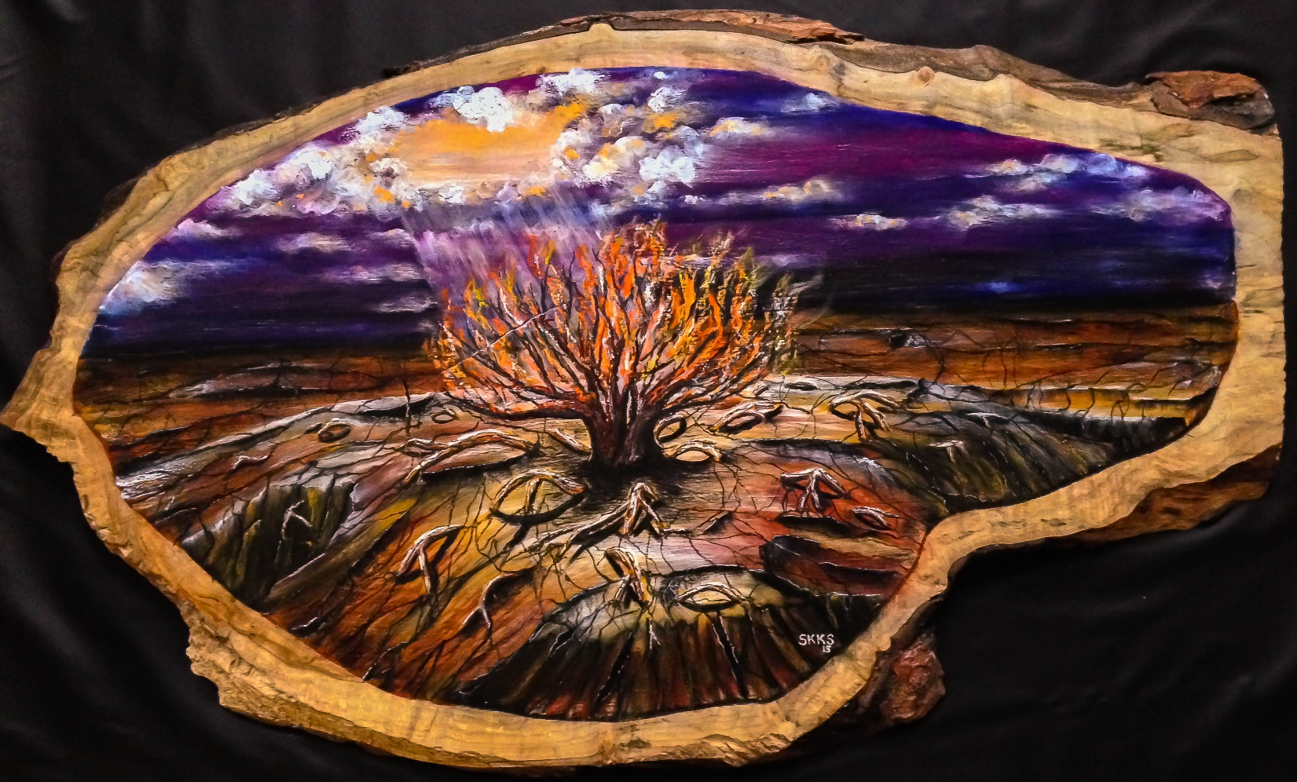

“The Nature of Love”
Chery
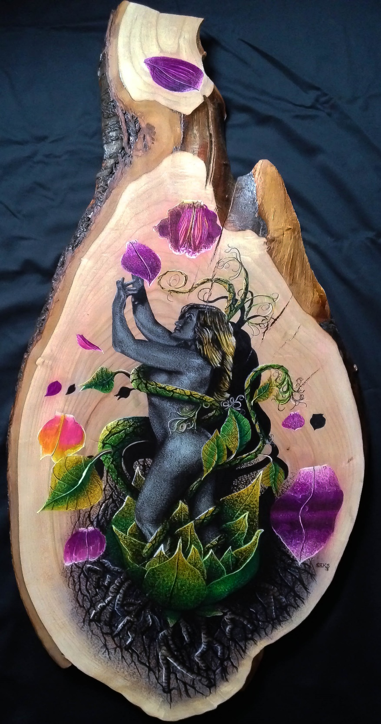

“For Lilly”
Big leaf maple
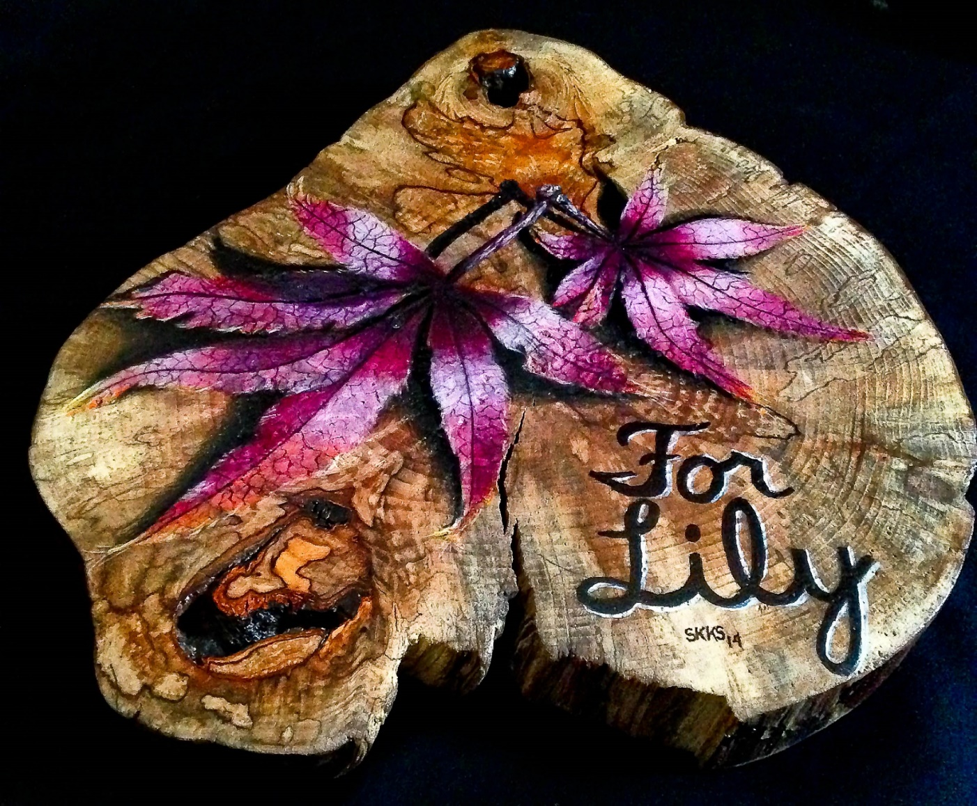

“Bravery”
Black walnut
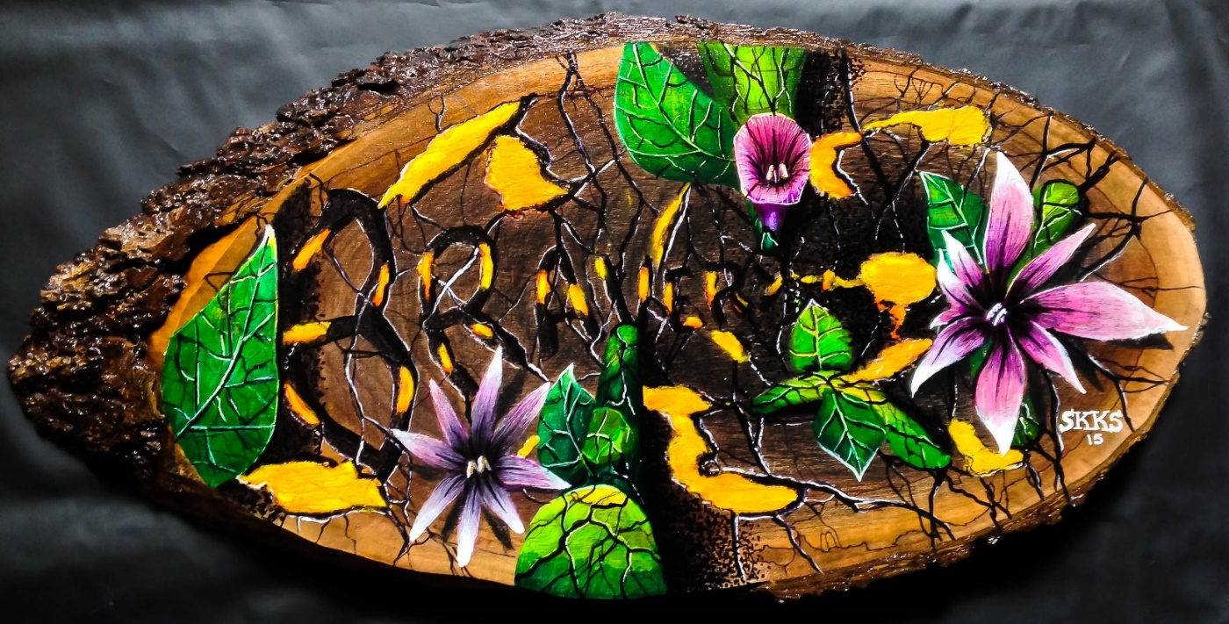

“Discovery”
Cherry
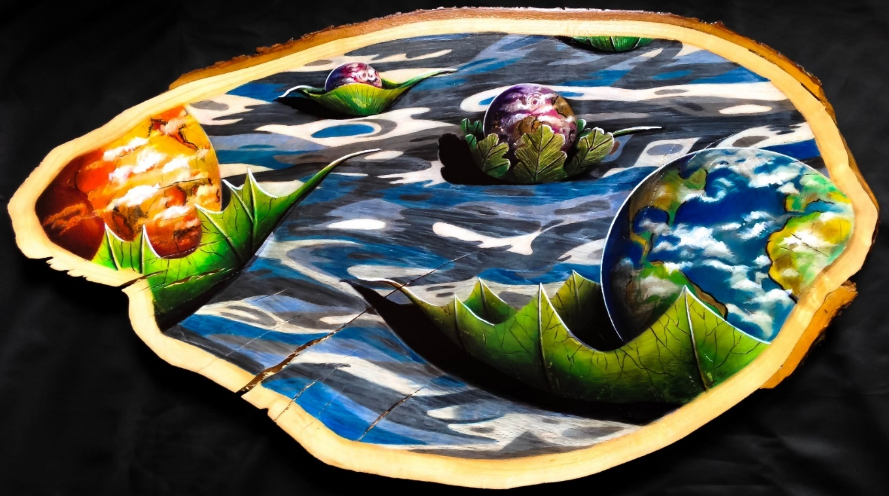

“Blackbird singing in the dead of night”
Big leaf maple
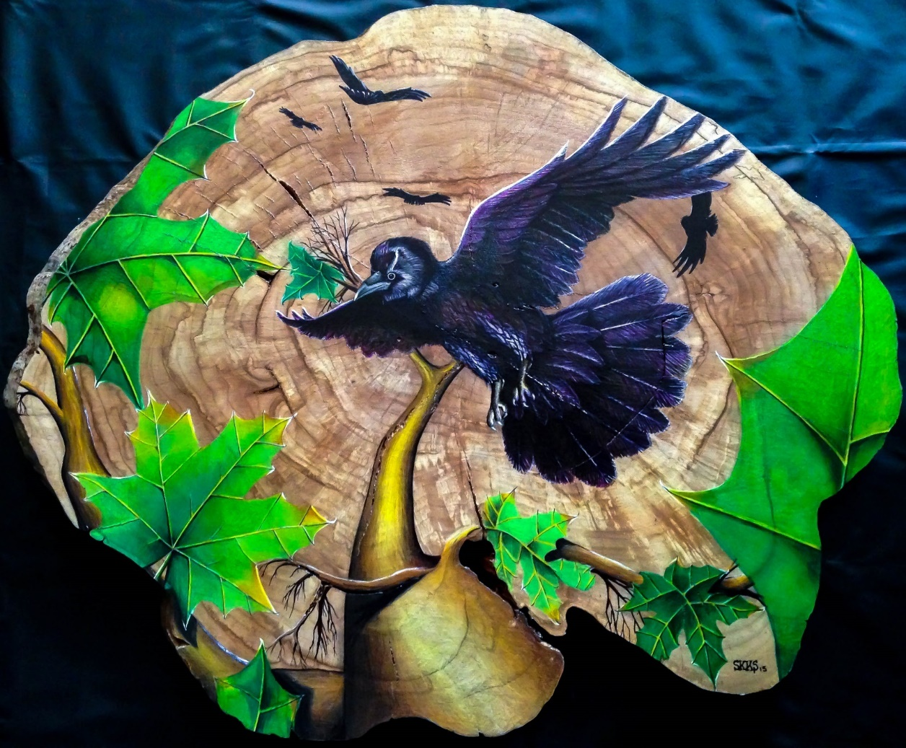

Throughout the last 12 years of creating no matter the condition (healing from surgeries), living situation (married or single), city of residence, type of art created, while traveling, or local business frequented, I would work on all types of art even these pieces of art on arbor in public. It is how I became known, and most of all a way to give positive energy back to an environment regardless of someone purchasing art or not. It is something I still do today.
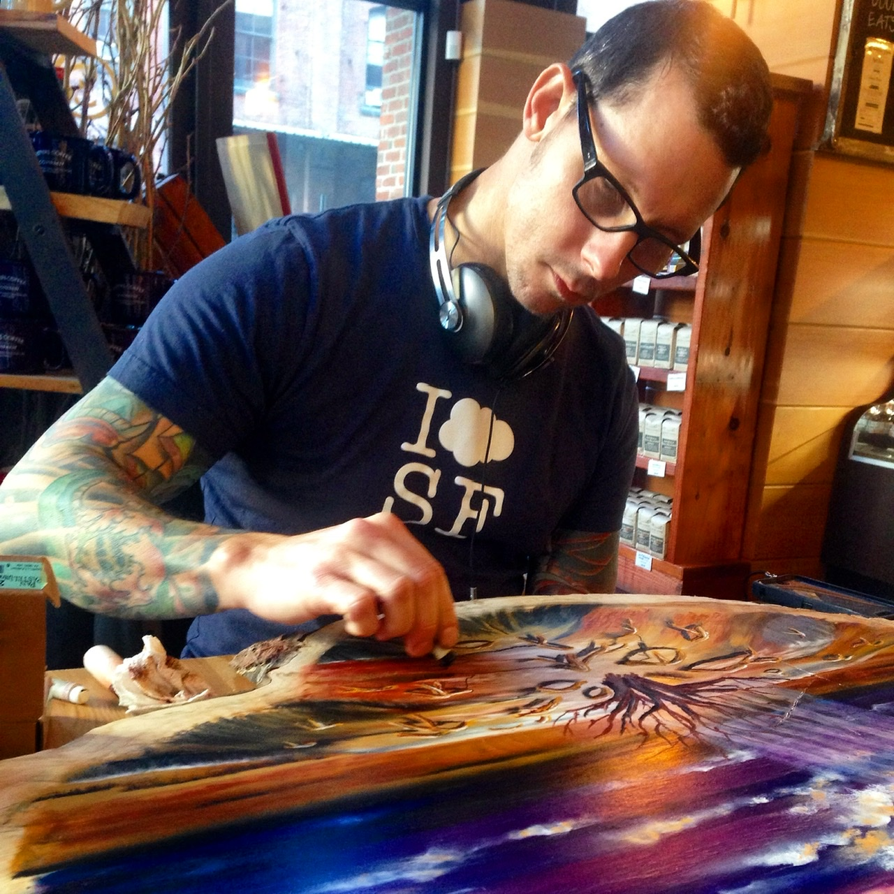

“Kill em with kindness”
PNW cedar
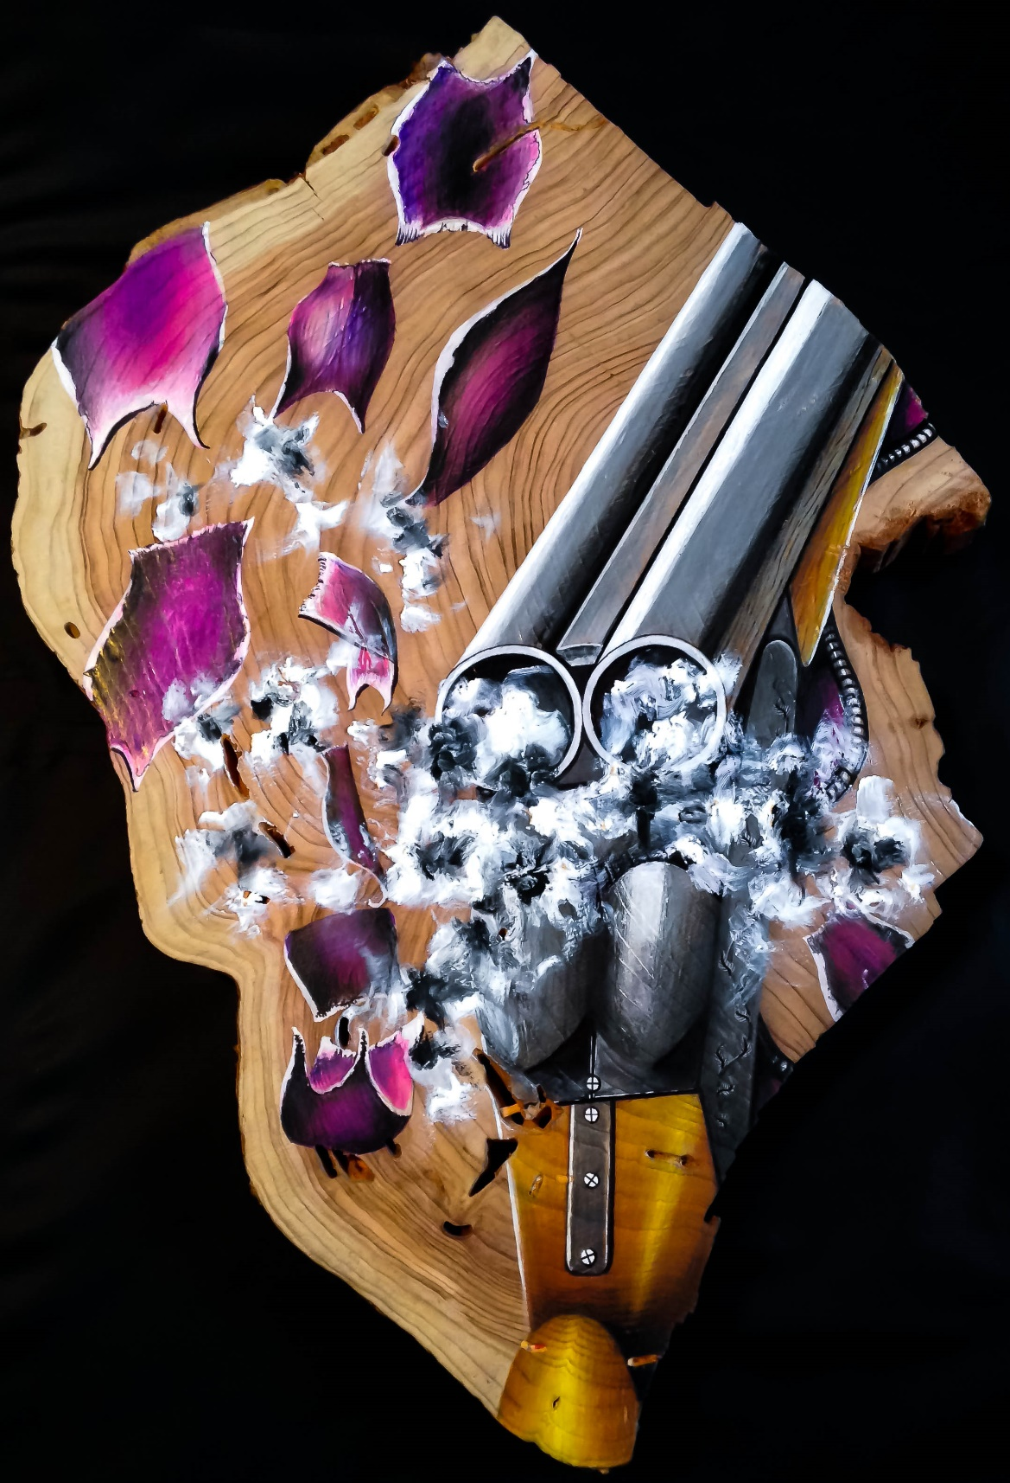

“What is your passion”
“Redwood”
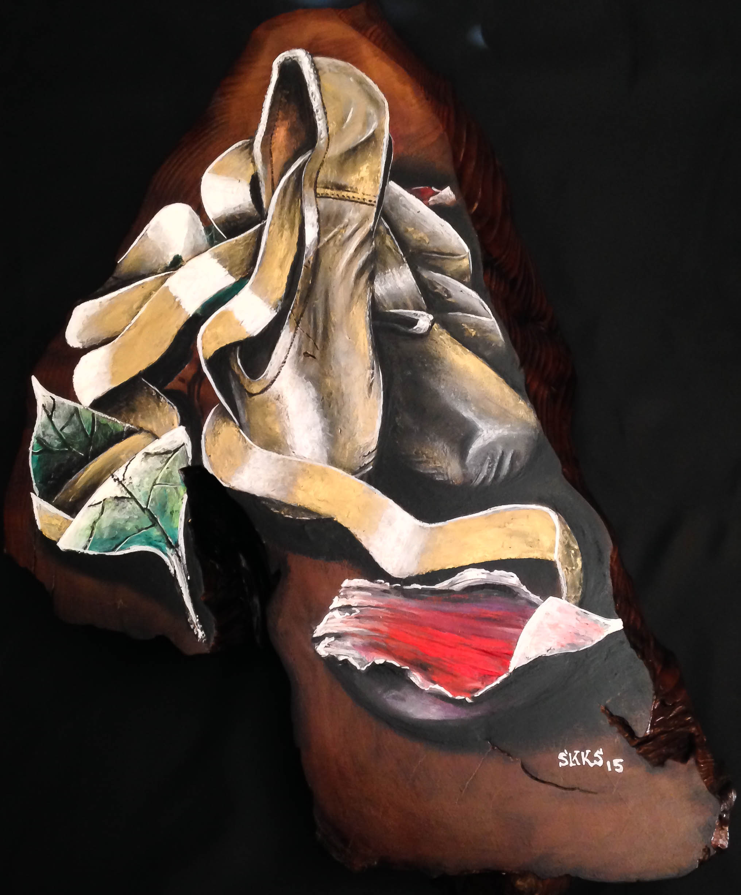

“A perfect pair”
Big leaf maple
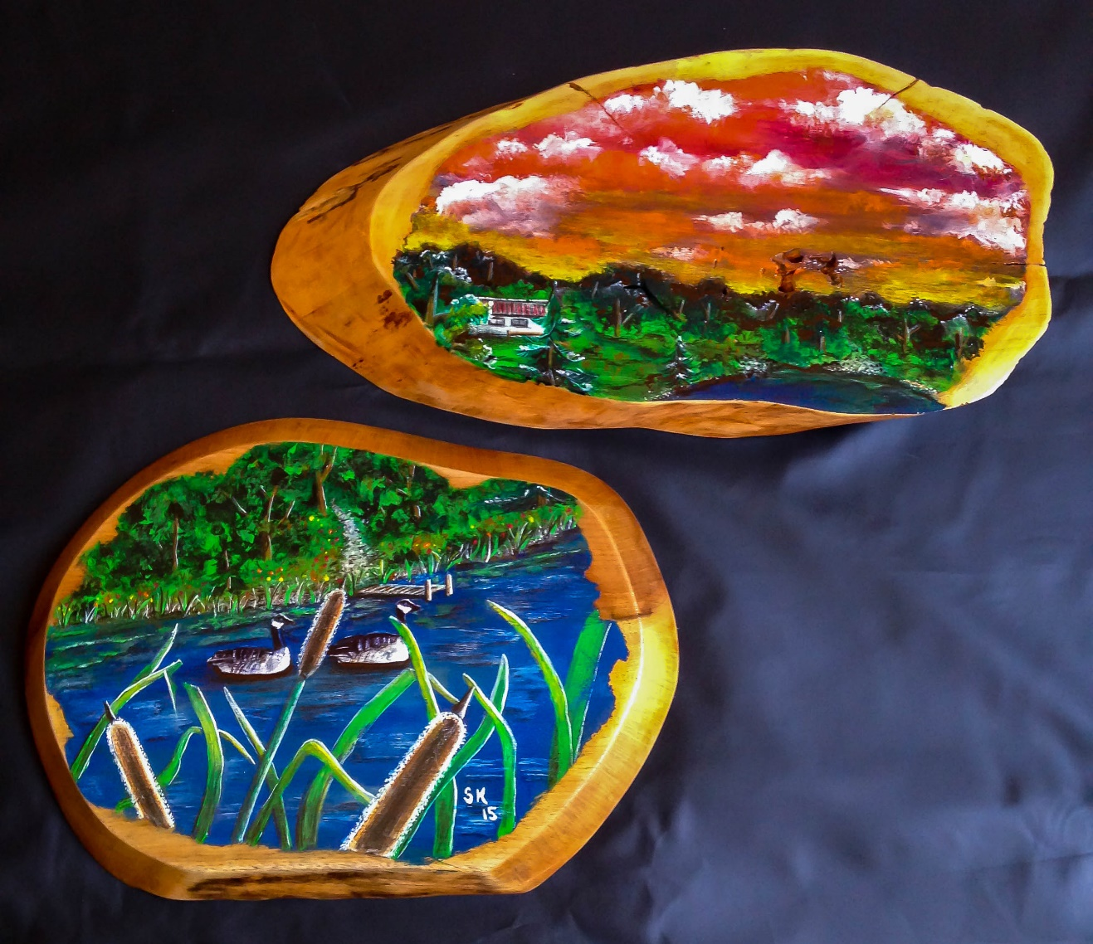

“Patience is rewarded”
PNW cedar
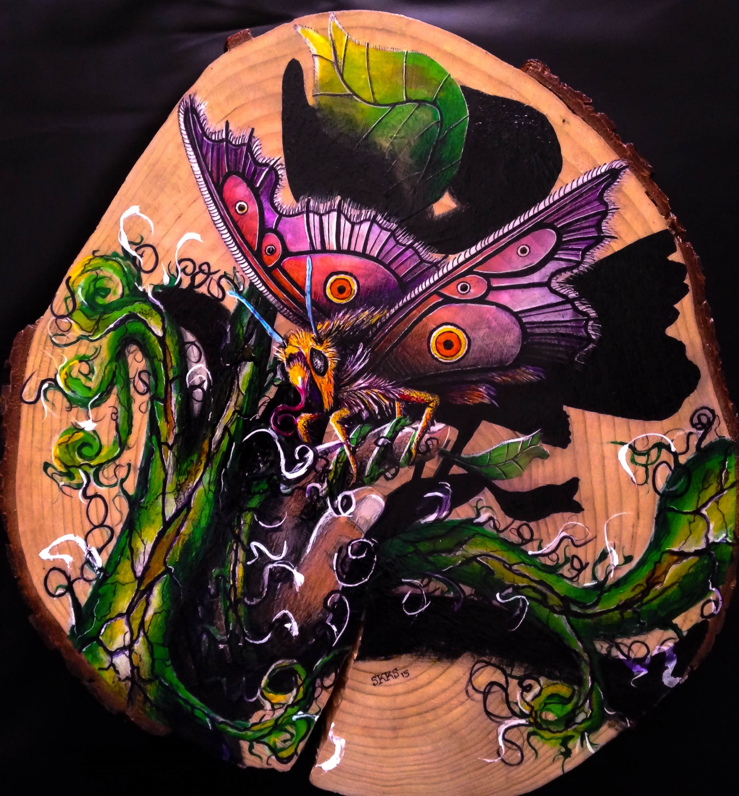

“Rooted Investing”
Black walnut
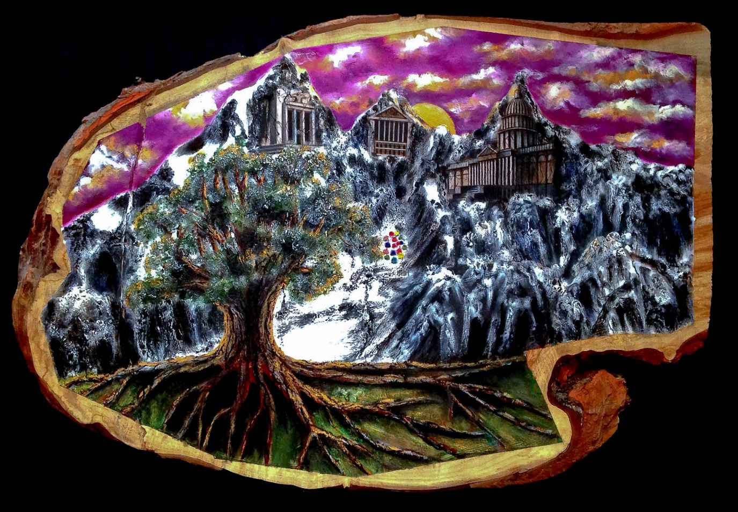

“Home is where the heart is”
Black walnut
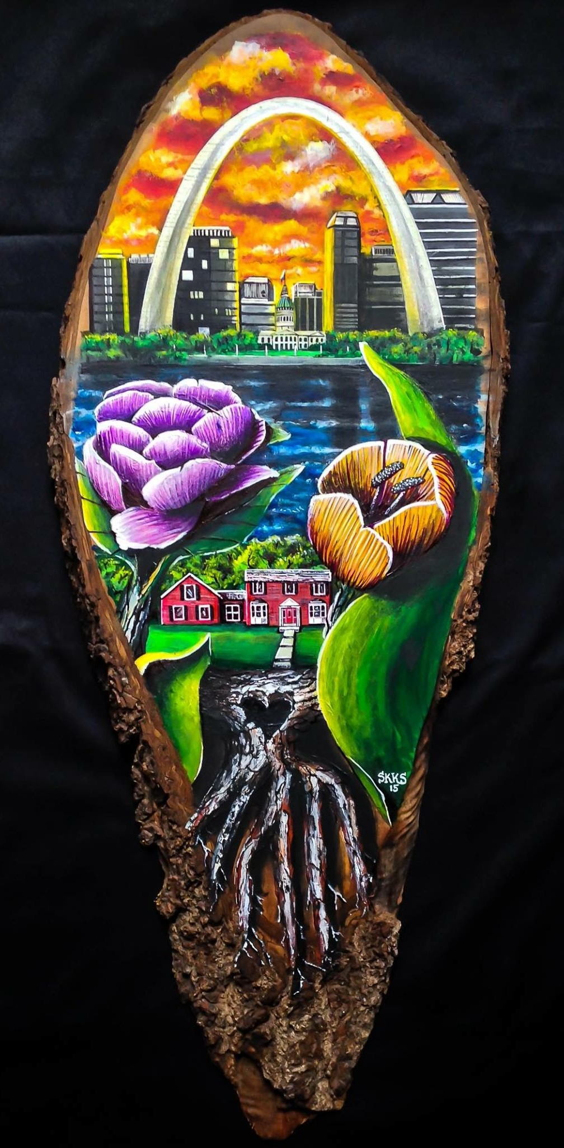

“Little man Conrad”
Birch
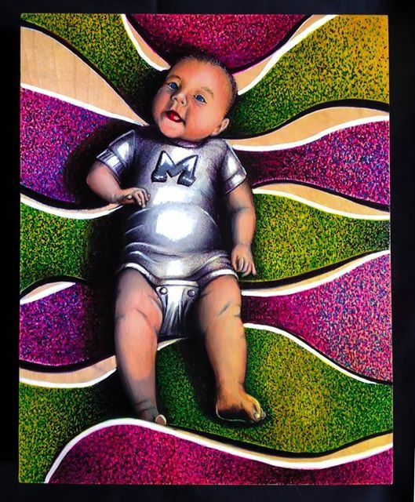

“The wild ride”
Black Walnut
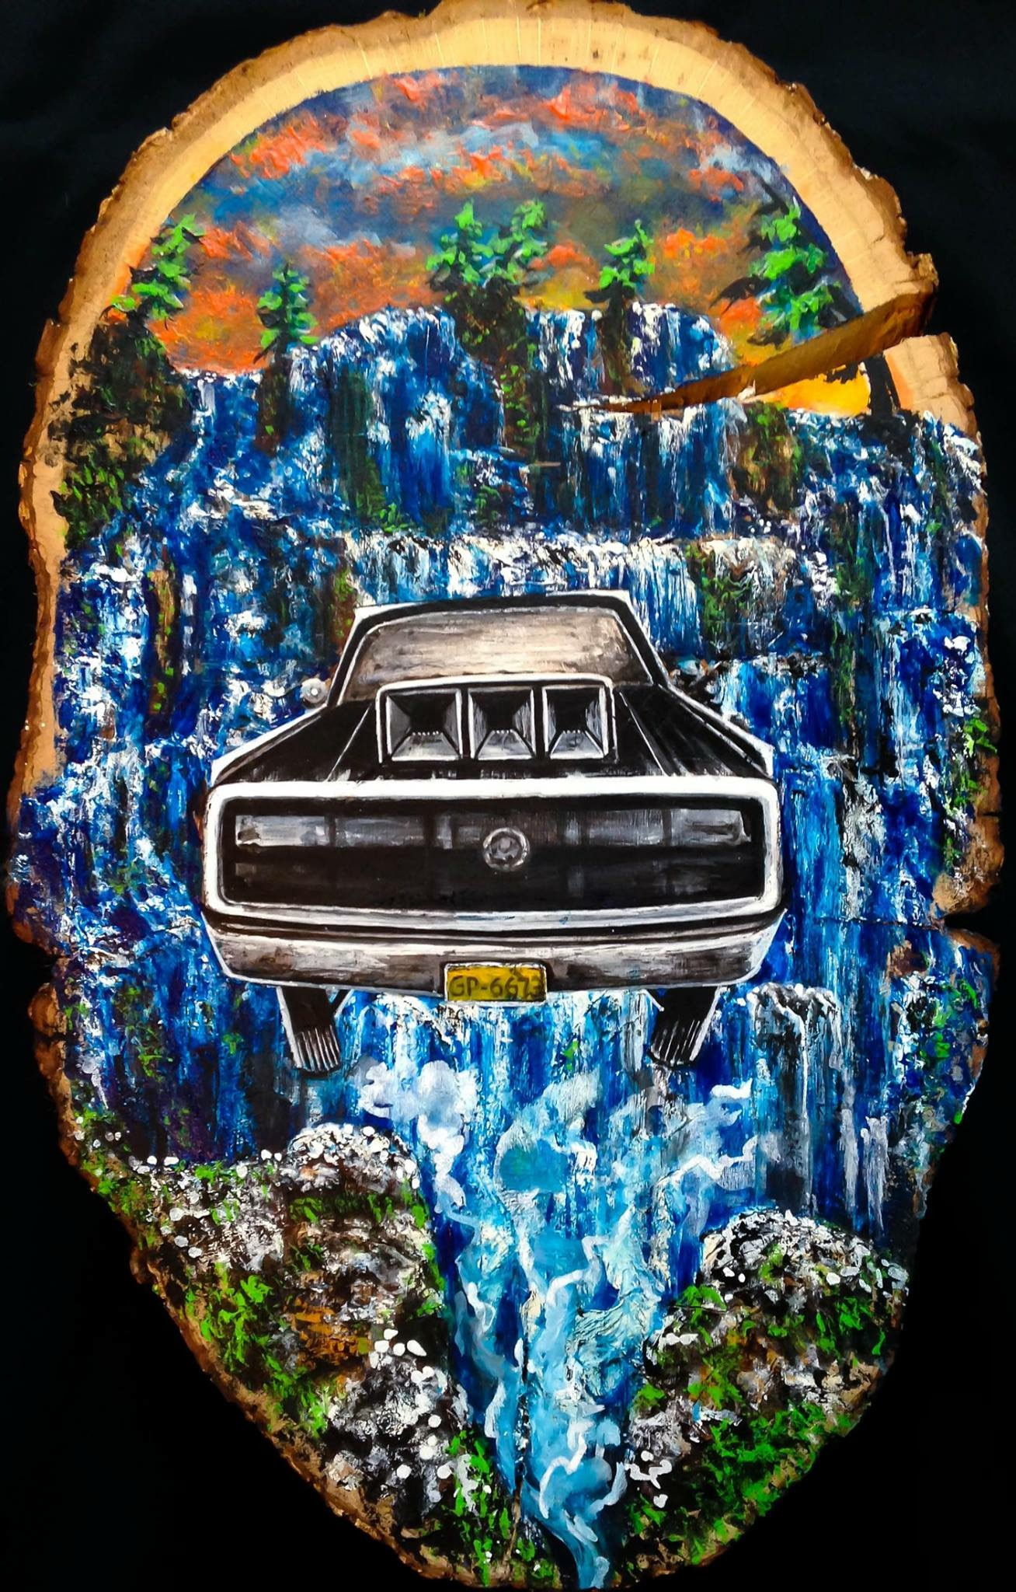

“The gift of life”
Western pine 2x4’s

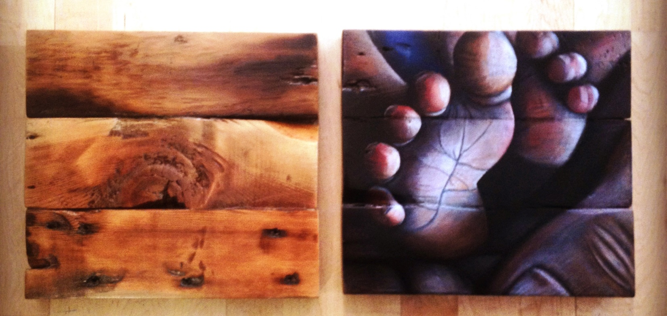

“Choose your own adventure”
Black walnut
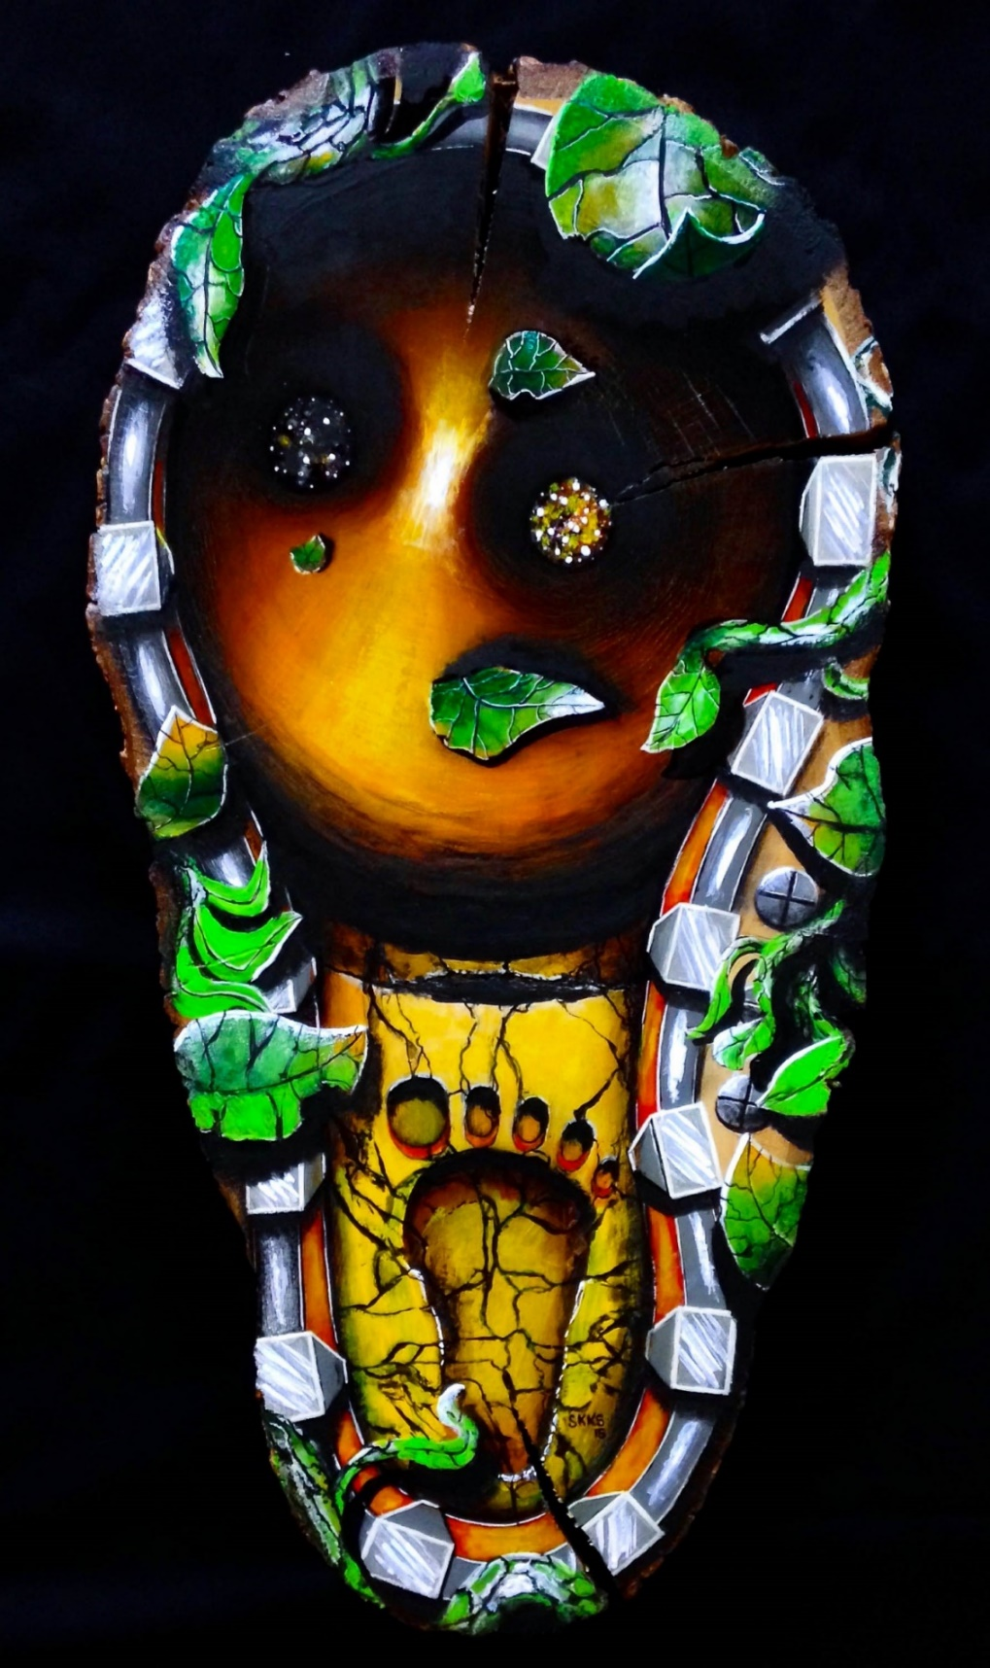

With every piece if it was for a commission or completely original, the process would start with an idea or a picture in my mind after meditation. Sometimes the idea would take a few days to completely materialize, then it was time to start. I am very thankful that every commissioned client gave me almost free reign on what the piece would look become.
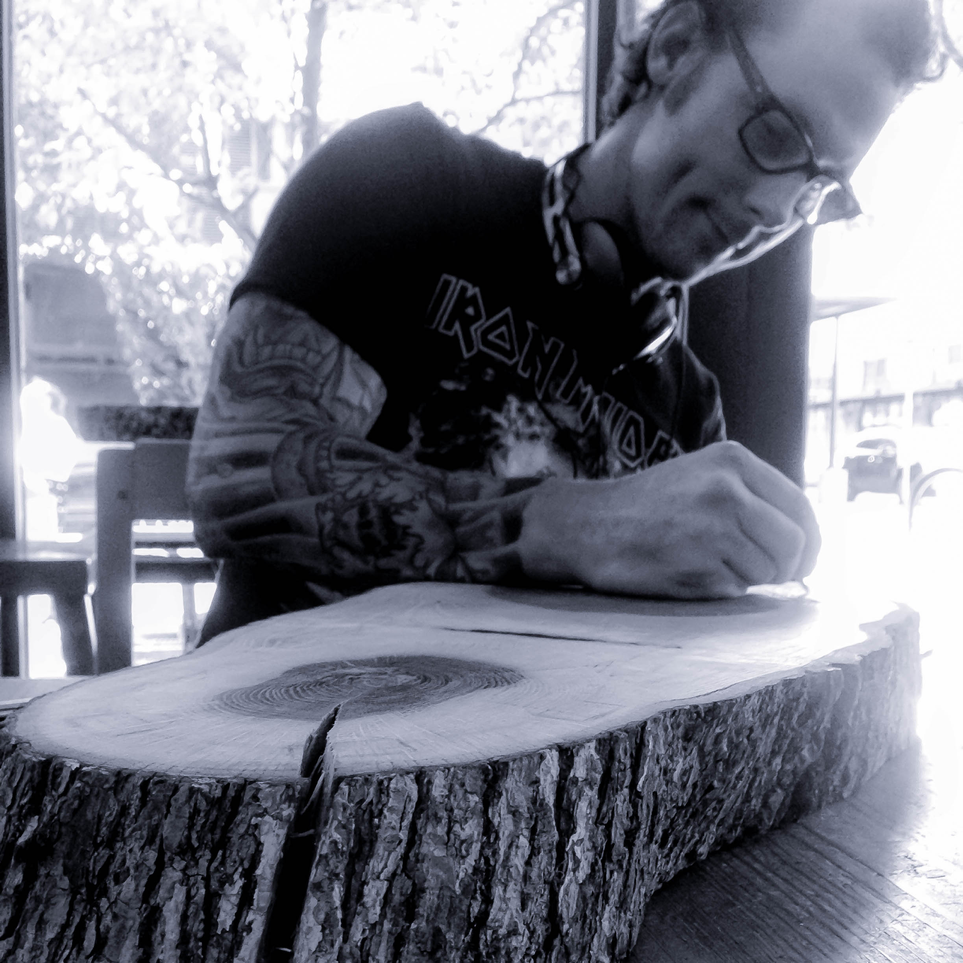

One of the best things about creating art is passing it along to someone else. The energy put into an art piece cannot remain stagnant, and it has always felt like it is time to pass it on when completed. This has been a core value through the entire 12 years and remains to this day. I have created over 600 originals and given at least half of them away in the process. The icing on the cake is when a client or recipient of an art piece thanks you with a picture or letter since it doesn’t happen as much as you might think.
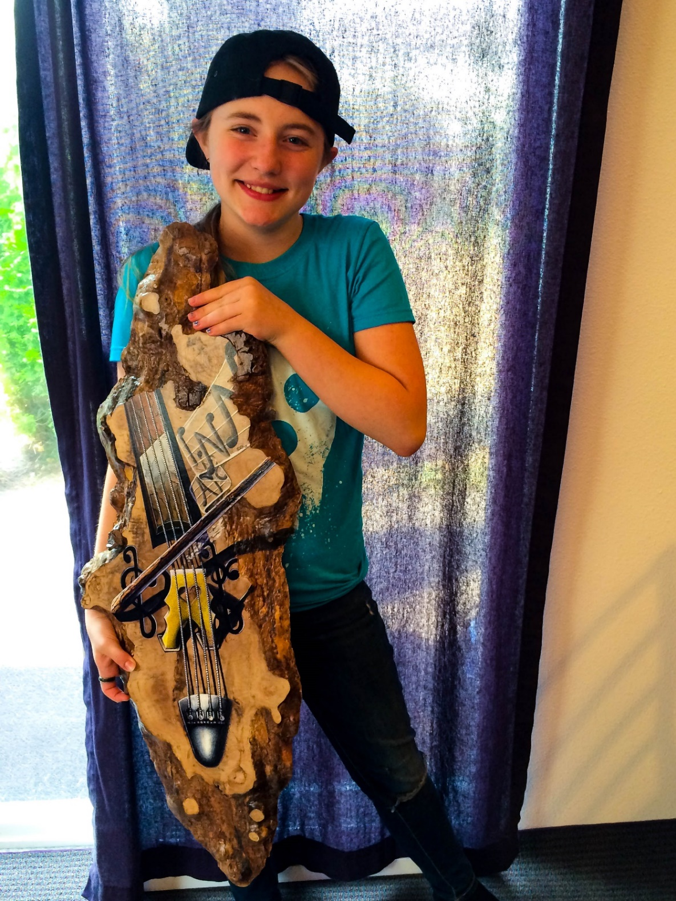
“Music for Aislinn”
Big leaf maple burl
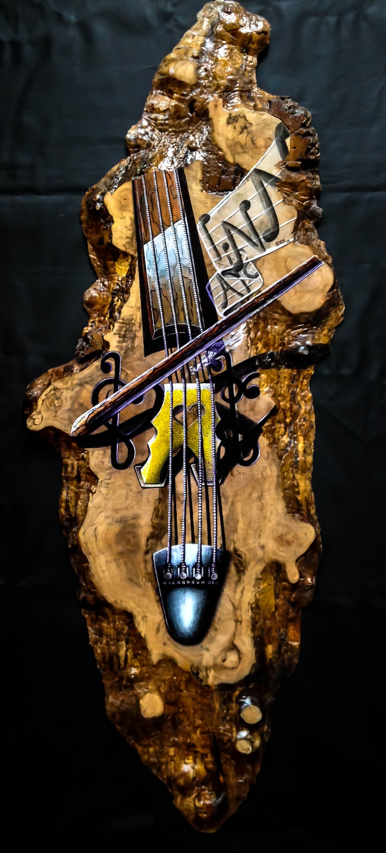

“Seek and you shall find”
Black walnut
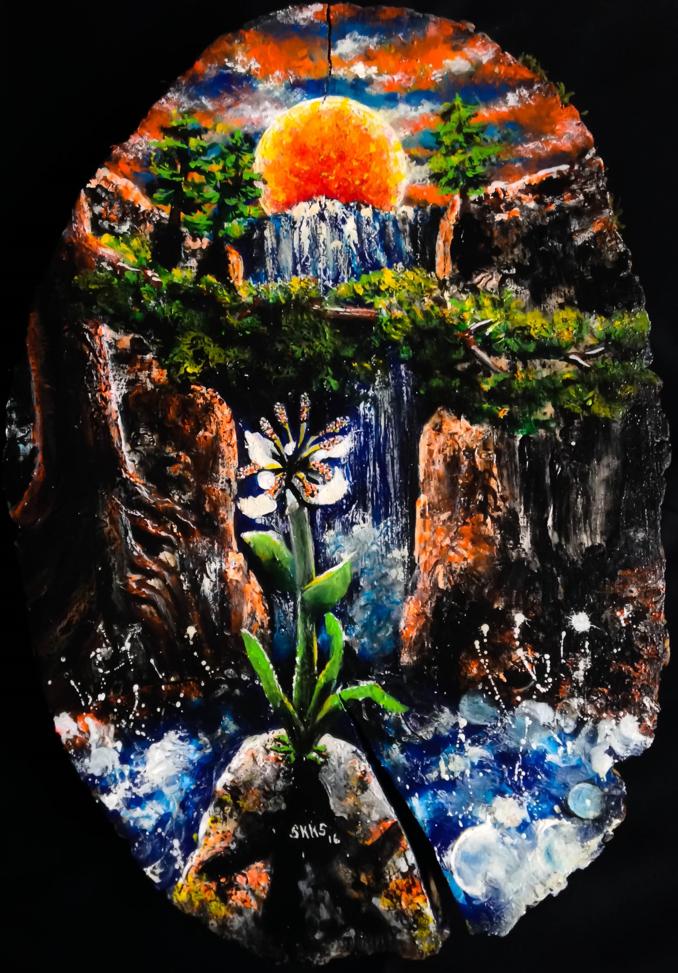

“Growth
Poplar
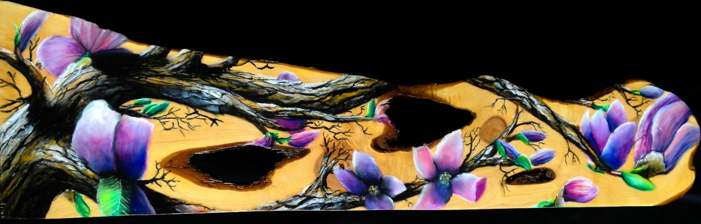
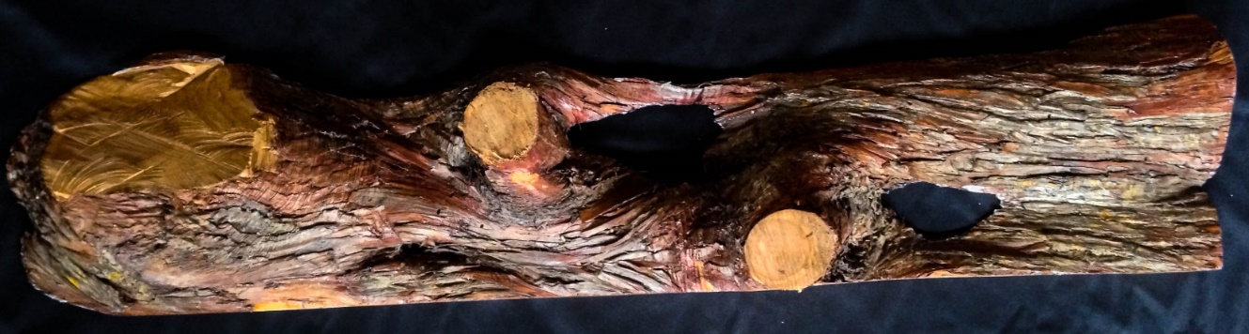
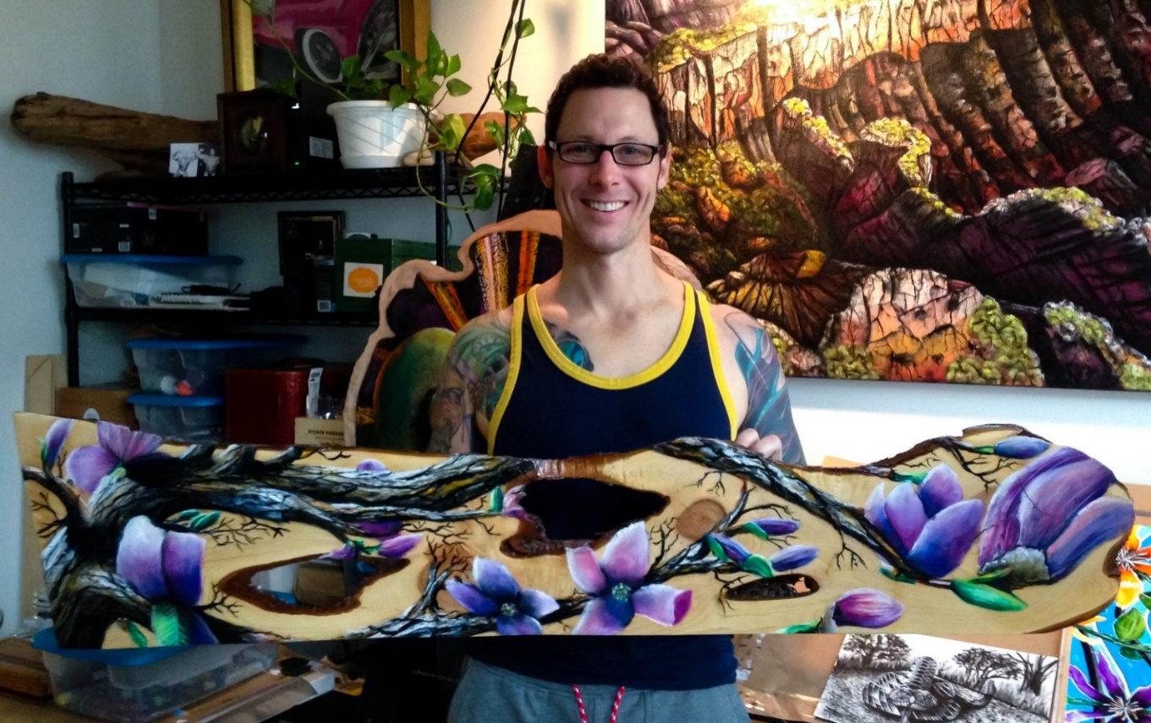

“Your future builds upon past experiences”
Big leaf maple
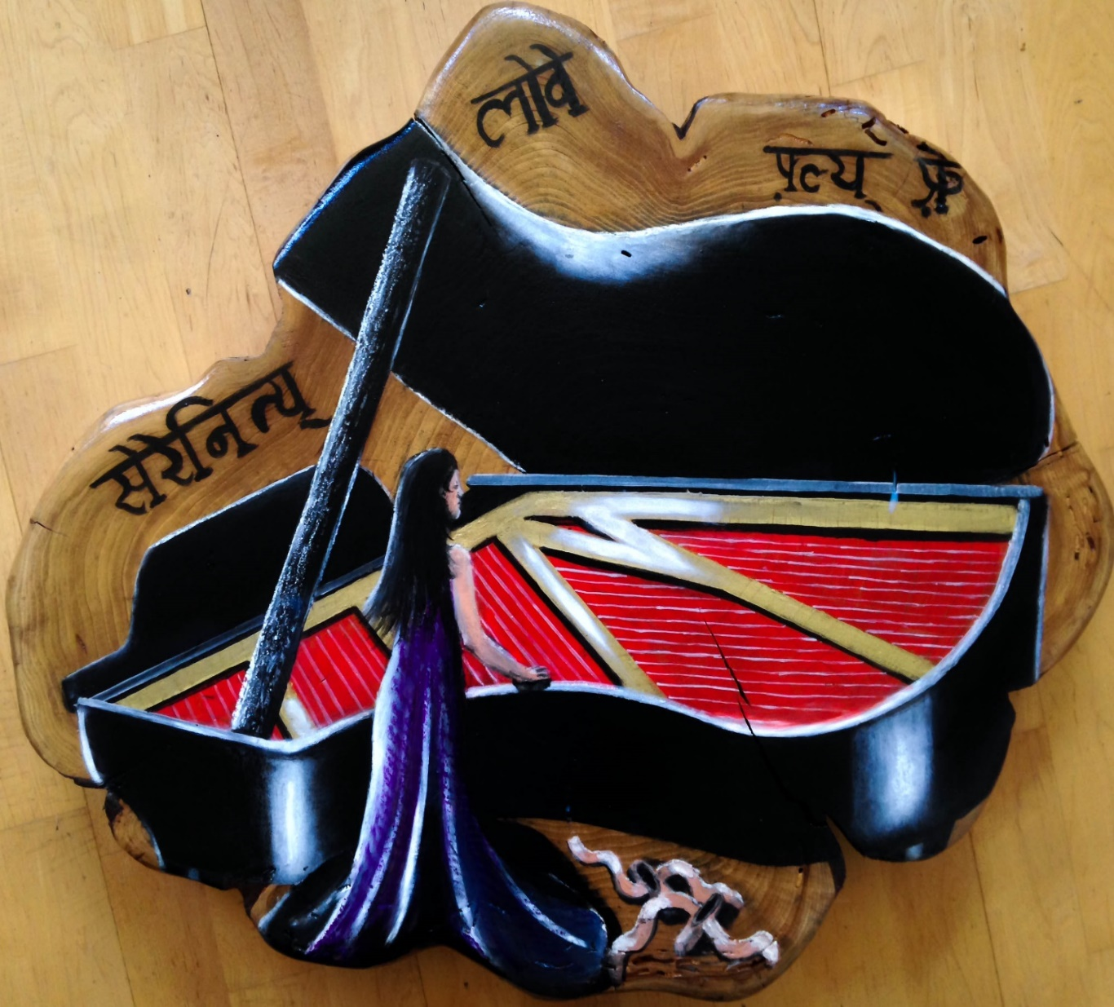

“The California beer bears”
Black Walnut
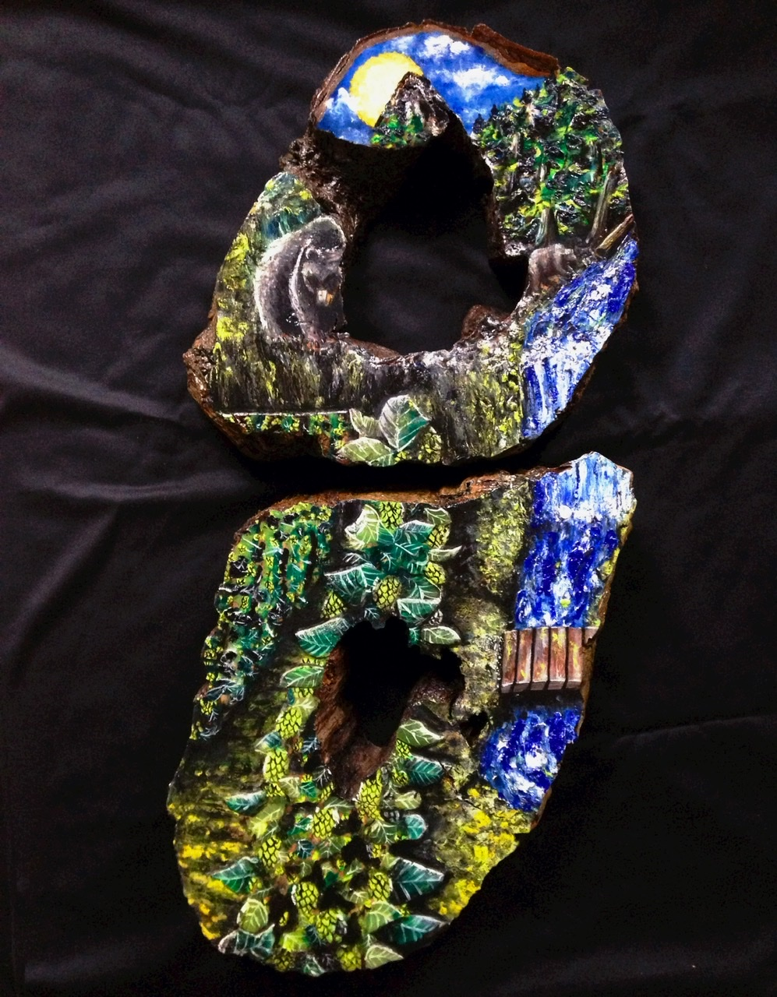

“Take back your time”
Black Walnut
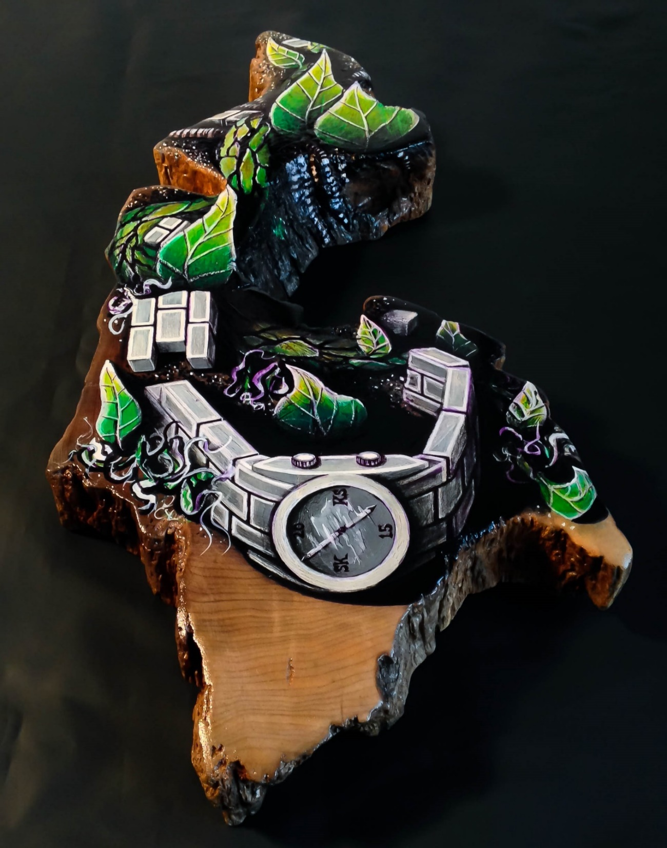

“Time is a thief.” If you belief… What I have found being creative every day for the last 12 years if it is through art, cooking, singing, dancing, building furniture, writing or playing music the more you do this the more authentic and original one will become. Time doesn’t seem so harsh anymore as well, and you begin to look forward everyday to the endless possibilities we have. Abundance starts to happen.
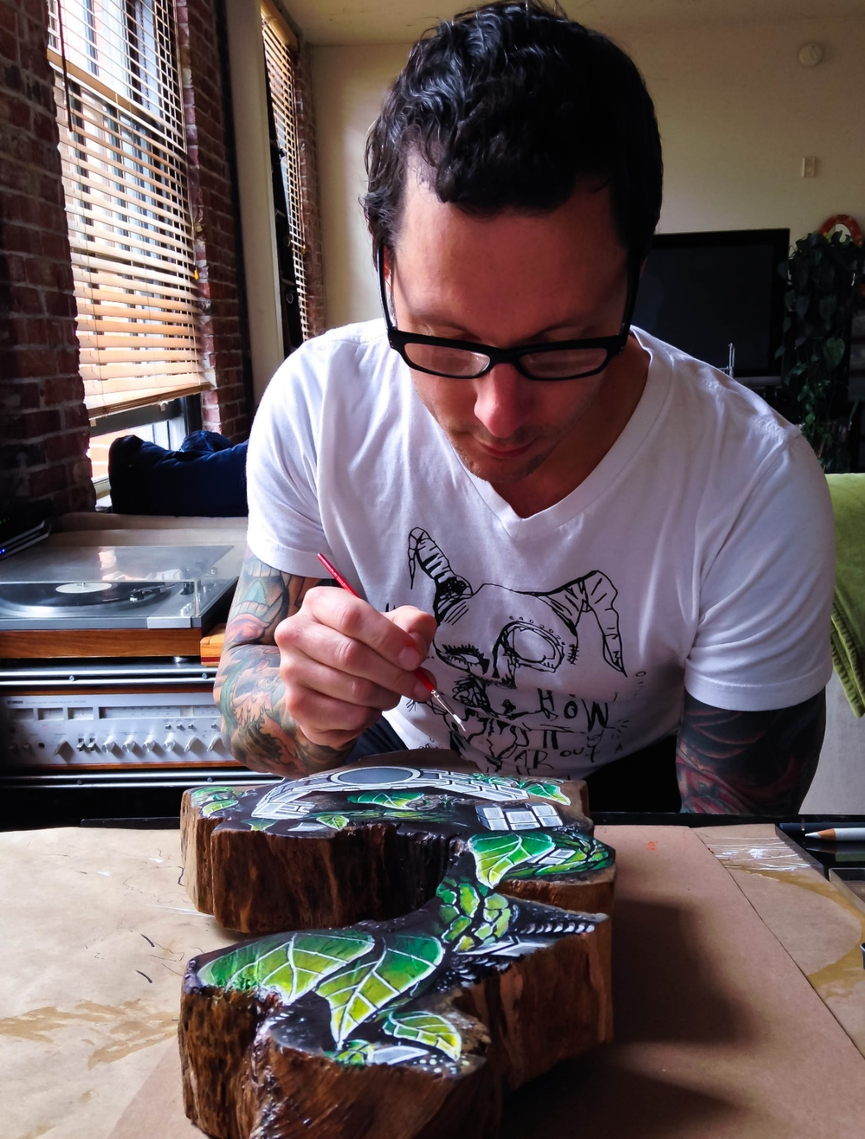

“Fish on”
Black walnut
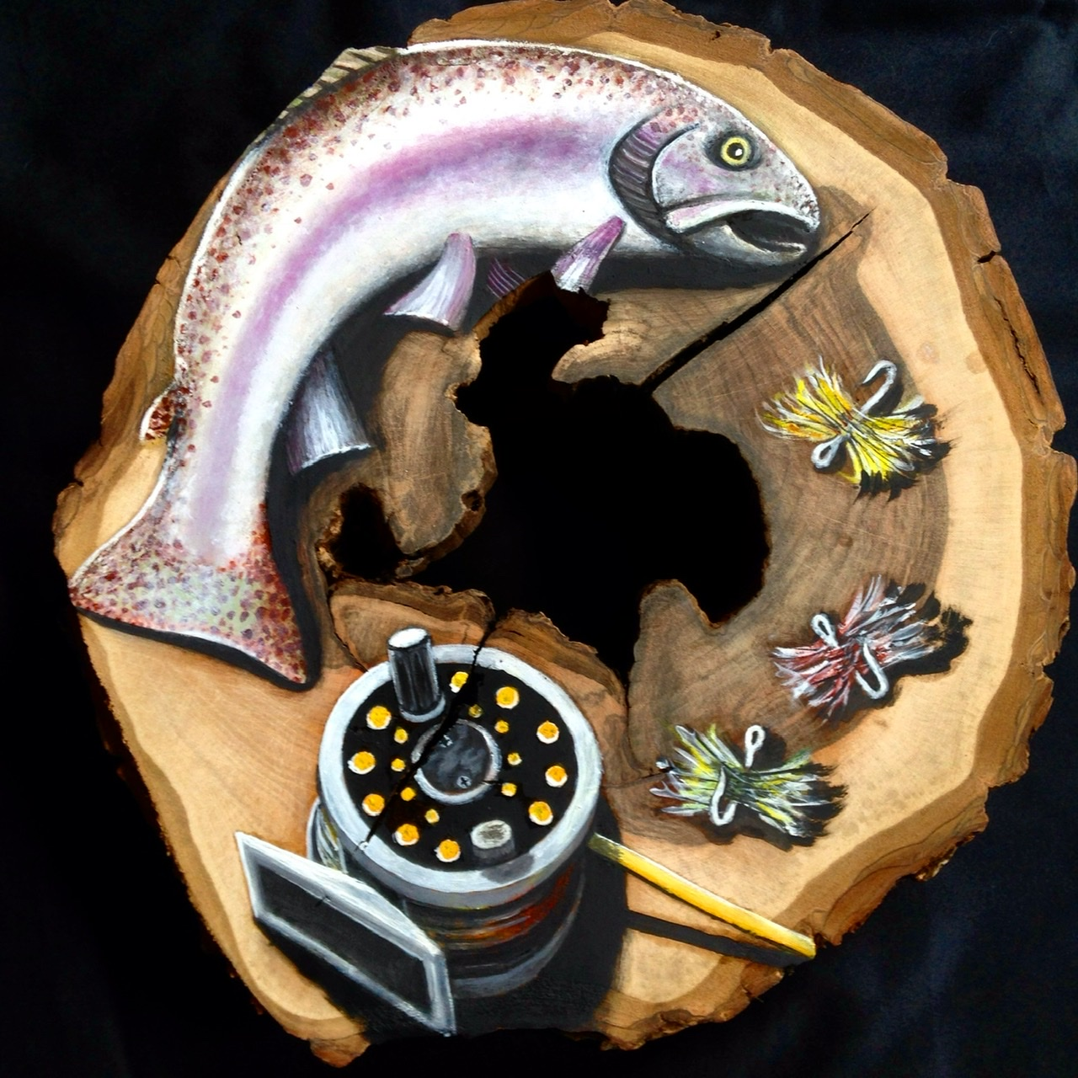

“We’ve finally arrived”
Big leaf maple
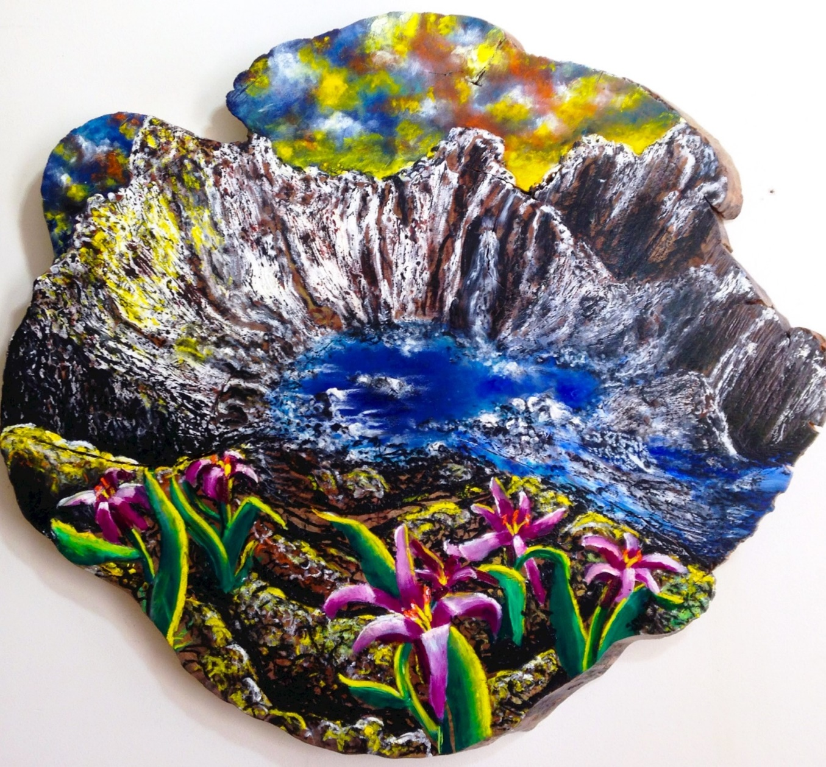

“Chance Encounters”
Big Leaf maple
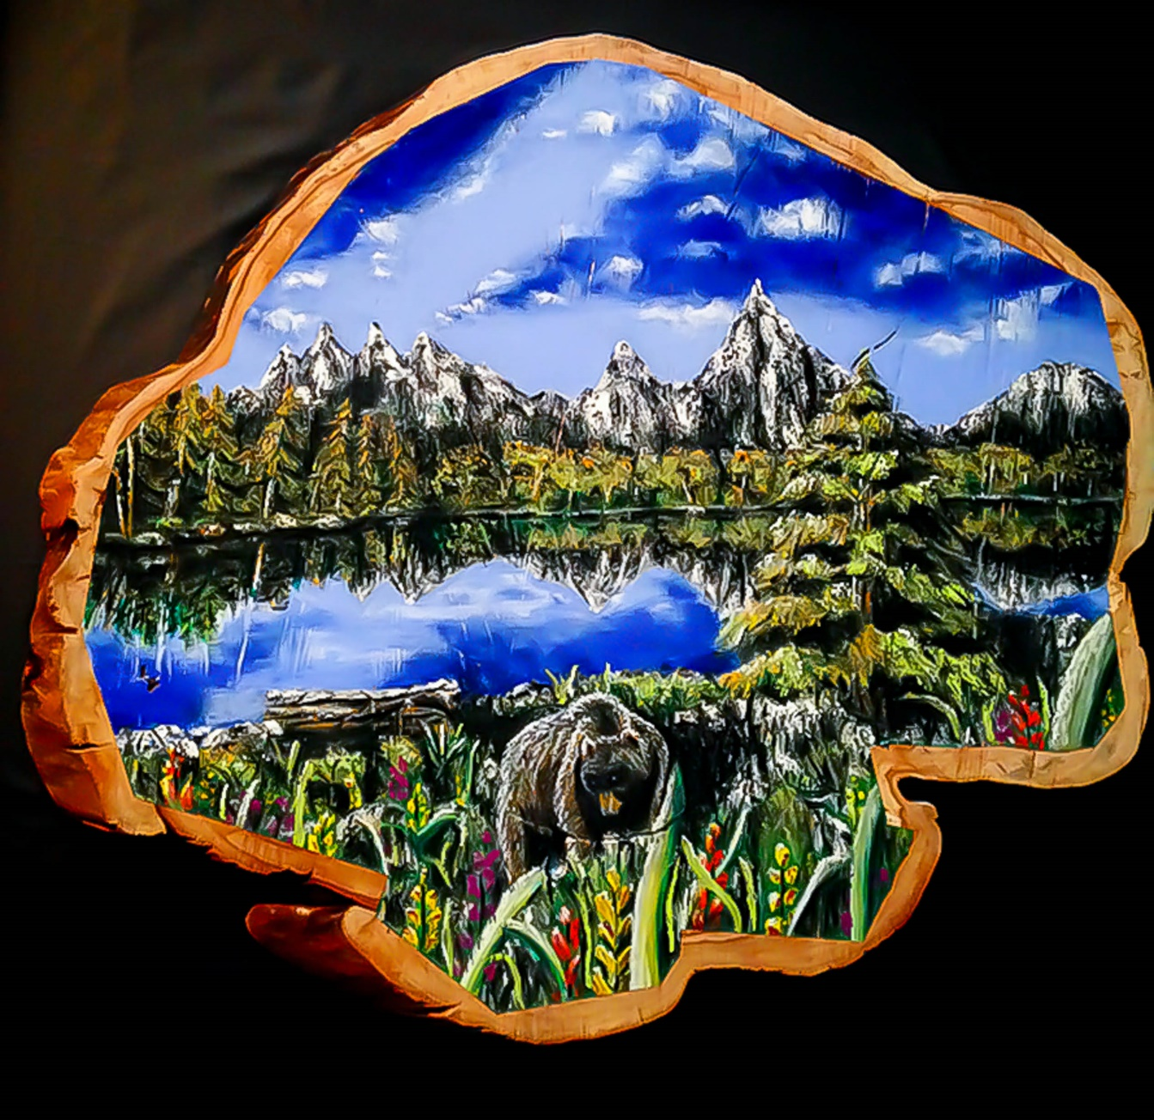

“Moon Goddess”
PNW cedar
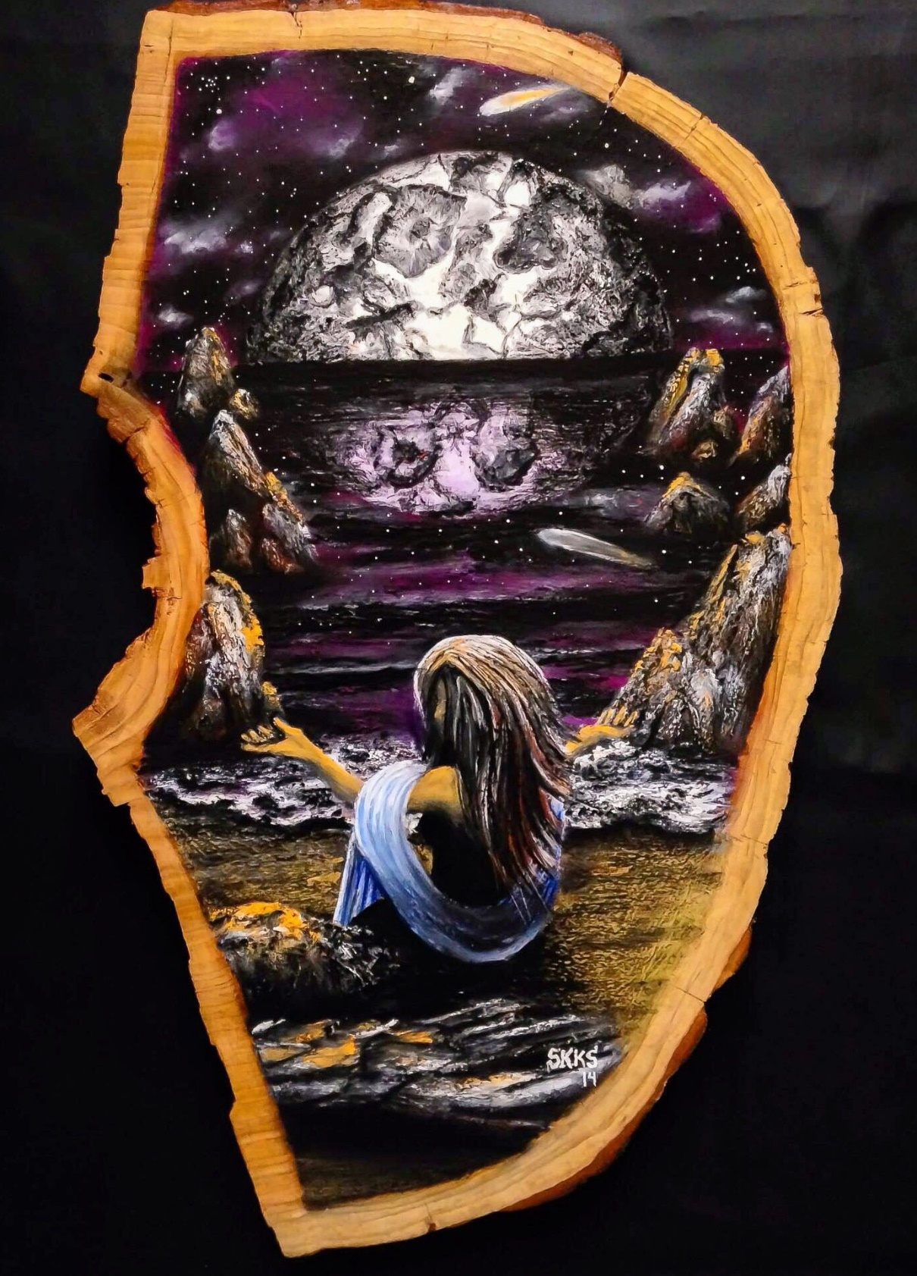

“Music makes the world go around”
Big leaf maple burl
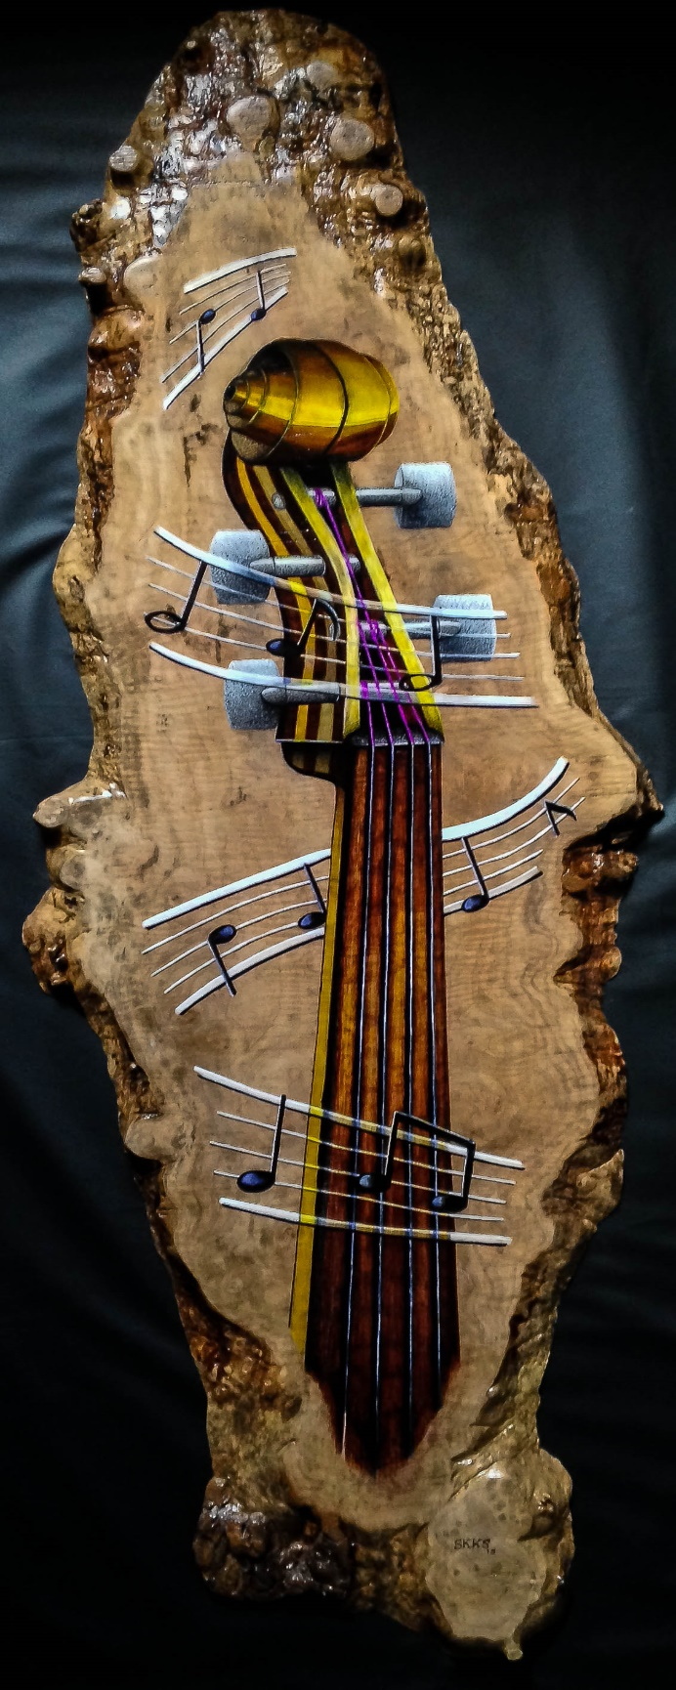

“Bosco and the crabby patty”
Big leaf maple
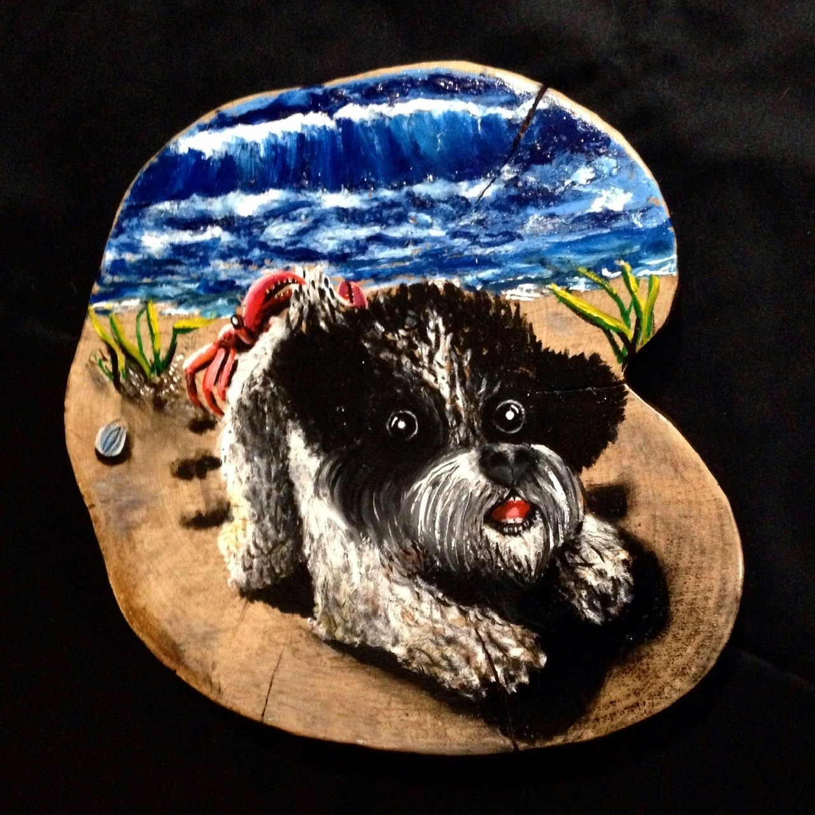

“Wolf and Hawk, an unlikely pair”
Poplar
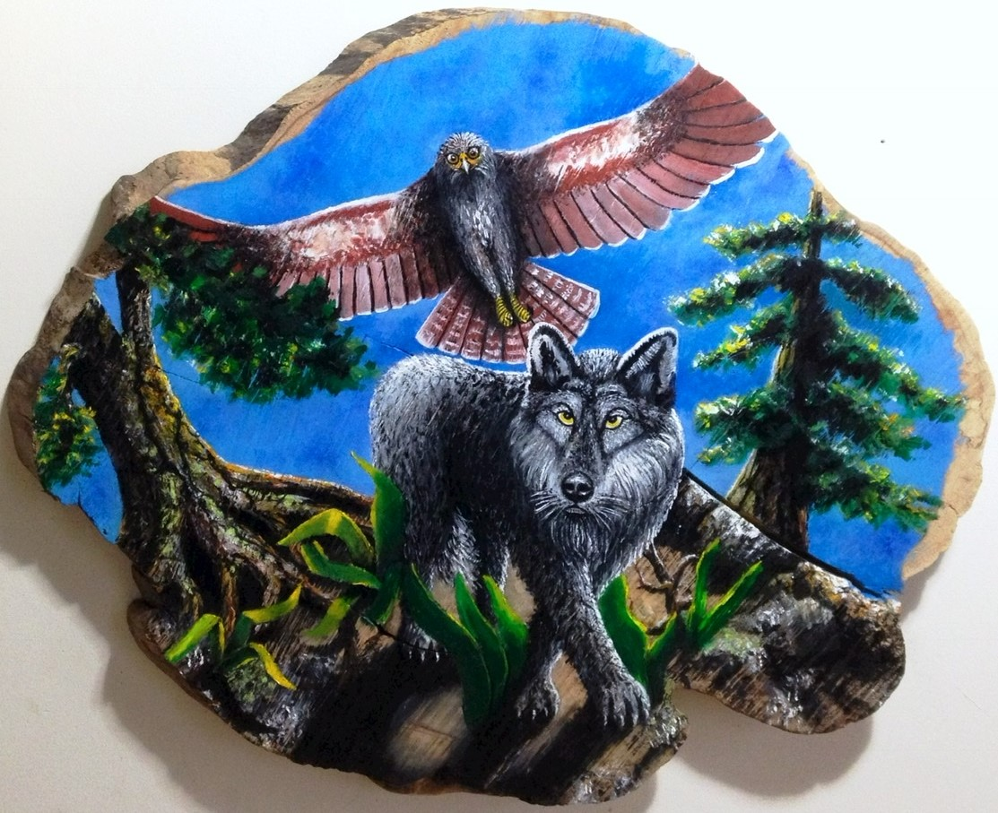

“For Freya, a sapling is born”
Black walnut
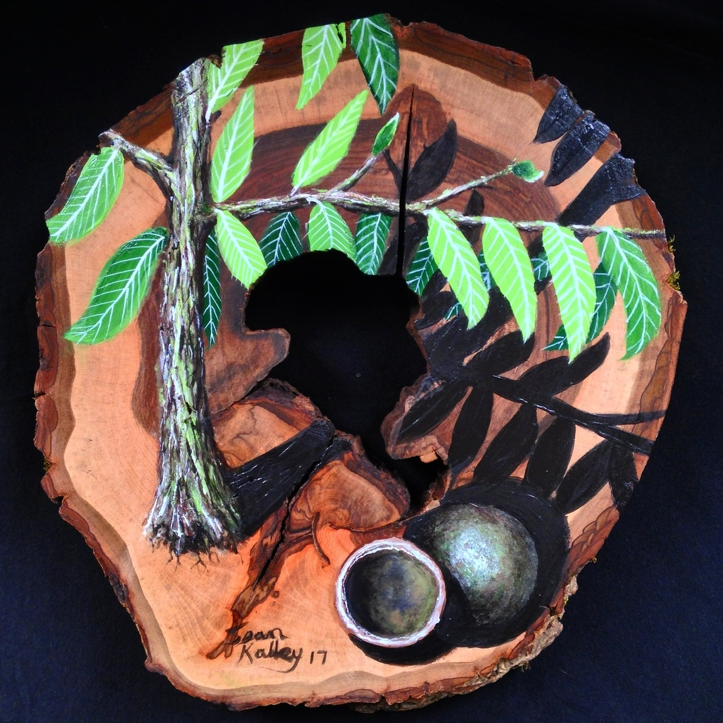

“Arsenal Fanatic”
Pine wood scraps
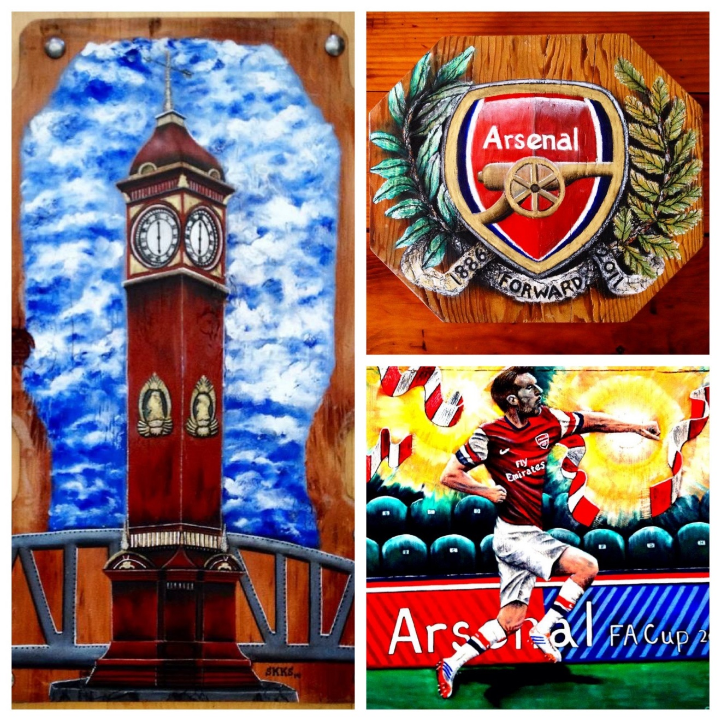

“Ellie, 2 become 3” lily of the valley
Western pine
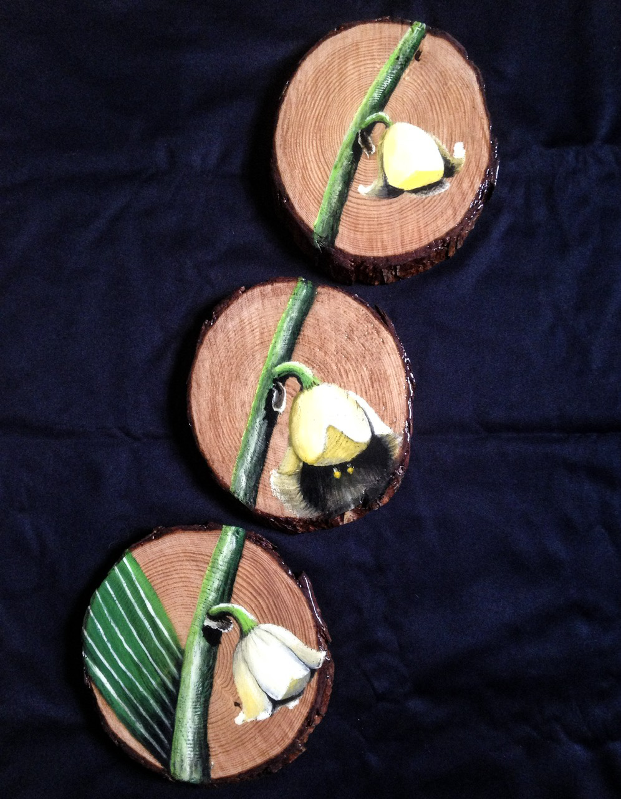

Most of the time the rounds or cross sections would be cured, yet unfinished. In the beginning I would sand them for hours by myself until realizing how much harder this was to do then on plank boards. This is the densest part of the tree, so it would take 5 times as long to achieve a relatively smooth evenly flat surface. Then after quite a bit of looking I found a place in Portland called “Creative Woodworking” that had a huge CNC machine. It was worth the extra cost and completed the task in minimal time.
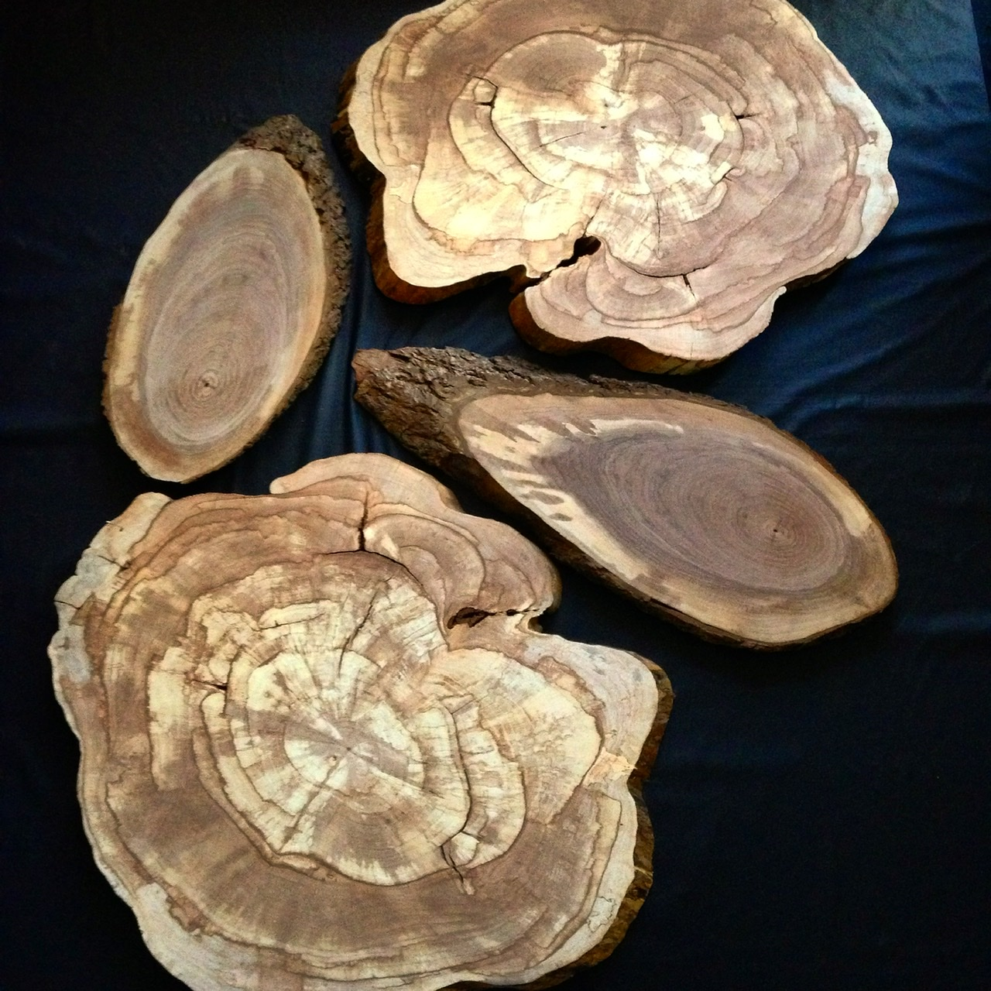

“Breakthrough”
PNW pine handmade frame
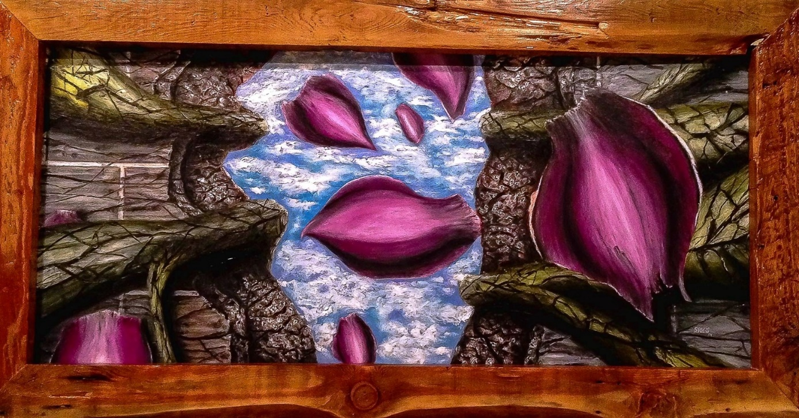

“Black Hole Sun”
PNW pine
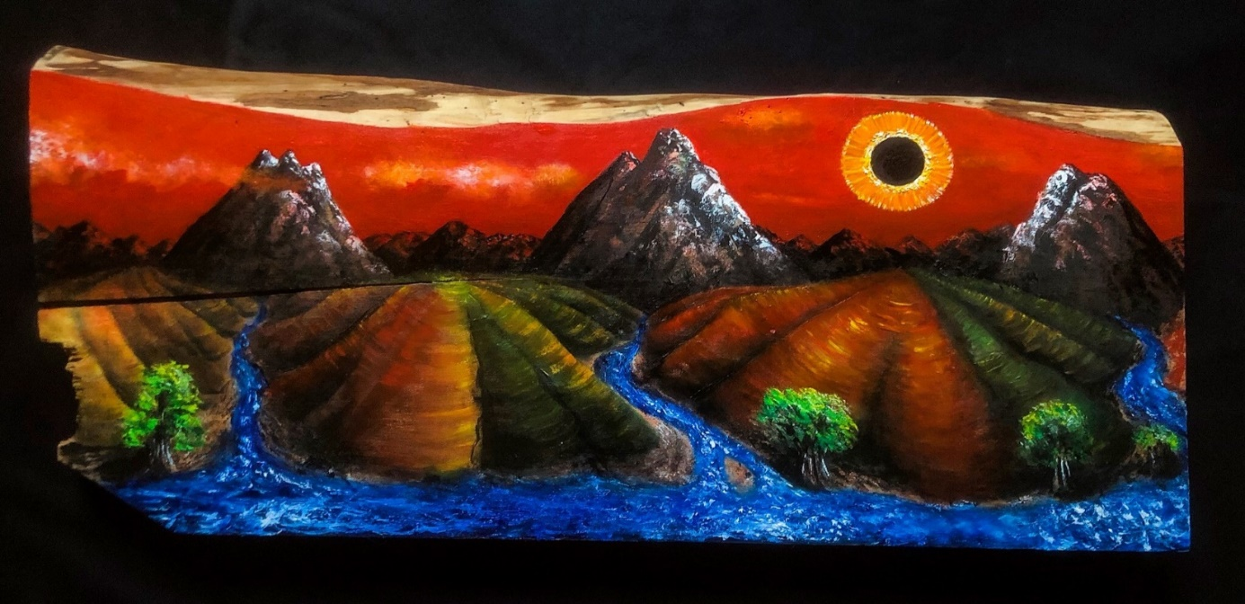

“The heart of nature”
Western pine 2x4’s
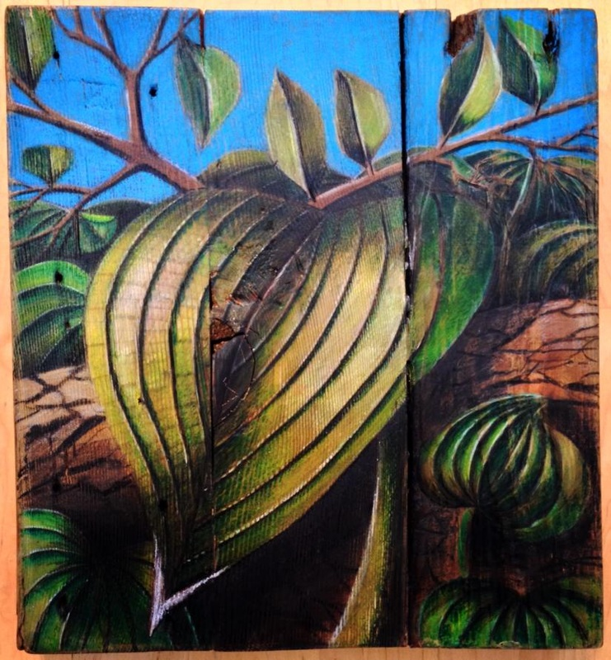

“Nice Kitty”
Black walnut
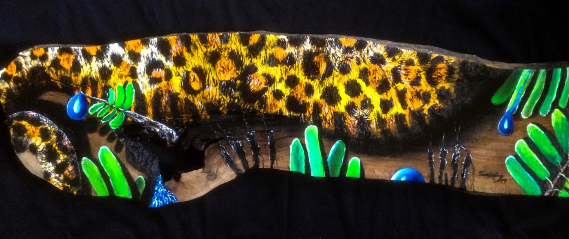

“I want to see it all”
Black Walnut
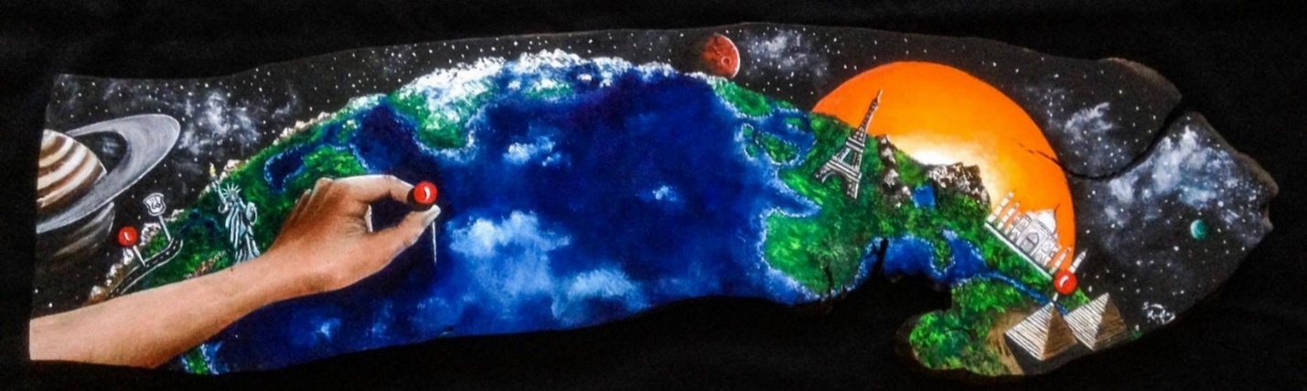

“Be Gentle”
Redwood
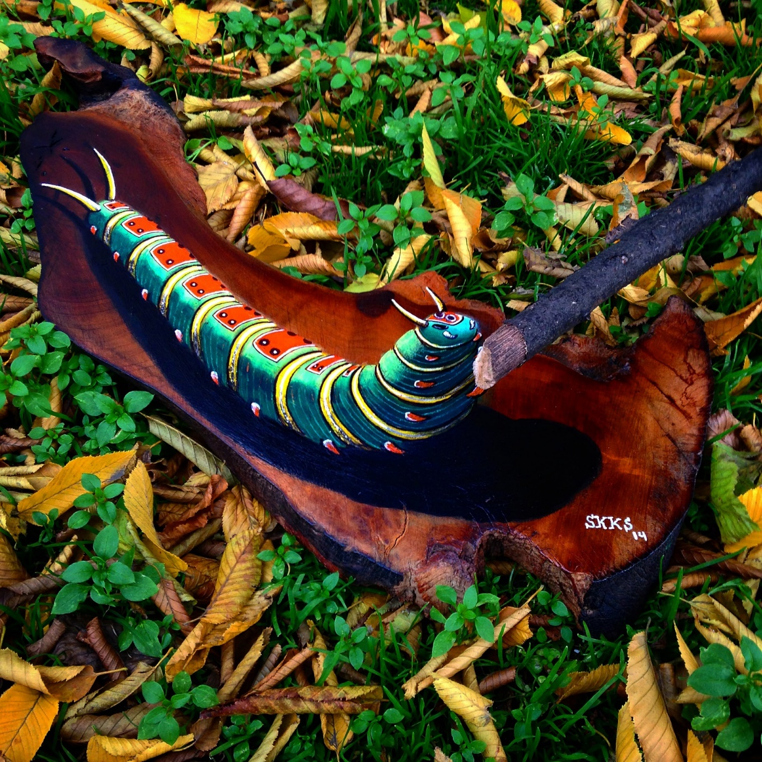

“Get Rhythm when you get the blues”
Poplar
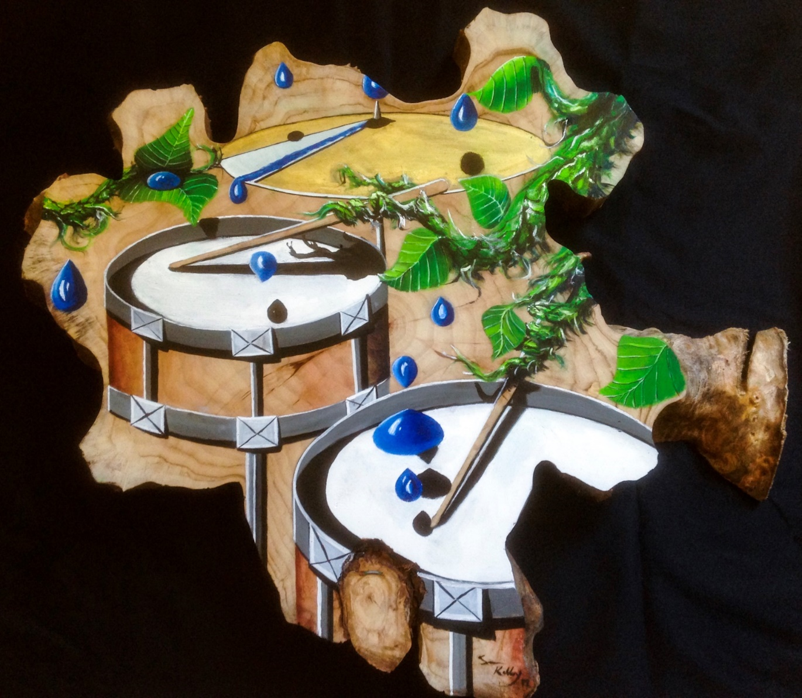

“Water is life”
Big leaf maple
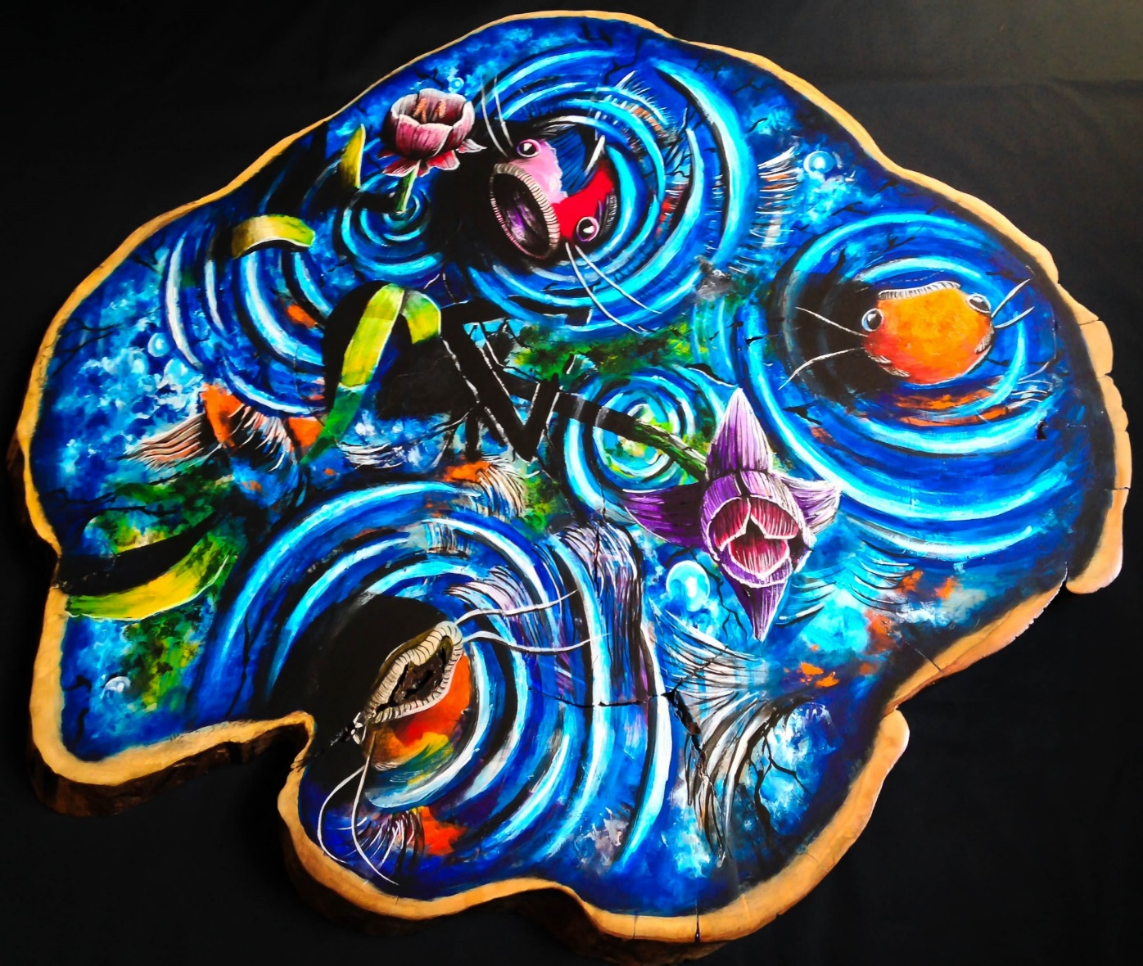

“The wand chooses the wizard”
Western pine
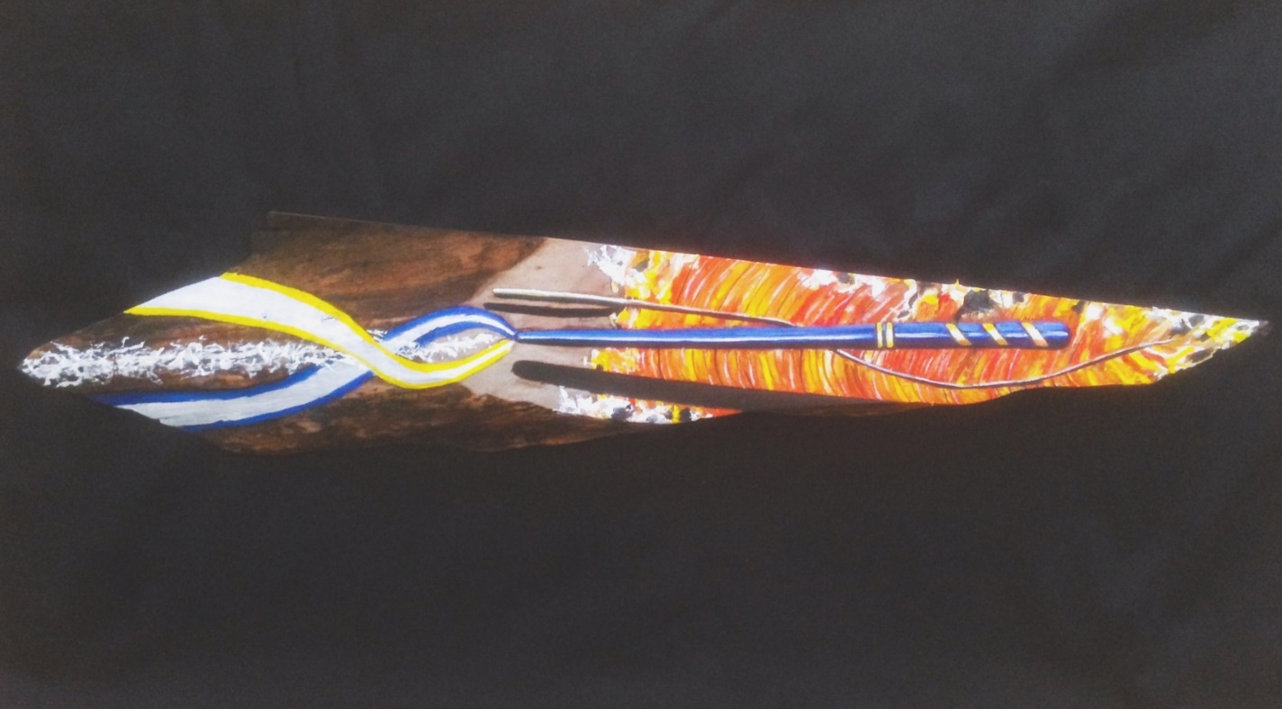

“Eyessssss on the prize”
Pine
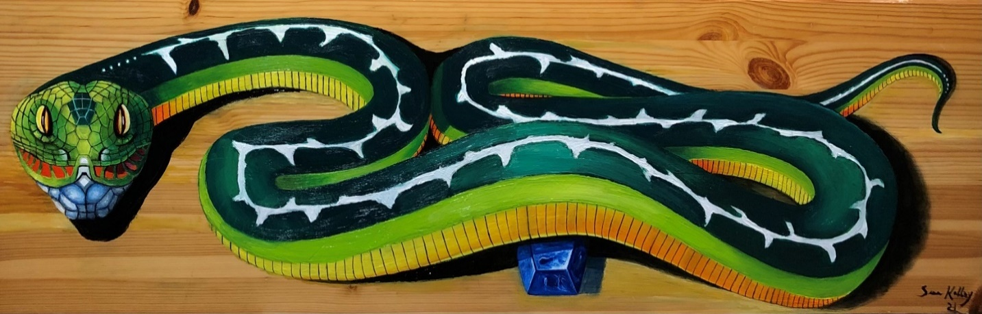

“Sea serenity”
Western pine
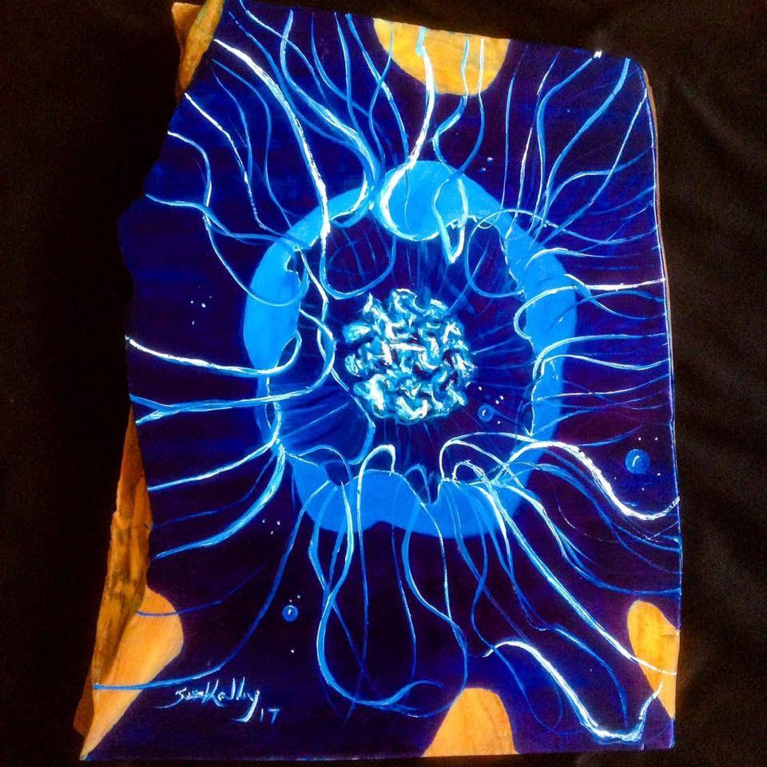

“Whale of a tail”
Black walnut
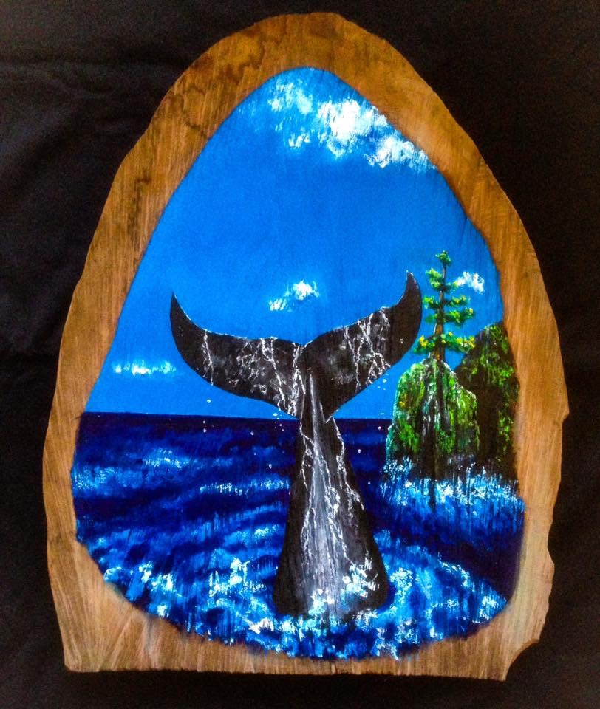

While creating these pieces in public while in Portland, I would carry these either by hand or in my Chrome motorcycle backpack that I still have today. Yes, they were heavy, and I would have to be very careful as to not mess up the work that was just finished at the local spot. Sometimes I would use the restroom only to find someone sitting at the table with their coffee cup sitting on top of the art piece. Patience is a virtue and awareness is gained through life, sometimes. It was a lesson in understanding expectations that continues to evolve today.
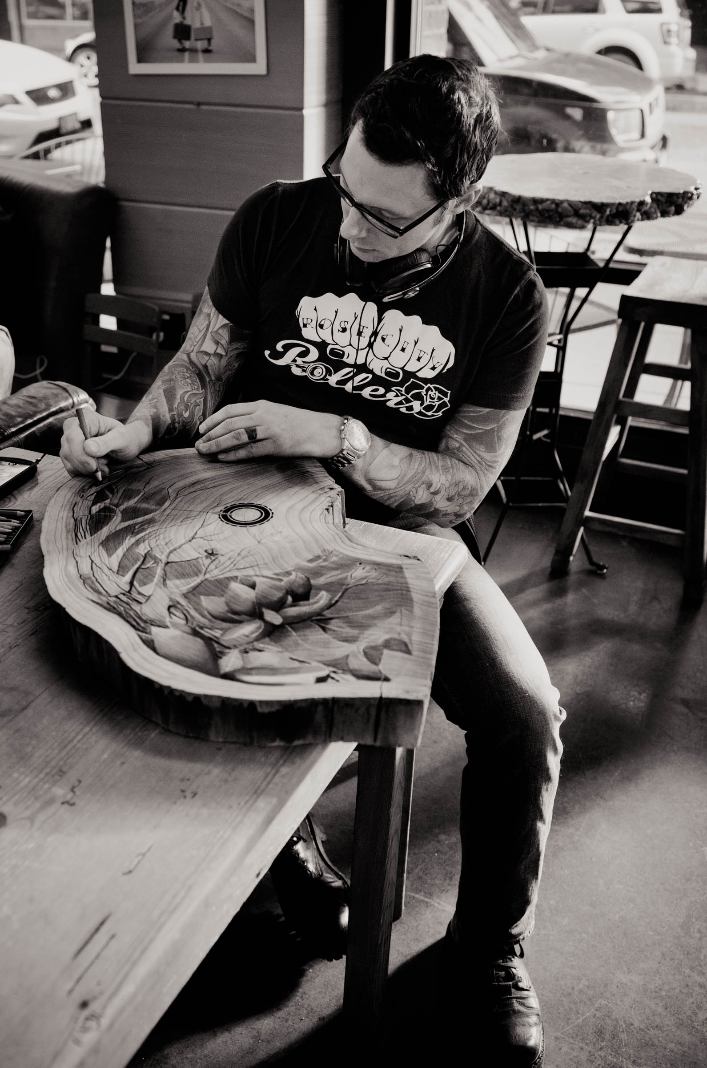
“The Heart of Illinois”
Western Pine
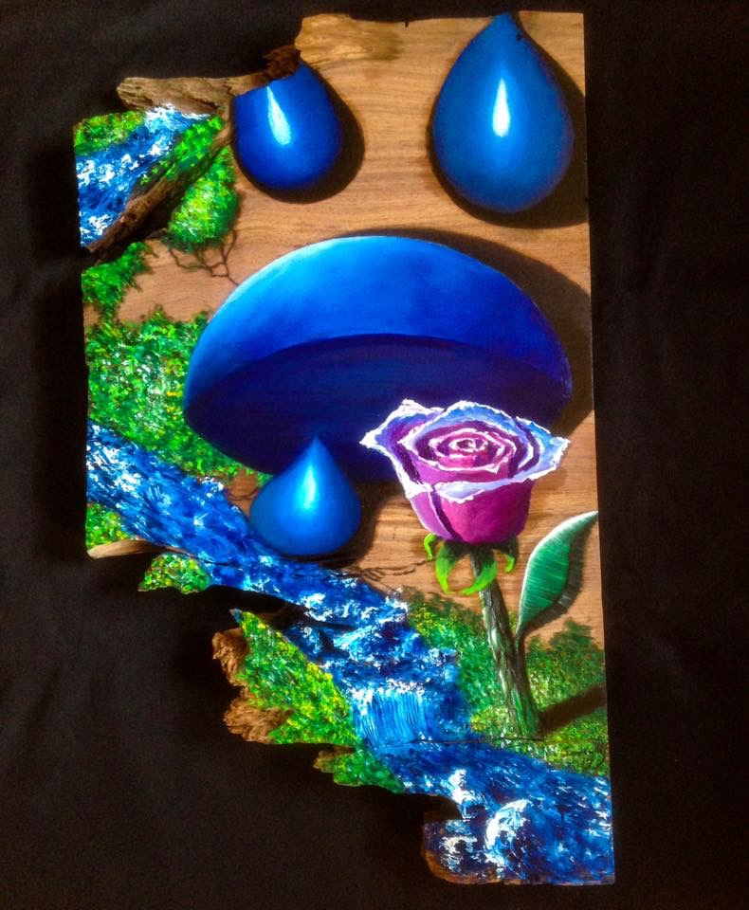

“Endangered in Oregon”
Cherry
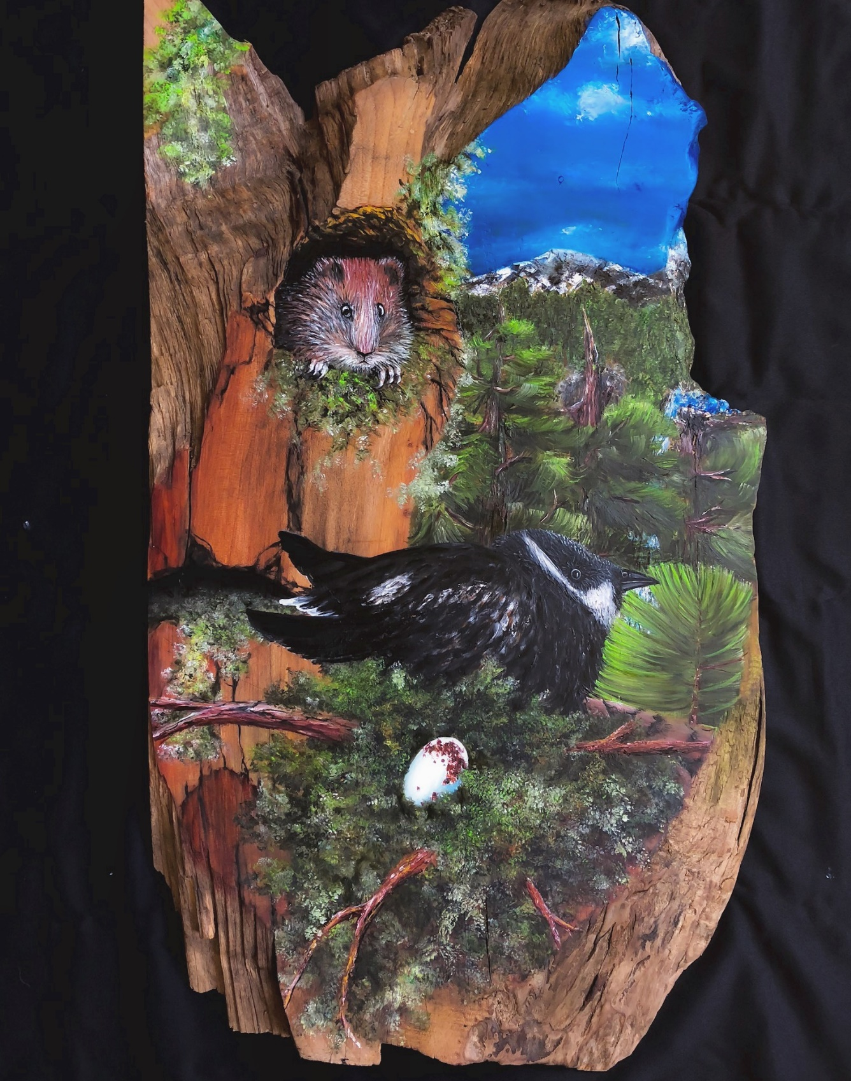

“Reflecting”
Big leaf maple
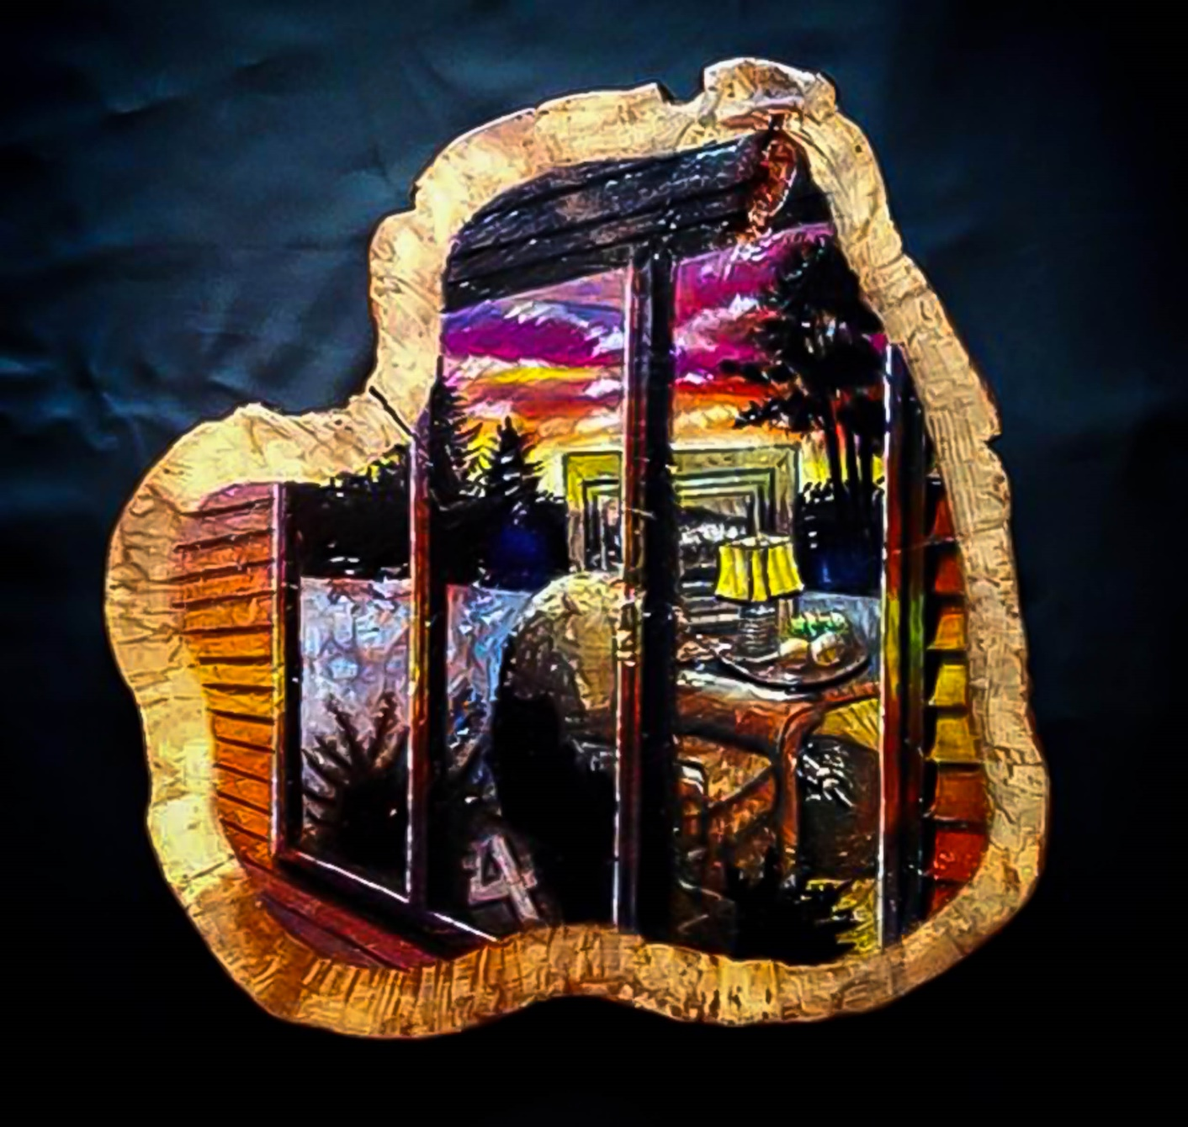

“Roll the dice”
Western pine
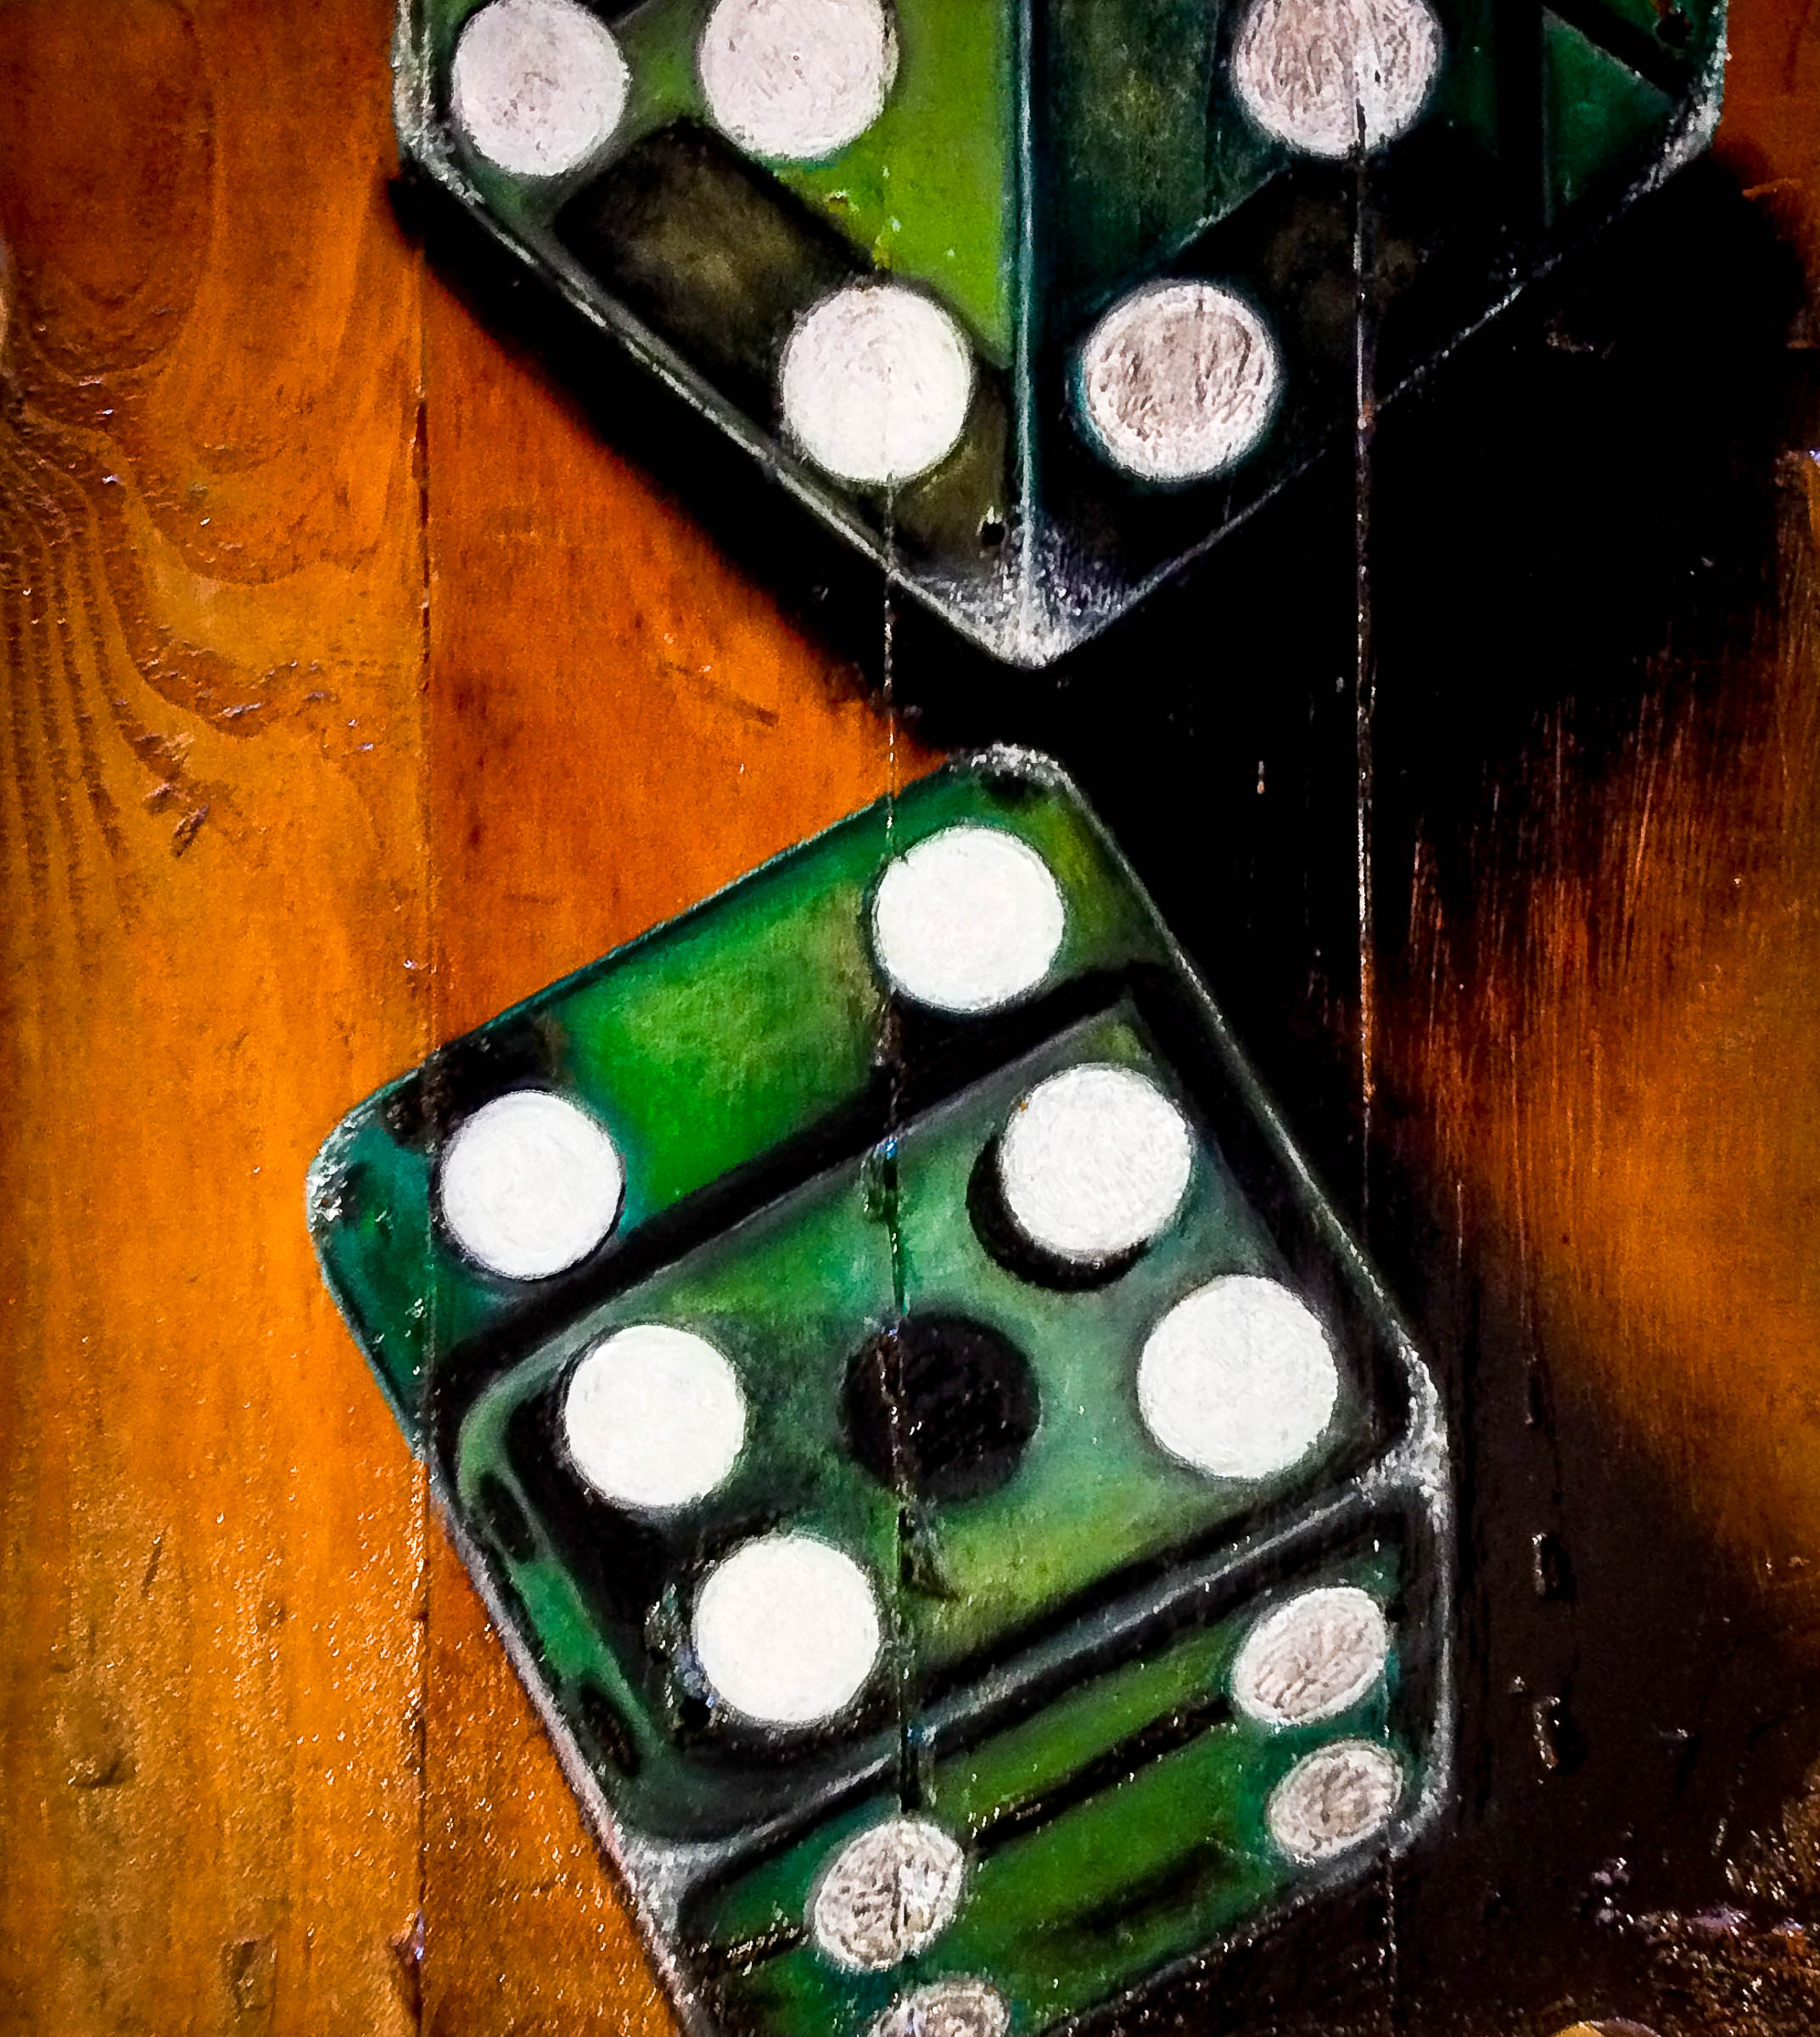

“Blame Canada…”
Western pine”
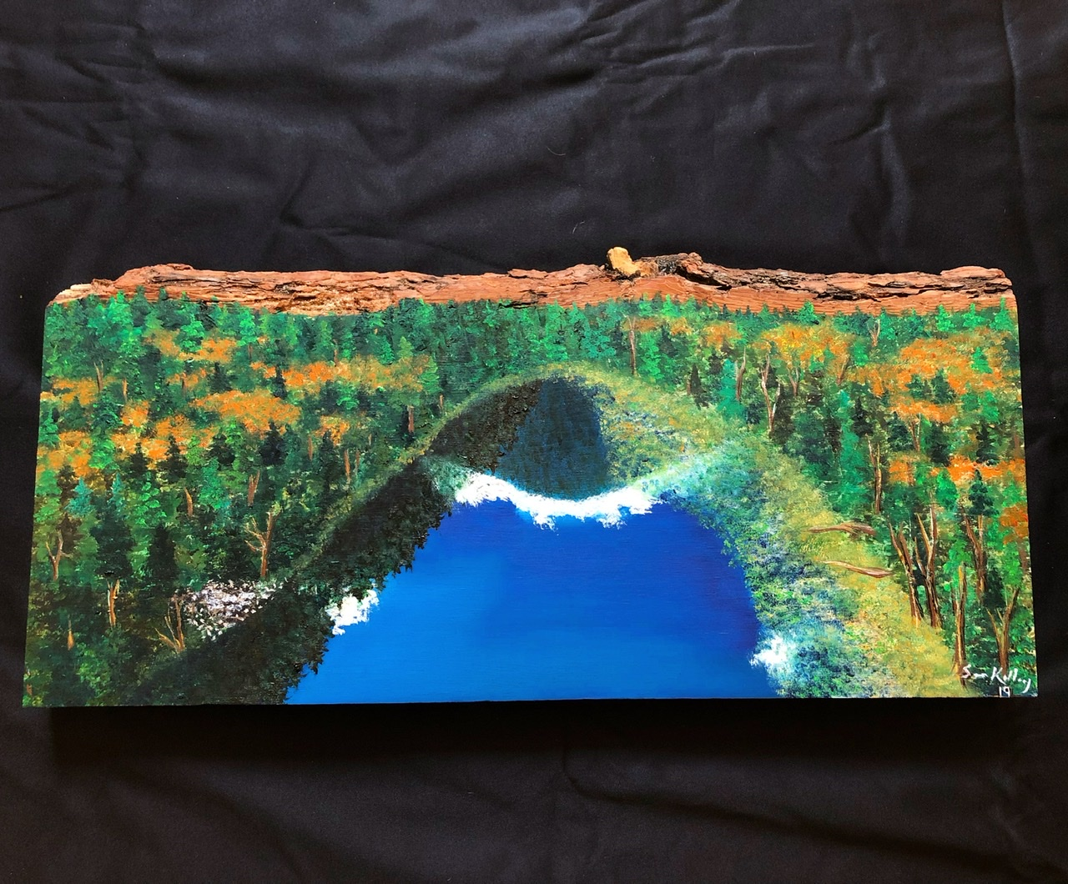

“Cenote Surprise”
Yucatan Hardwood
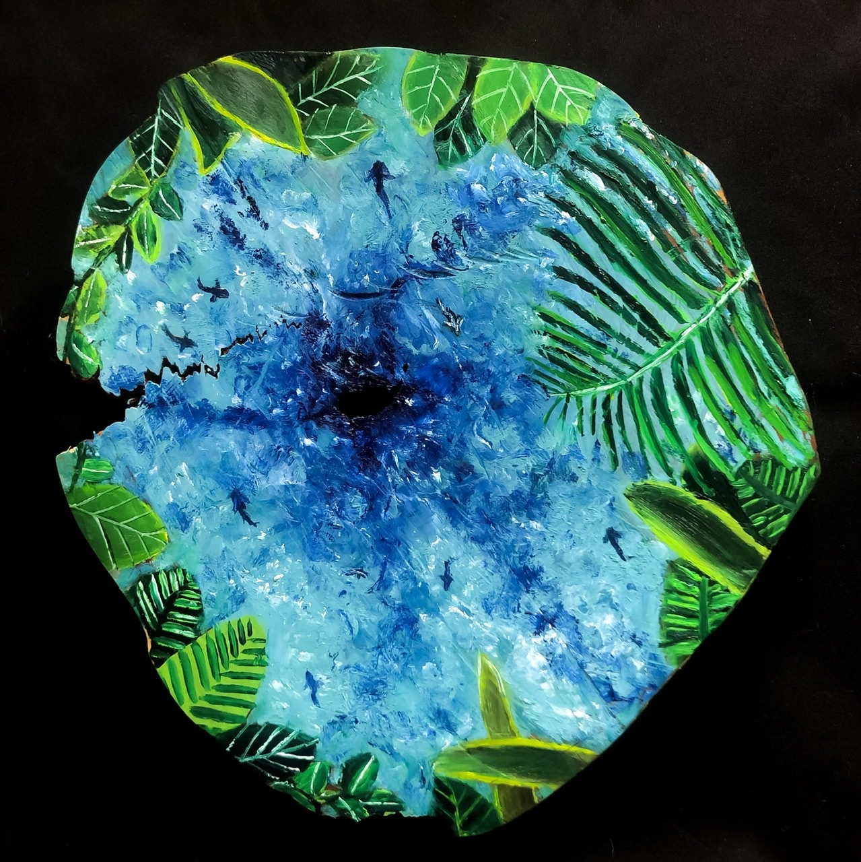

“Casa de Las Olas”
Poplar
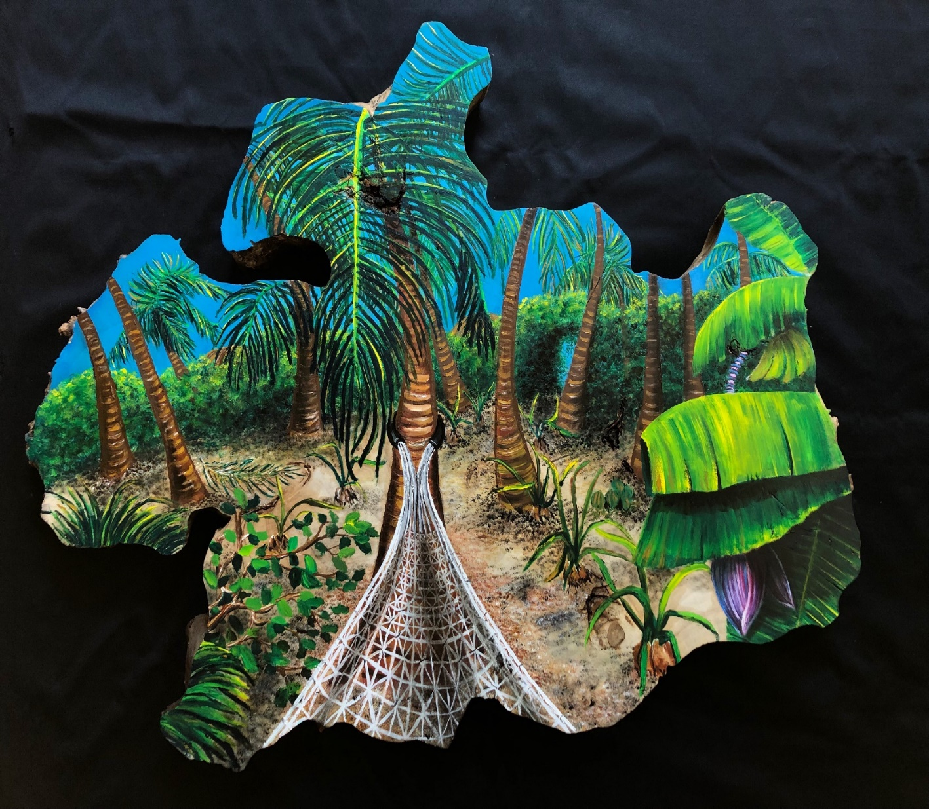

“Wild Orchid”
Black walnut
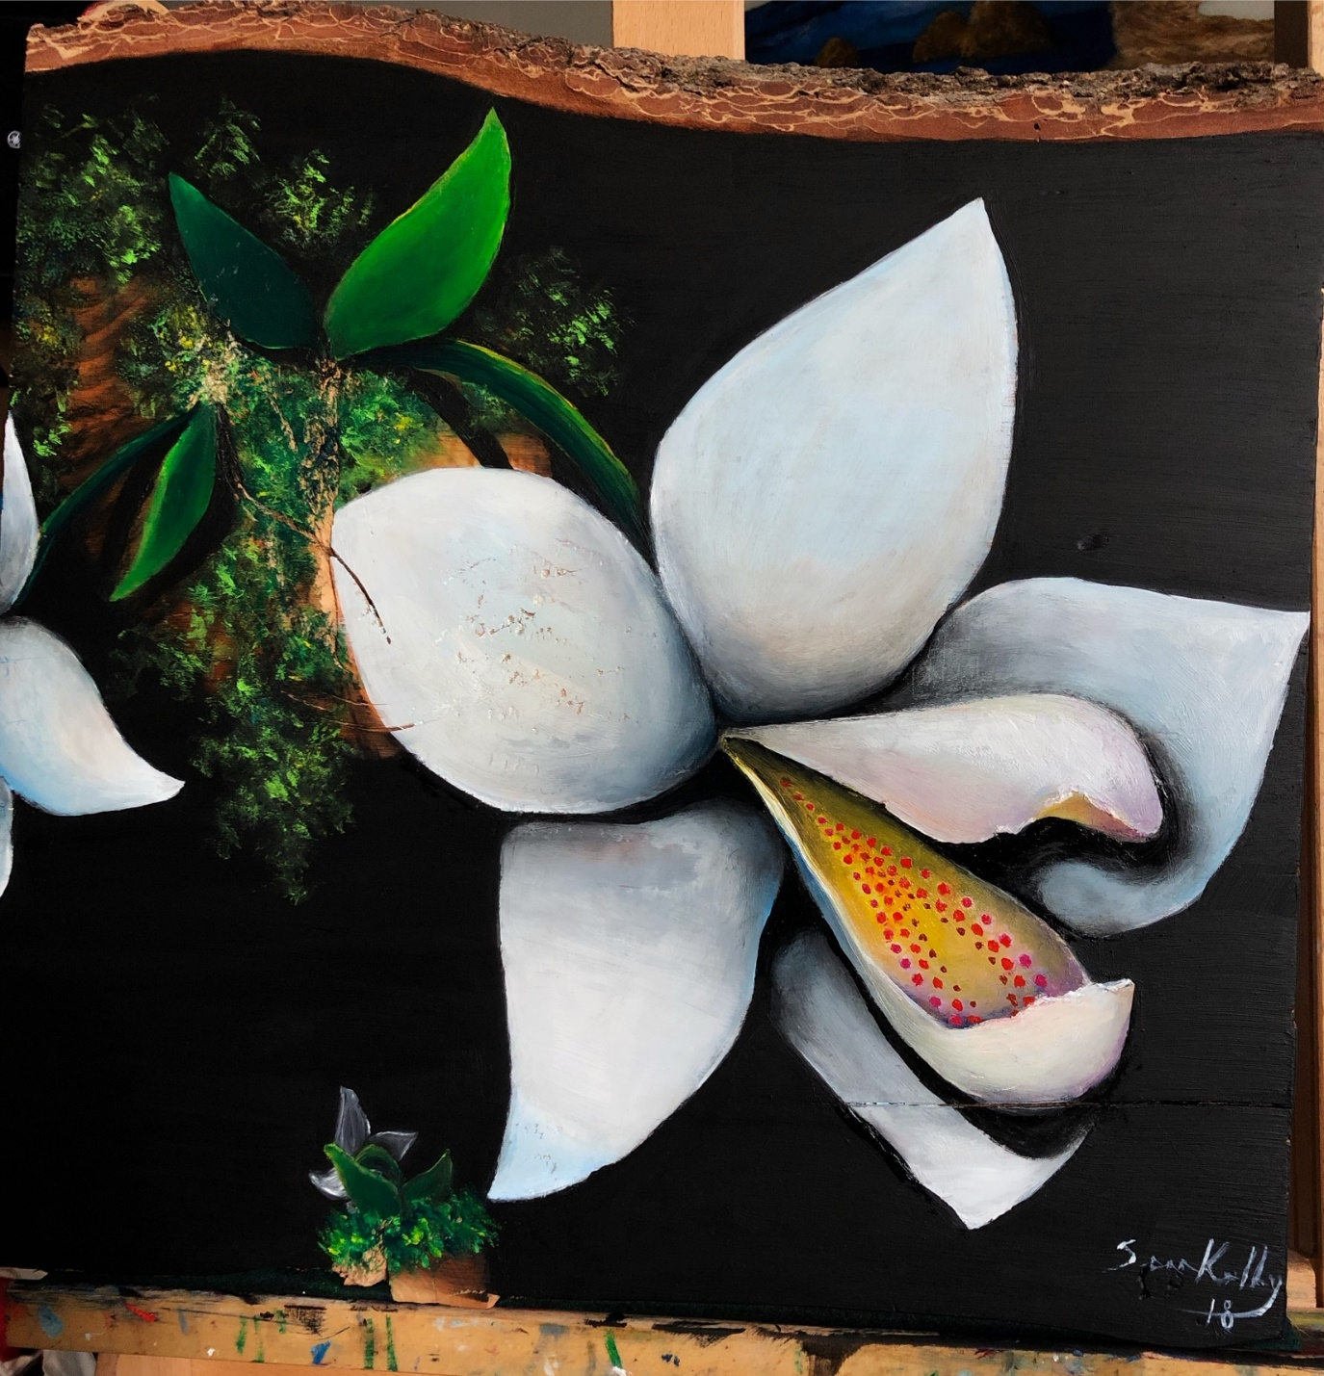

“The tiger heron”
Western pine
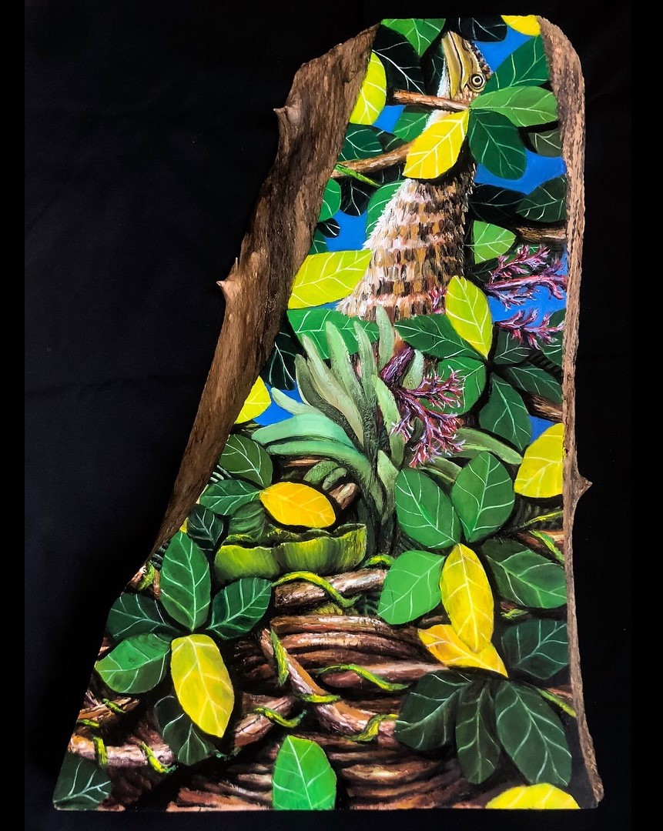

“Synchronized flight”
Cherry
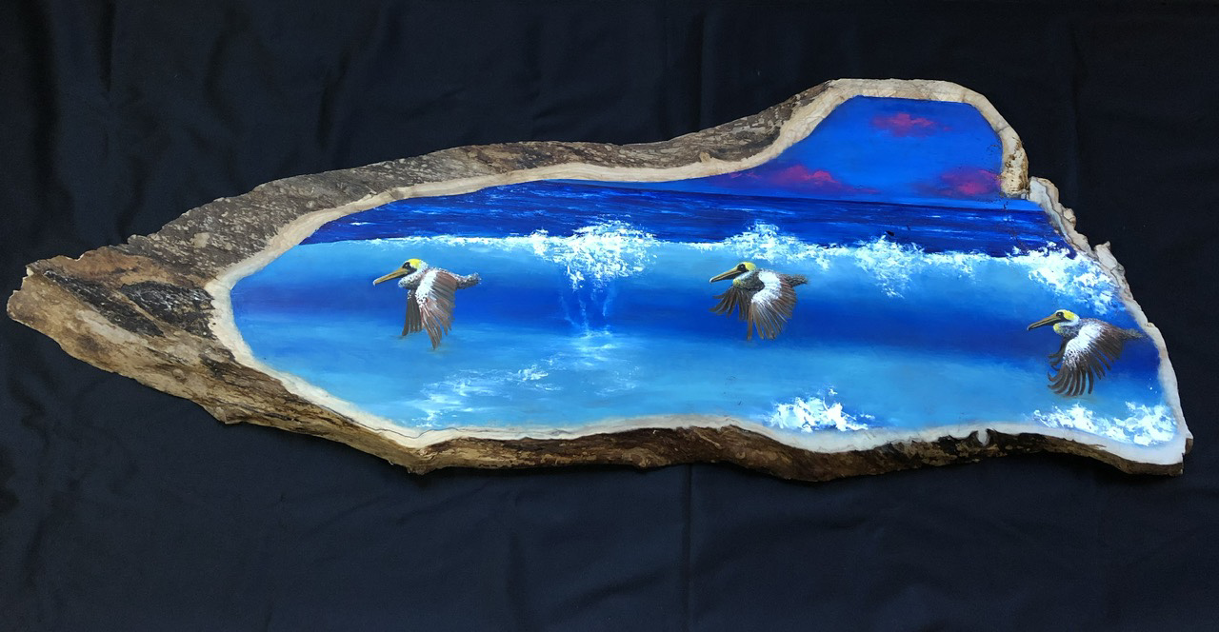

Many of the rounds or cross sections I would receive from friends or acquaintances looking like this. Usually they were cut into rounds as best as the person could get them with a chain saw. It really didn’t matter, and I was always thankful to receive arbor that had fallen instead of being chopped down. We would agree to some sort of compensation which usually meant that I would create a piece of art out of the finished round. It was always cool to see what the cross section would look like after getting a treatment from the CNC.
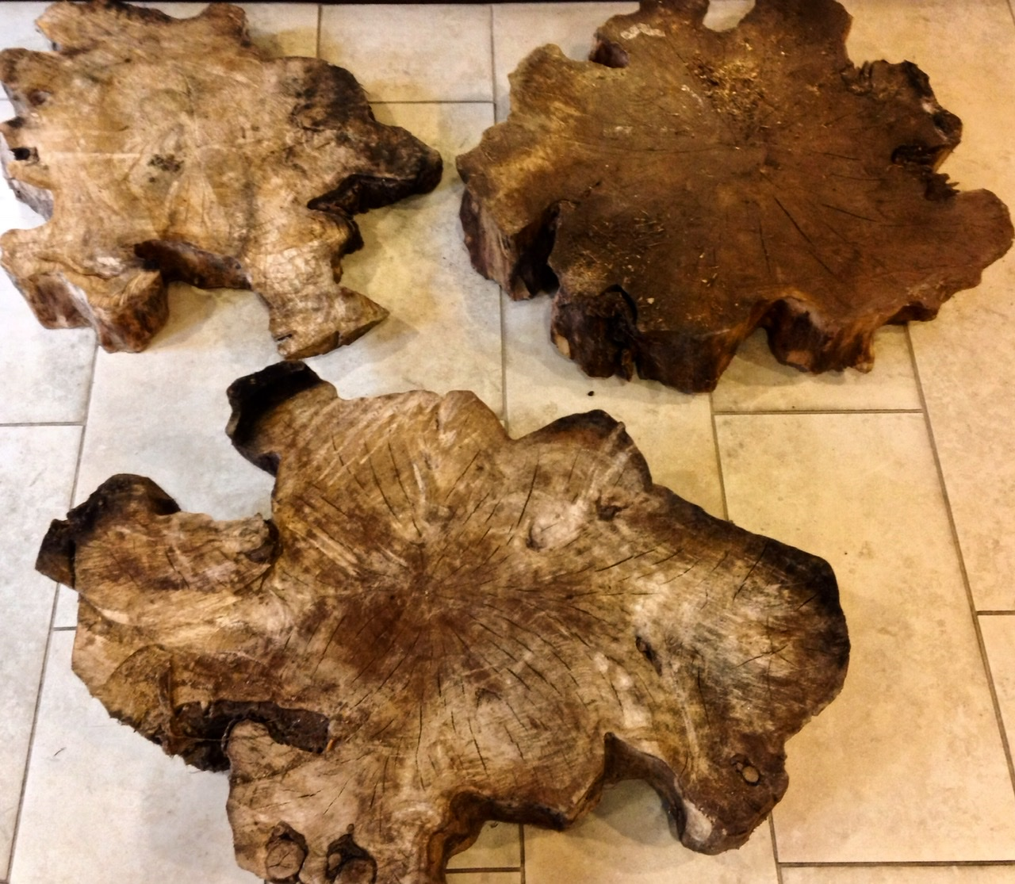

“Who lands on a glacier?”
Black Walnut
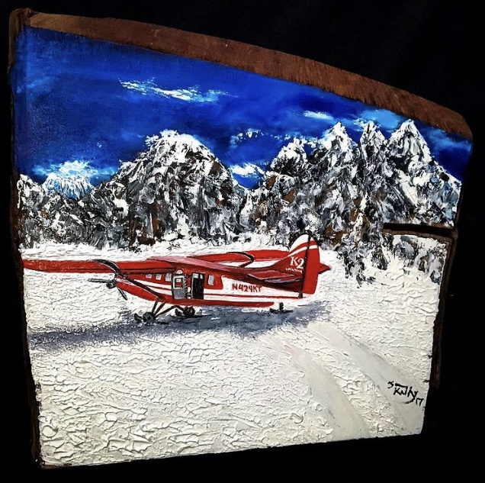

“A walk in Alaska”
Black Walnut
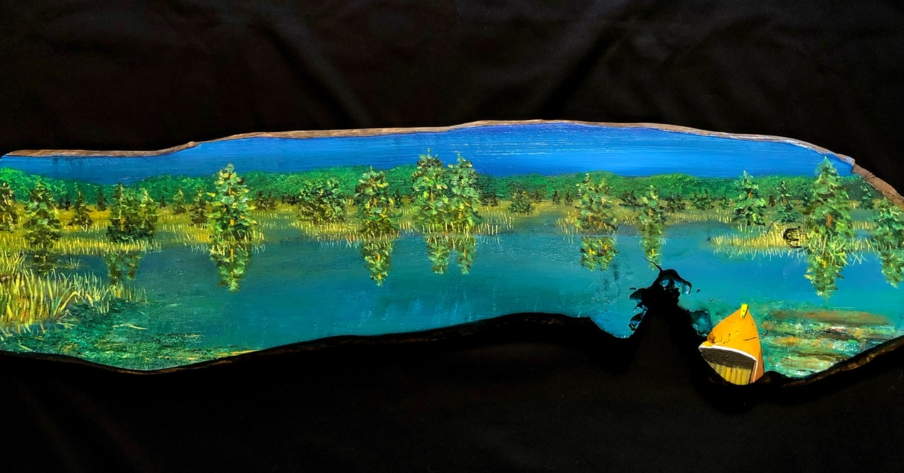

“Denali Dreaming”
Black walnut
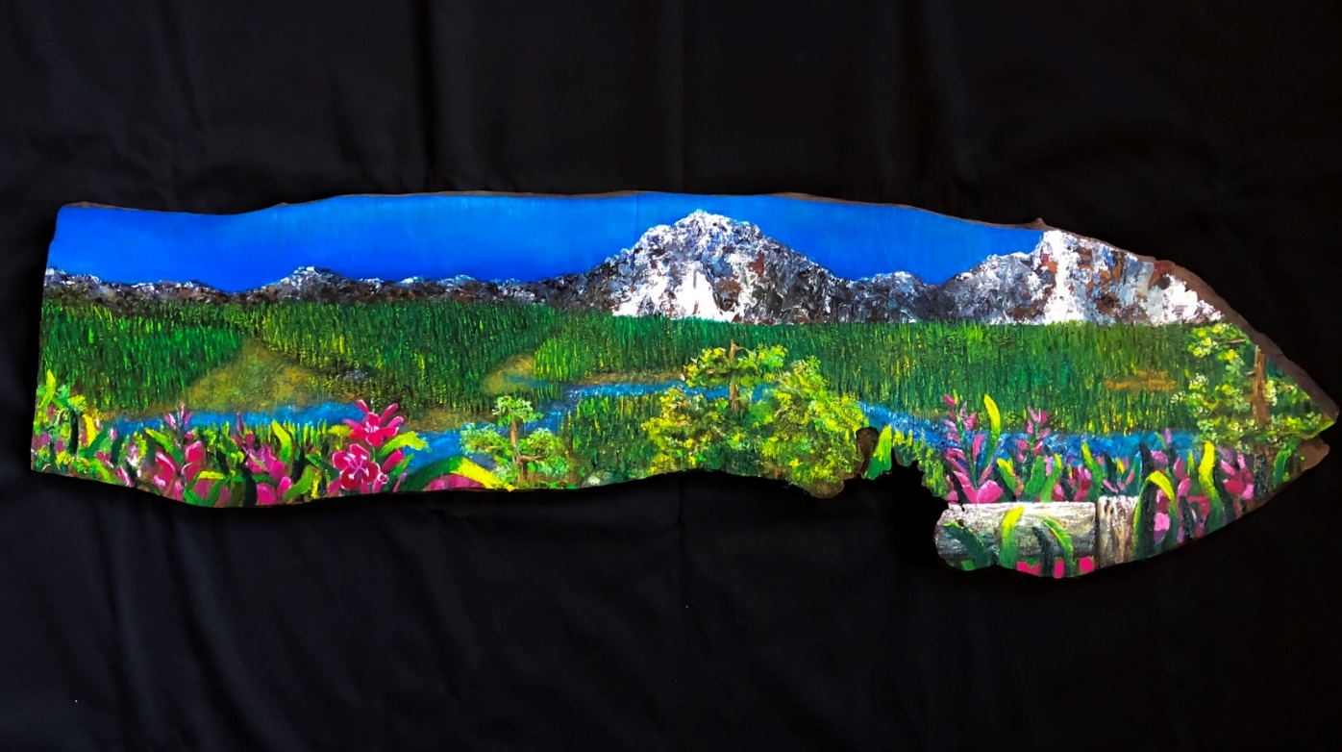

“The Talkeetna Express”
Western pine
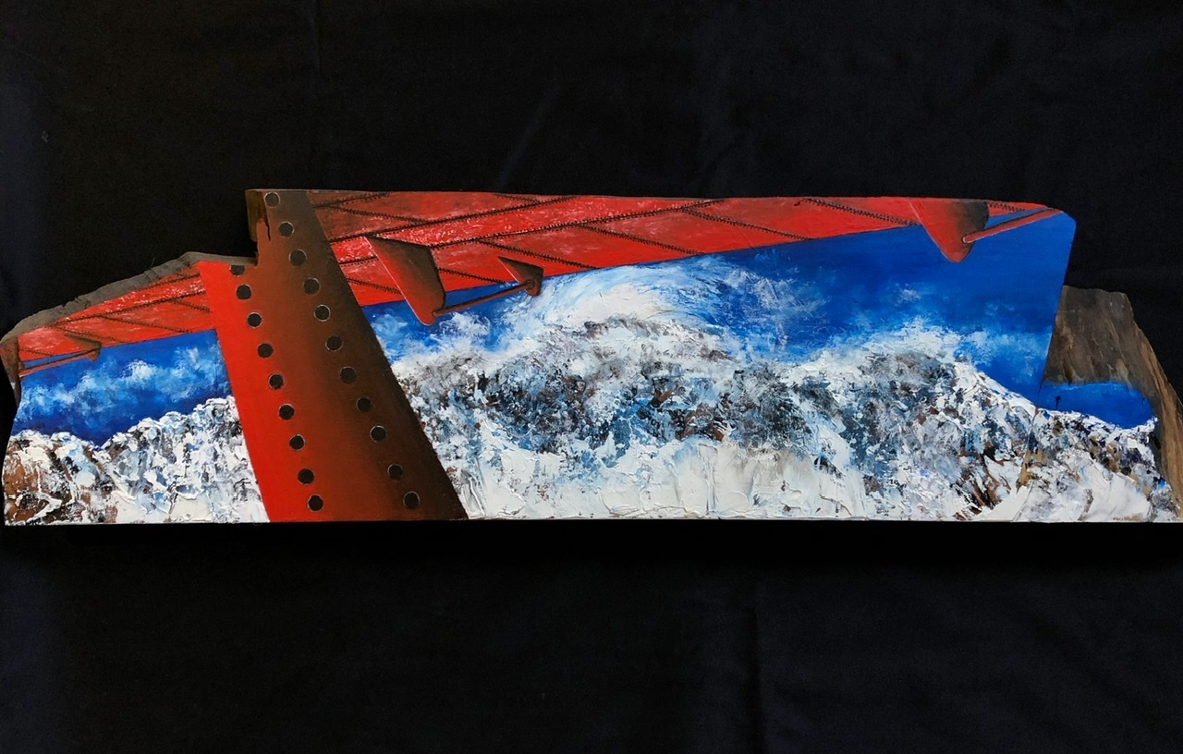

“Hidden in Oceanside”
Big Leaf maple
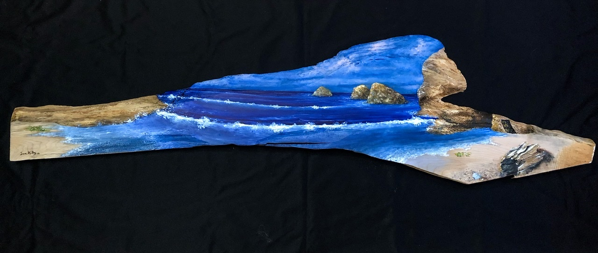

“Spring fever”
Repurposed pine
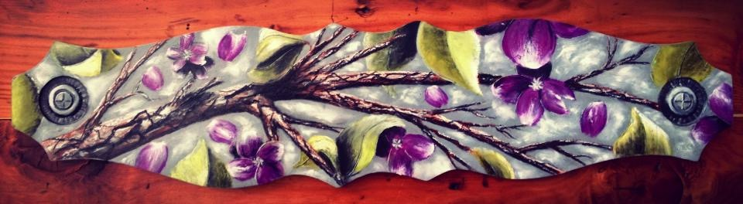

“Don’t be crabby”
Black walnut
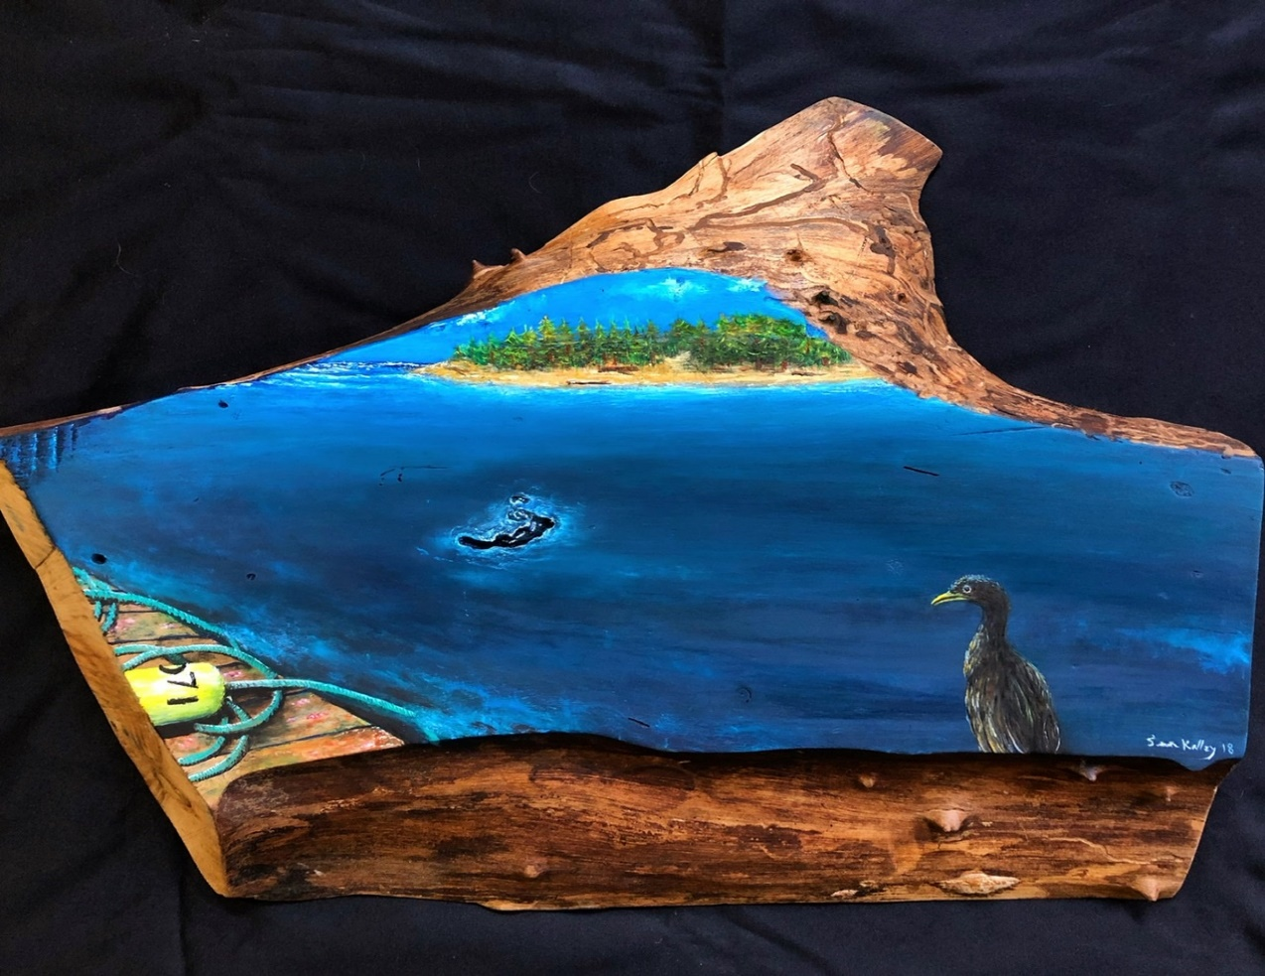

“One of my favorite things…”
Western pine
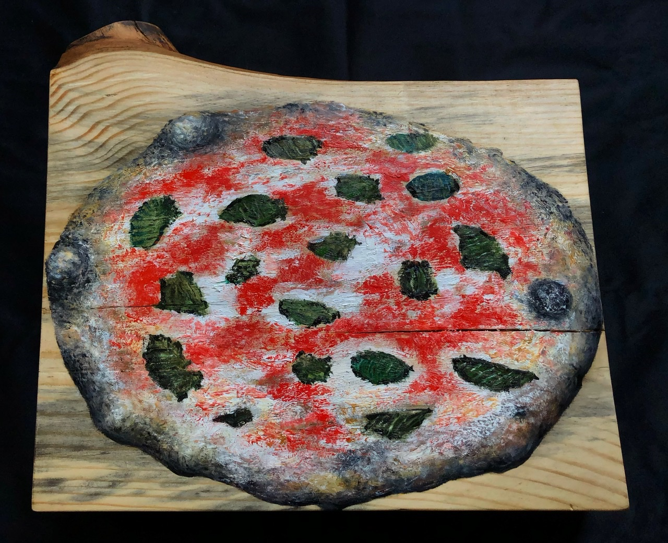

“Snow skate, Birth of a seed, Pinball Wizard, SSSlitering”
Pine skateboard blanks
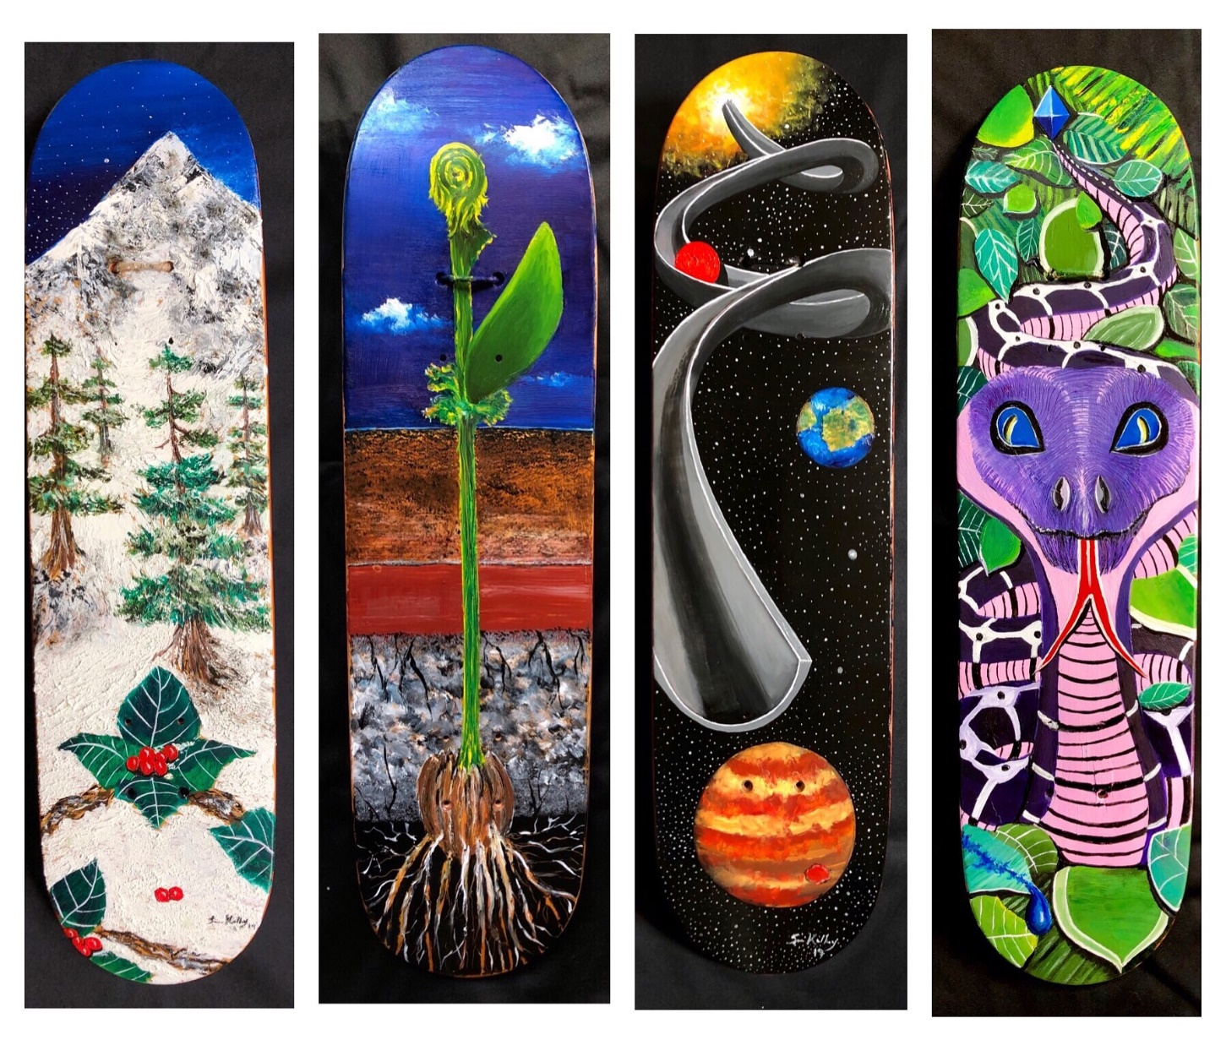

“Aquatic Illusion”
Black walnut
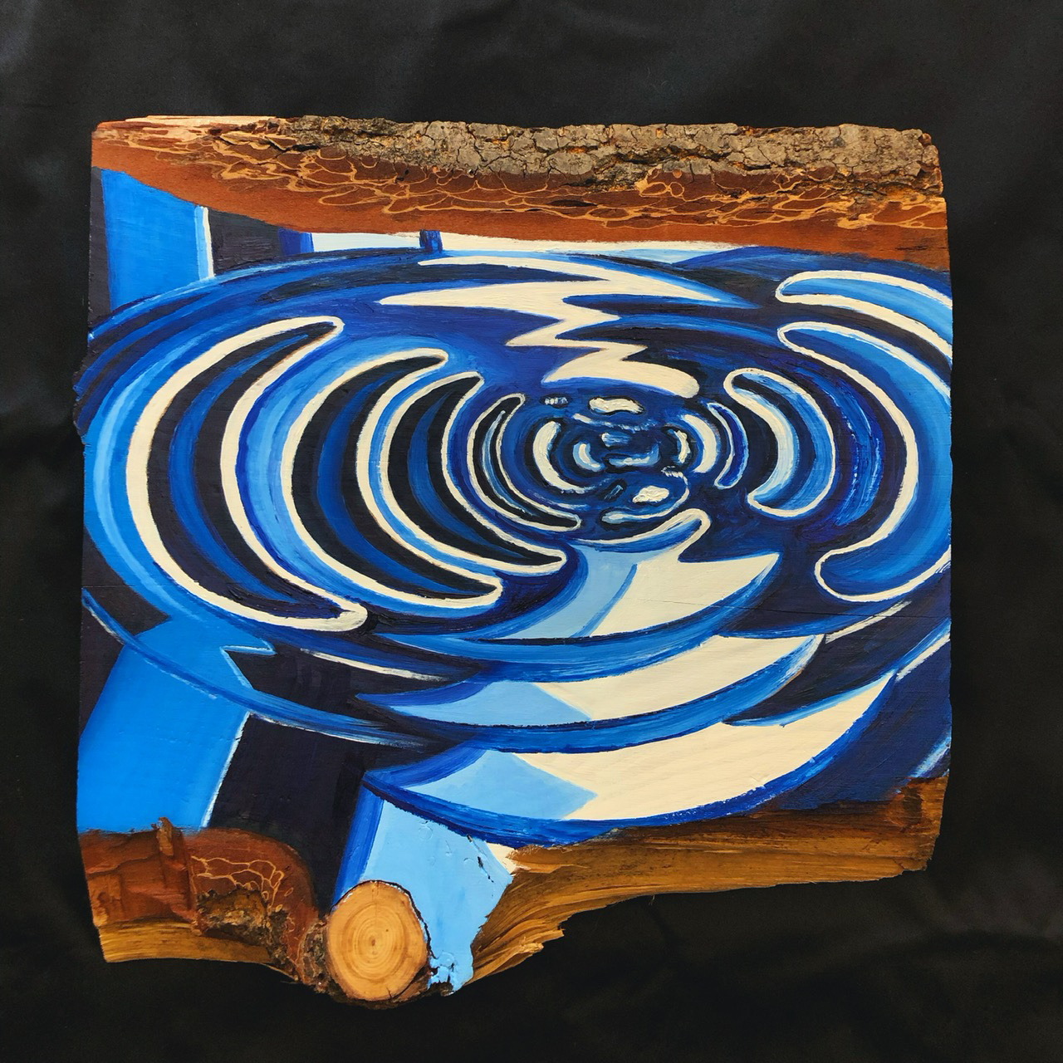

When the cross sections came back from Creative woodworking sometimes it was hard to paint on them for a bit. Especially after I would put a small amount of lemon or orange oil on it cleaning off the dust bringing out the natural colors. In the end once the oil dried out, I would feel ready to create an original on the round.
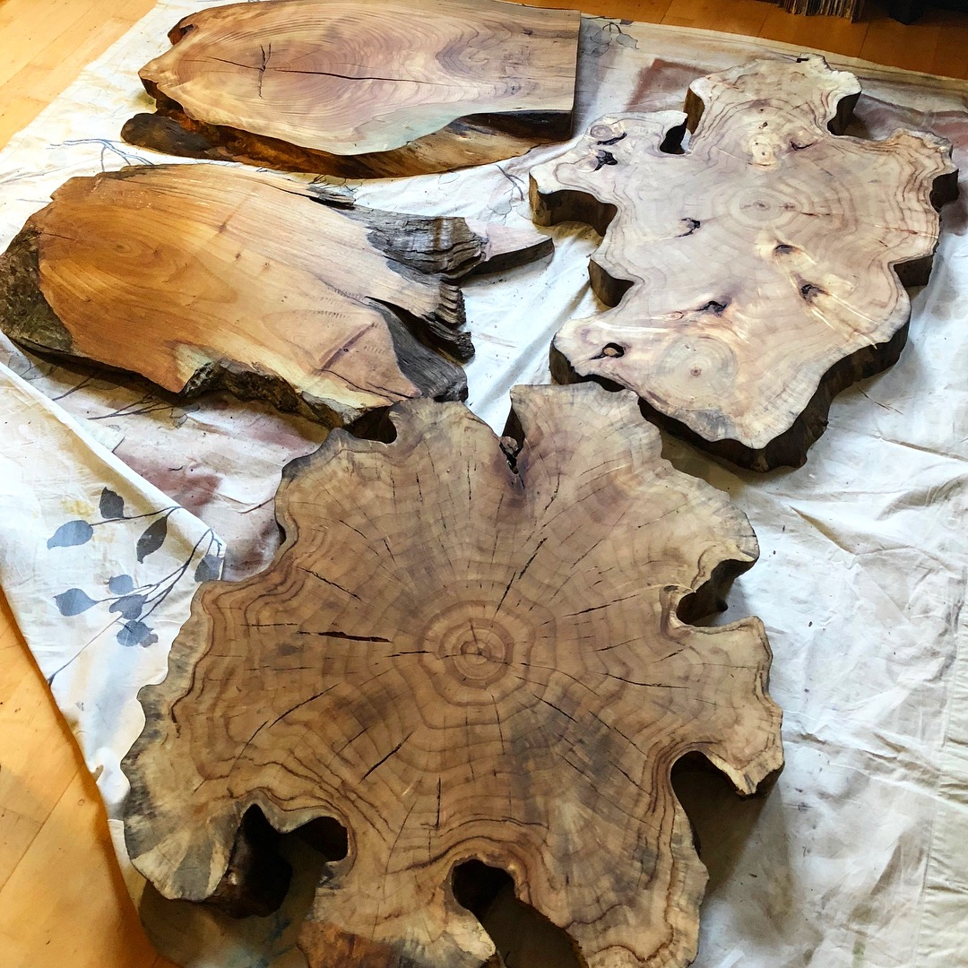

“Willamette Wonderland”
Black walnut
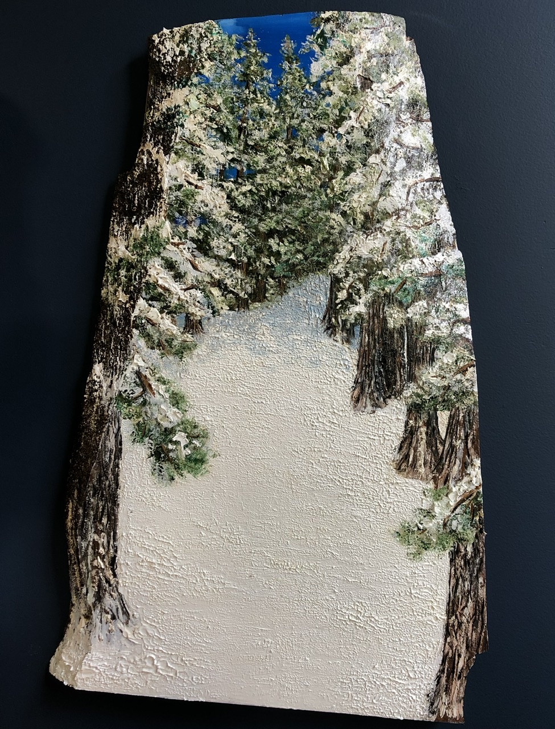

“The eagle has landed”
Western pine
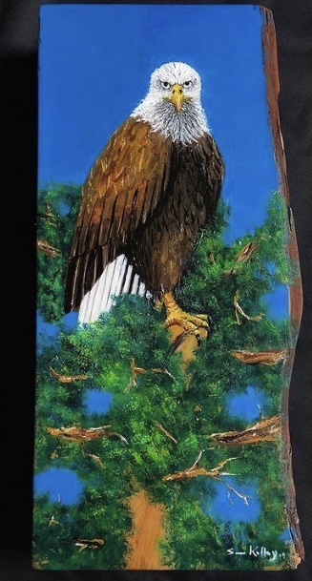

“Peace on the mountain”
Poplar
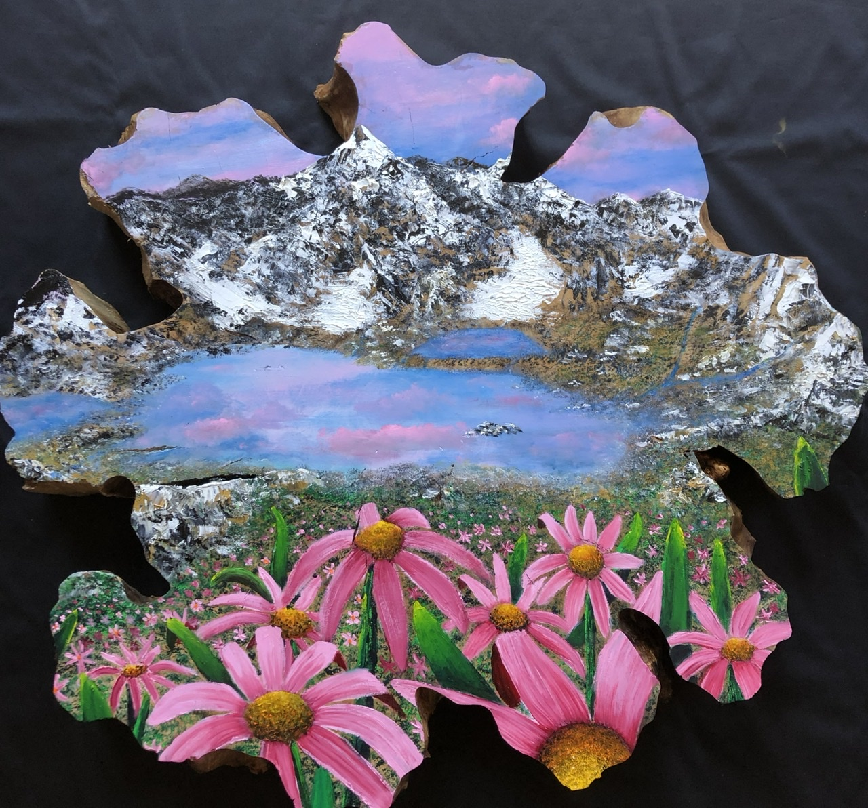

“A river runs through it”
Cherry
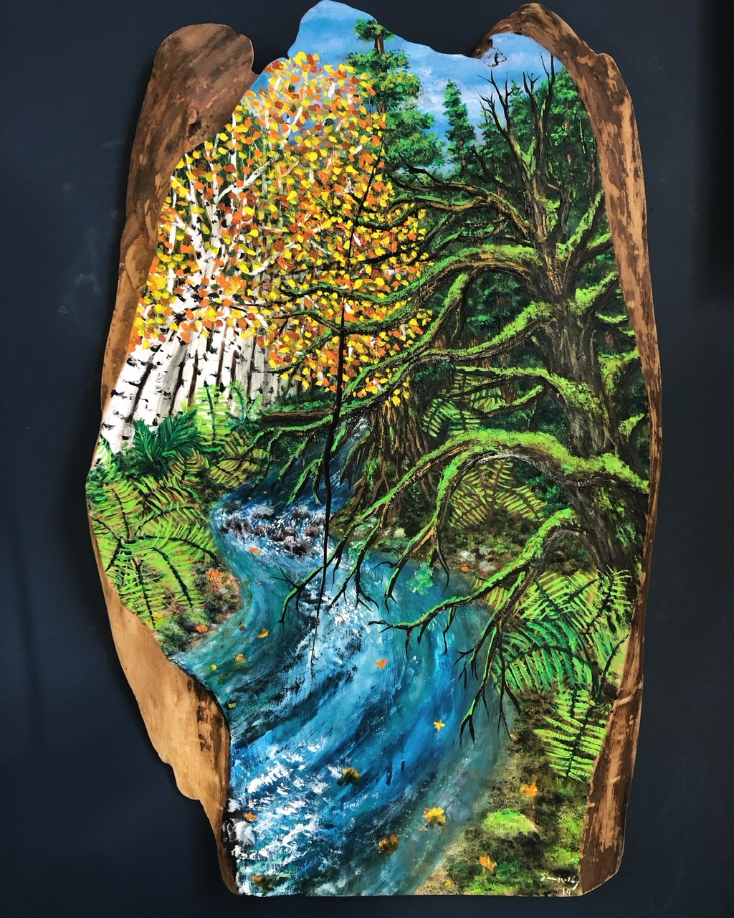

“To give love freely”
Western pine
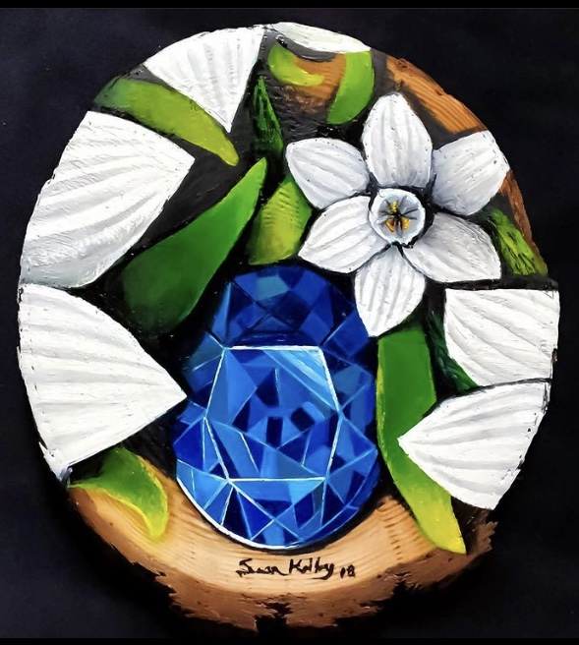

“My dream”
Western Pine
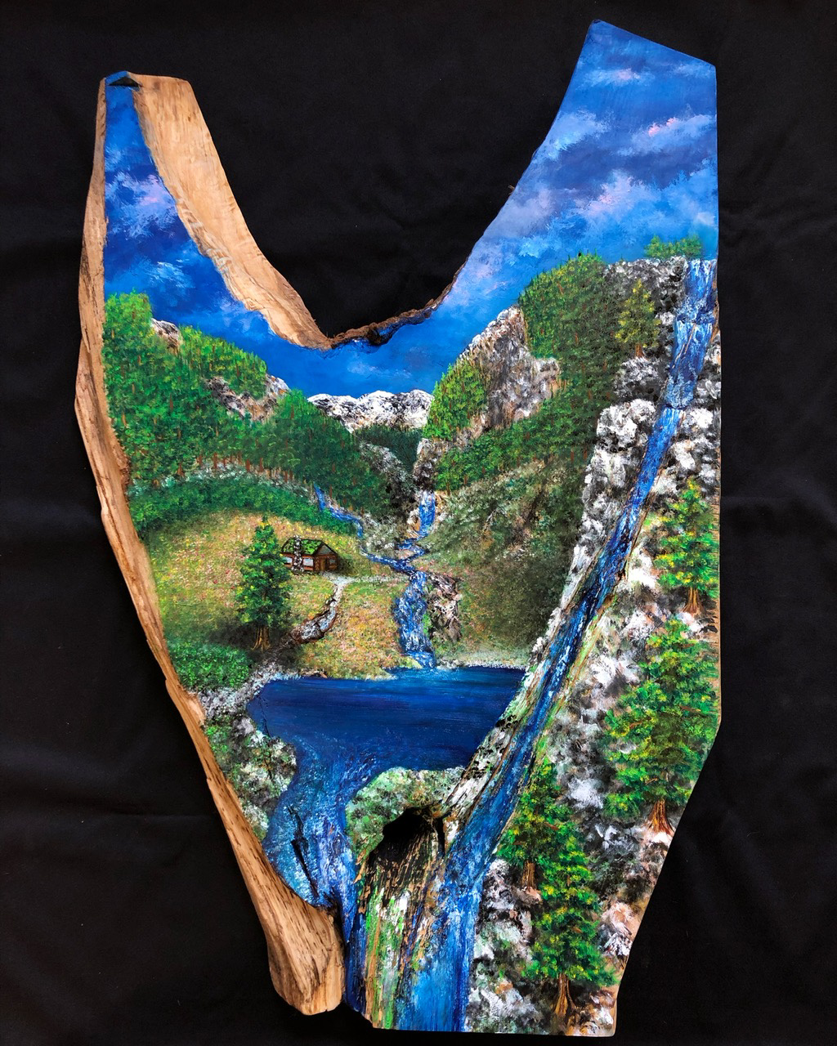

“Lilies for Danielle”
Birch
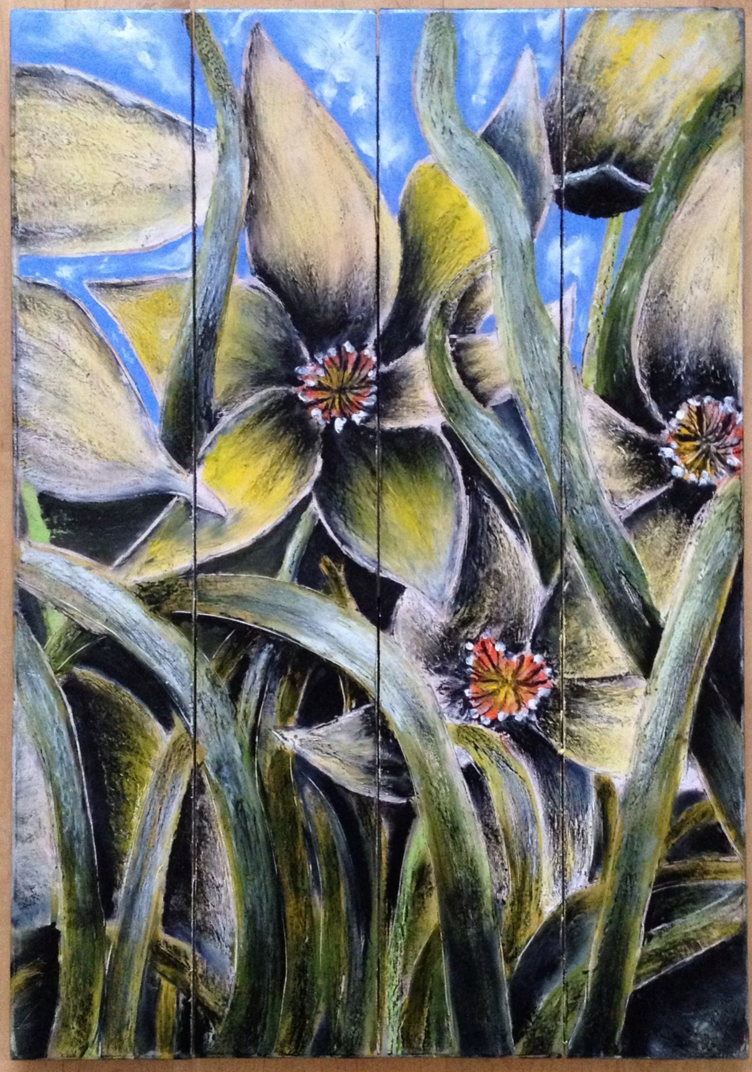

“Solitude in Central Oregon”
PNW cedar
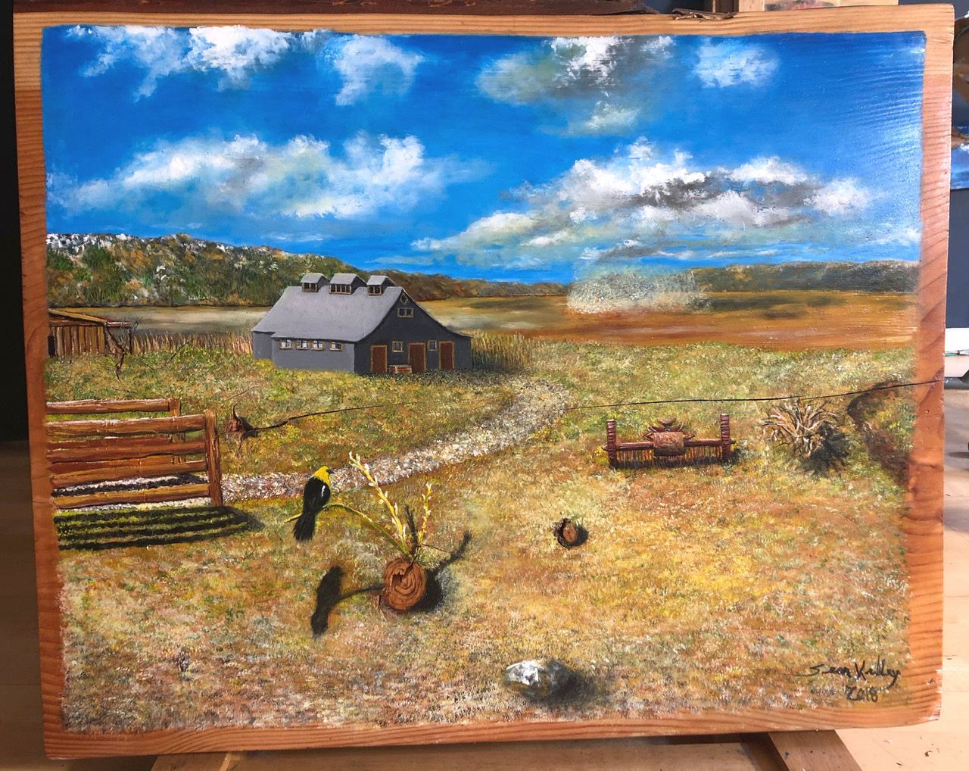

“At the heart of it all”
Western pine

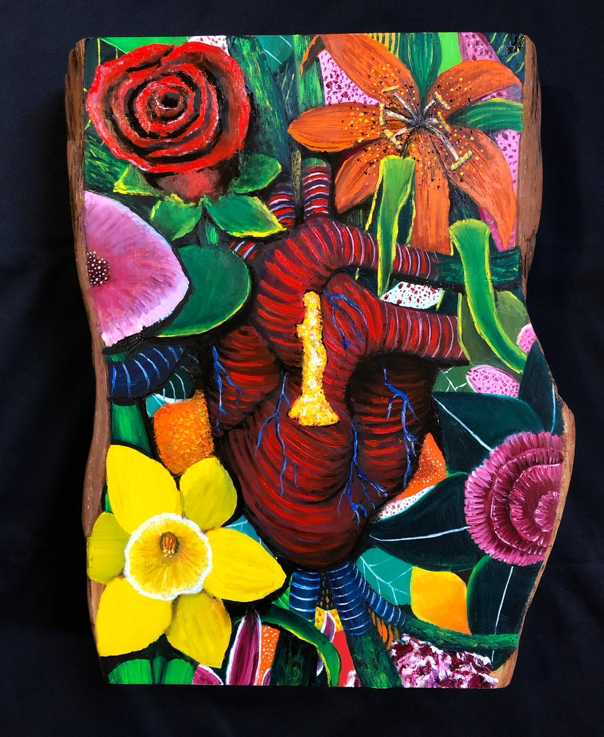

“The family crest”
pine
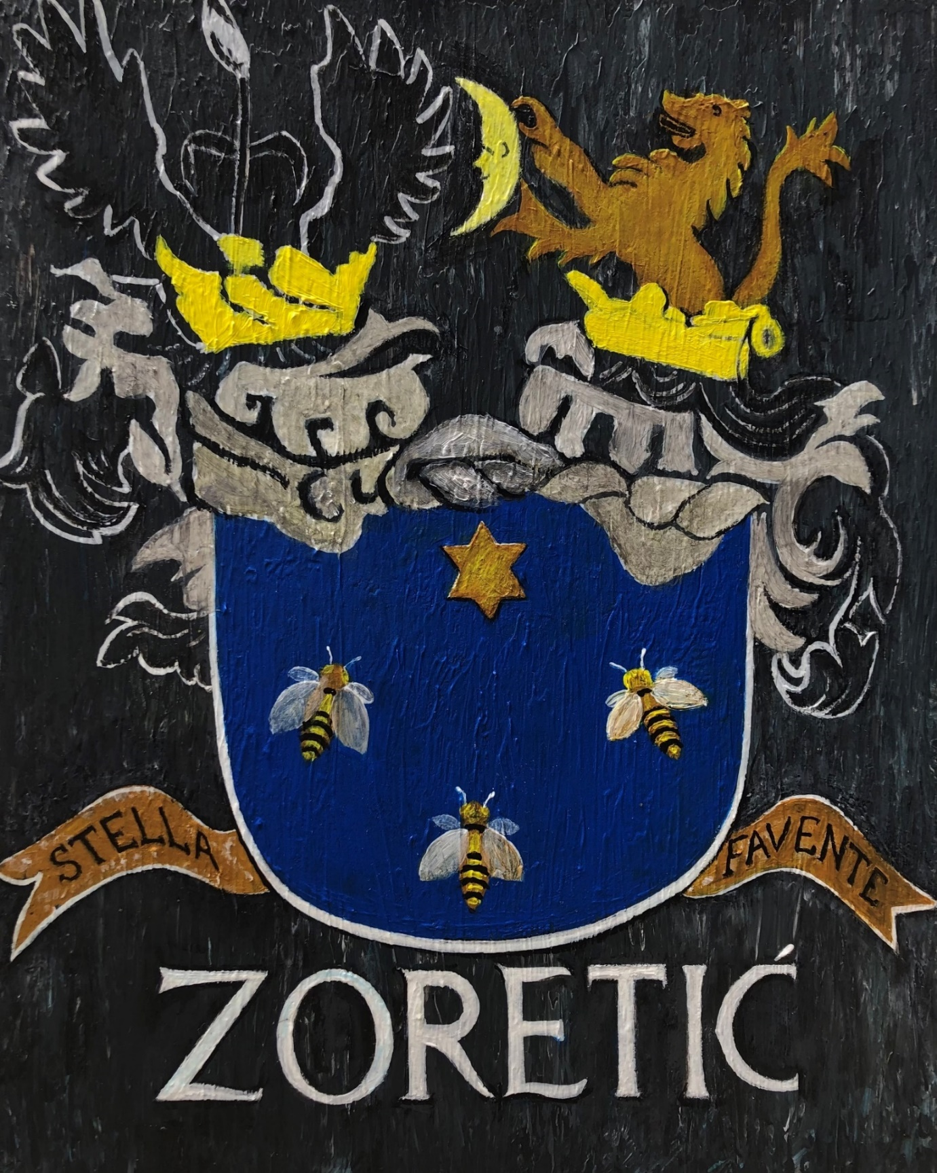

“To be free”
Pine
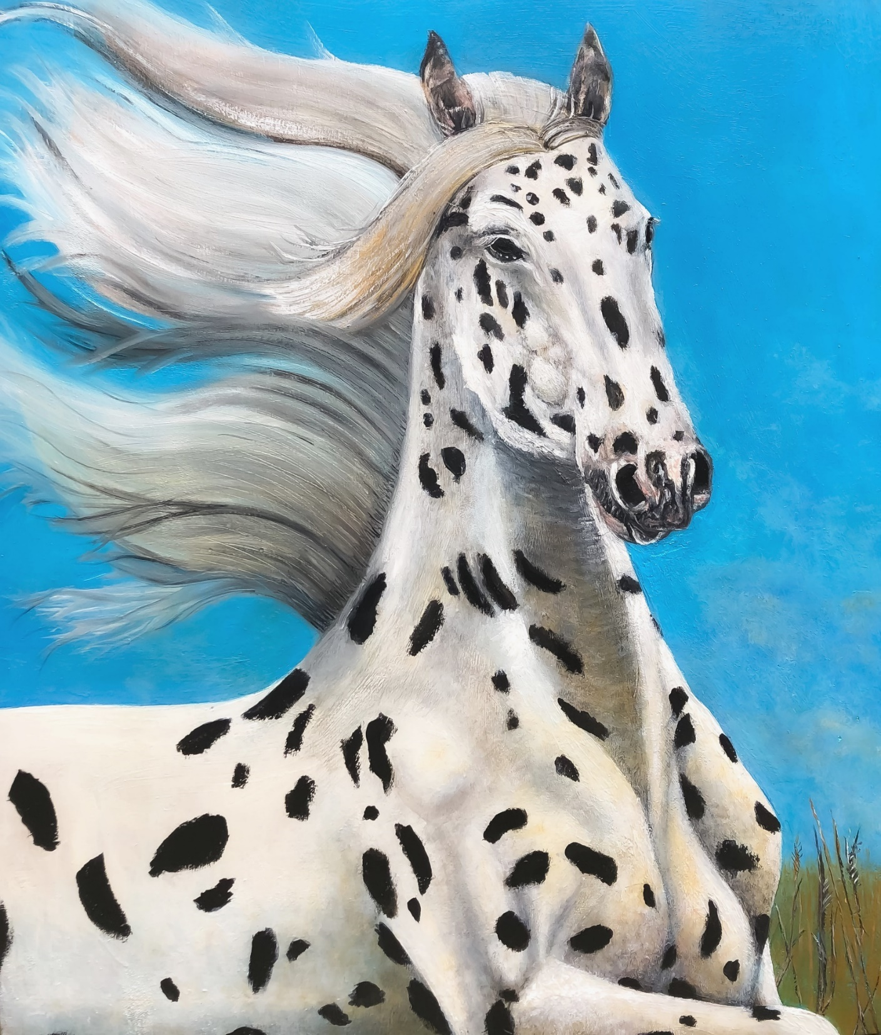

“Lekker”
Pine
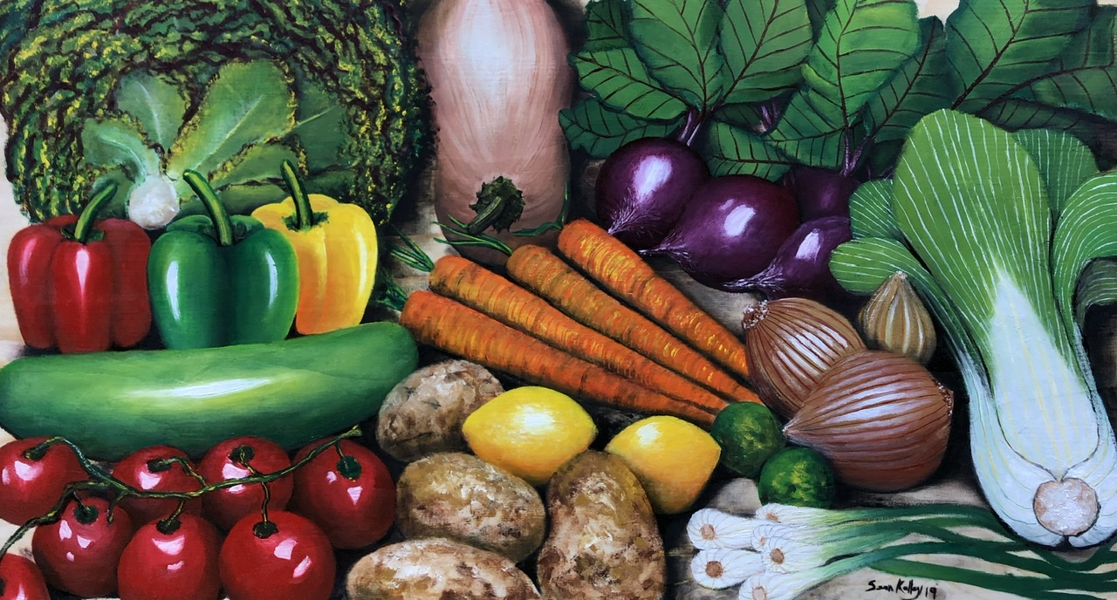

“A walk in the moonlight”
Pine
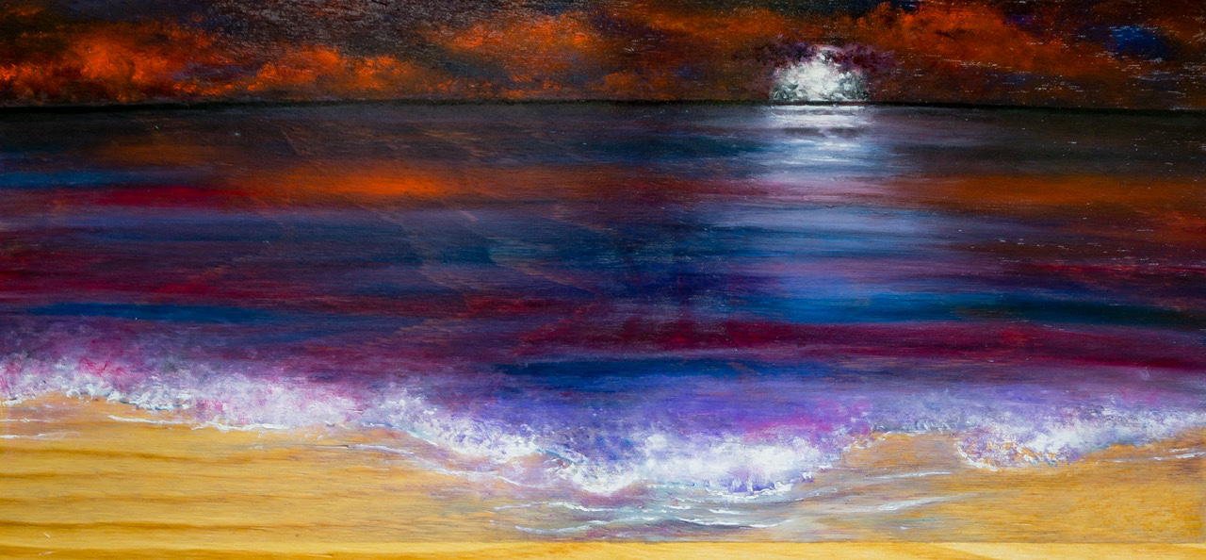

“Check please”
Pine
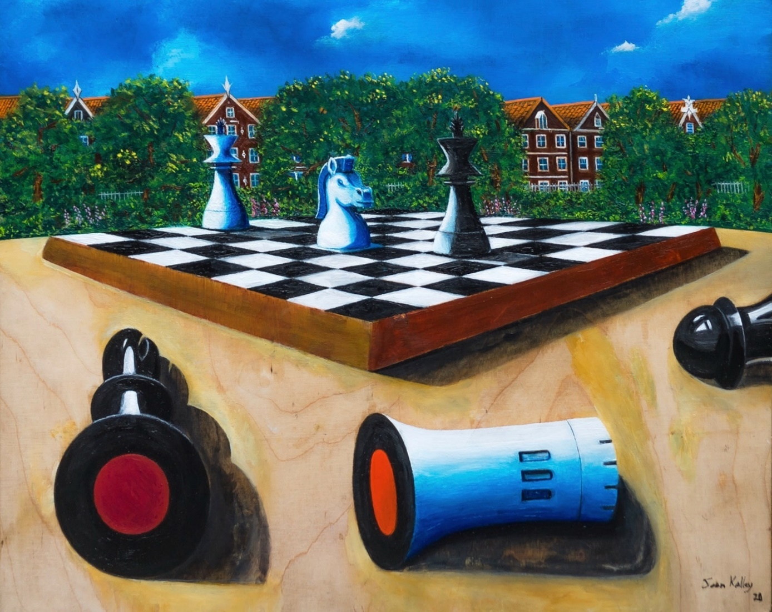

There is nothing like the feel of something natural in your hands that served a purpose living in the world sometimes hundreds of years. Then to be allowed to repurpose it into another form of beauty in an original authentic way. You can feel, smell, and see the cycle of life in the rings of a tree, and it reminds us that nothing is permanent in this material world we live in. How we choose to live our lives while expressing ourselves is our only true legacy much like the individual uniqueness of every single cross section of a tree.
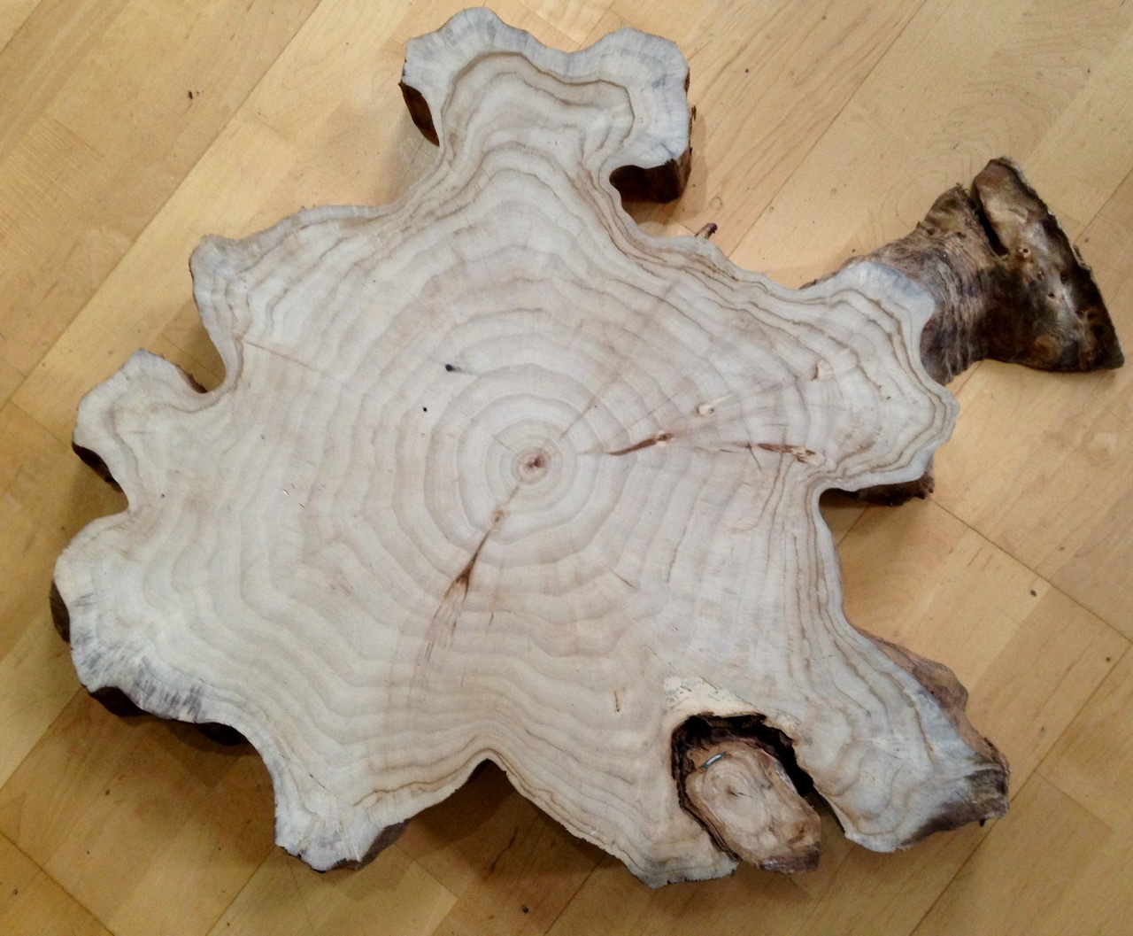

Afterword

After finding all the pictures, organizing them in timeline of creation, and remembering the names for each art piece it feels as though a chapter is finally being closed in my life. Art, the natural world, and daily creativity will always be an integral piece throughout life due to the constant expression during the last 12 years. I am very proud of each of these creations, and that each one has a home still today. The energy we put out in the world as truth needs to be shared with others as an inspiration to try something even though not everyone might not understand. That takes courage, and inspiration from within authentically to keep trying and sharing with the world.
One aspect of creating every day has reminded me that each of us has a unique purpose to fill in this lifetime. Only you can find this in yourself, and there are so many examples to derive inspiration from. Don’t be fooled into thinking that if we all become one collectivized group or the same that it will lead to some form of utopia that everyone will benefit equally. It is our divine natural right for individual unique authentic expression that adds the next layer of human beauty to a world that we are constantly connected with. There is no separation as energy flows between all aspects of life, and it is our choice to recognize this. Just as the unique rings on a tree measure time and the outside environmental factors, it is our chosen actions and expression through life experiences that demonstrate our connection to time.
Thank you for appreciating creativity, and I ask you to take a chance on yourself finding something unique from within as well. It is worth every step through the process of awakening that inner fire.

“Got Wood”
By
Sean Kalley

